Persons with disabilities in 2025
As of 31 December 2025 in Poland, there were 4.1 million persons who held a valid certificate of disability or a level of disability issued by the medical examination committee or an equivalent. Such persons accounted for 10.9% of total population.
4.1 million Persons with a certificate of disability or a level of disability or an equal one

Disabled persons with legal confirmation
Disabled persons with legal confirmation hold at least one of the following certificates:
- of disability or a level of disability issued by the medical examination committee;
- of a level of incapacity to work issued by the Social Insurance Institution (ZUS);
- of a level of incapacity to work on a farm issued prior to 1 January 1998 by the Agricultural Social Insurance Institution (KRUS);
- of level of disability issued prior to 1 January 1998 by the medical committee subordinate to the Ministry of National Defence (MON);
- of a level of disability issued prior to 1 January 1998 by the medical examination committee subordinate to the acting minister of internal affairs.
As of 31 December 2025, the largest number of disabled persons with legal confirmation held a certificate issued by the medical examination committee (3.2 million). Nearly every fifth disabled person with legal confirmation (19.0%) held a certificate issued by the committee as well as a certificate issued by ZUS. Around 12 thousand people held a certificate issued by the committee along with a certificate issued before 1 January 1998 by KRUS or a medical committee subordinate to MON or the acting minister of internal affairs.
Disabled persons with a certificate issued by the medical examination committee accounted for 79.0%
In 41.5% cases the certificate of moderate disability was issued, the certificate of severe disability in 29.2% cases and of mild disability in 23.2% cases. In the case of 146 persons aged 16 and higher data regarding the confirmed level of disability was missing. Other certificates with non-defined level of disability were issued for children up to the age of 16. Women accounted for over a half (53.8%) of the population of disabled persons with legal confirmation. Most persons (568.2 thousand) was aged from 70 to 74.
Women accounted for 53.8% disabled persons with legal confirmation

Chart 1. Disabled persons with legal confirmation by sex and age groups in 2025

As of 31 December
The largest number of disabled persons with legal confirmation per 1 thousand population was recorded in Lubuskie voivodship (164.7)
Source: own development based on the data in the Electronic System on Certification on Disability (EKSMOoN), the ZUS pension systems (EMIR and RENTIER), the KRUS complex system of servicing pension benefits, the MON information system, the MSWiA Pension Institution information system Emeryt.
The largest number of disabled persons with legal confirmation (464.3 thousand) lived in Śląskie voivodship and the smallest one in Opolskie voivodship (90.4 thousand). The index of the number of disabled persons with legal confirmation per 1 thousand population was the highest in Lubuskie voivodship (164.7) and the lowest one in Mazowieckie voivodship (75.3).

Map 1. Disabled persons with legal confirmation by voivodships in 2025

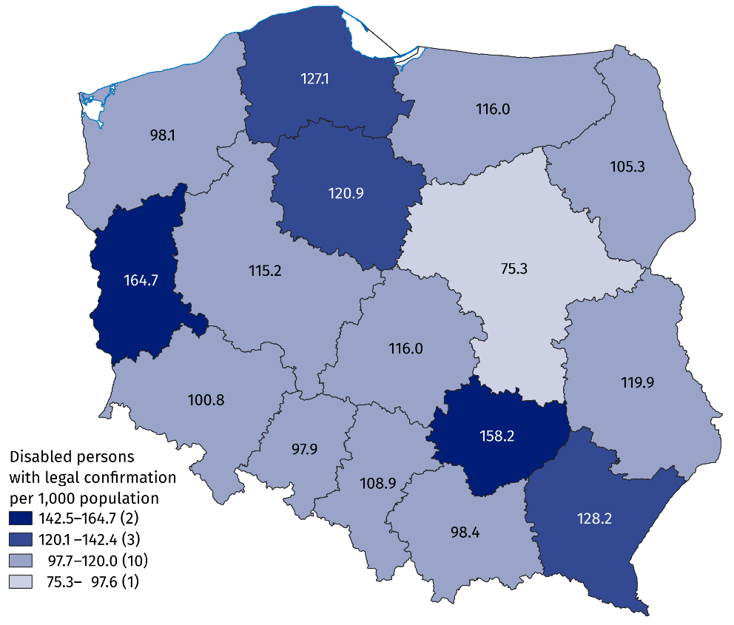
As of 31 December
Note: in case of 0.2 thousand persons the home address was not determined. The number of voivodships is given in the brackets.
Source: own development based on the data from EKSMOoN, ZUS EMIR and RENTIER, KRUS, MON, MSWiA.

Persons with a certificate of disability or a level of disability issued by the medical examination committee
As of 31 December 2025, 3,218.7 thousand persons held a certificate of disability or a level of disability issued by the medical examination committee. The certificate contain no more than three causes of disability. The certificates with:
- one cause – noted for 58.4% persons;
- two causes – 31.5% persons;
The largest number of persons held a certificate of disability or a level of disability issued because of motor impairment (1,476.5 thousand)
- three causes – 10.1% persons.
The largest number of persons held a certificate issued because of motor impairment (1,476.5 thousand), and the smallest one because of epilepsy (71.0 thousand).

Chart 2. Persons with a certificate of disability or a level of disability by its causes in 2025

As of 31 December

Note: each person may have one to three causes of disability.

Source: own development based on the data from EKSMOoN.
In 2025, the medical examination committees processed 921.6 thousand applications referred to certificate of disability, a level of disability or reliefs and entitlements. The largest numbers of applications was processed in Śląskie voivodship (110.8 thousand) and the smallest one in Opolskie voivodship (21.7 thousand). The index per 1 thousand population was the highest in Świętokrzyskie voivodship (44.3) and the lowest one in Mazowieckie voivodship (15.6). Most applications were processed in more than 30 days (82.9%). The biggest share of cases processed for more than 30 days was recorded in Pomorskie voivodship (95.3%) and the smallest one was recorded in Lubuskie voivodship (63.0%).
The biggest number of applications was processed in Śląskie voivodship (110.8 thousand)

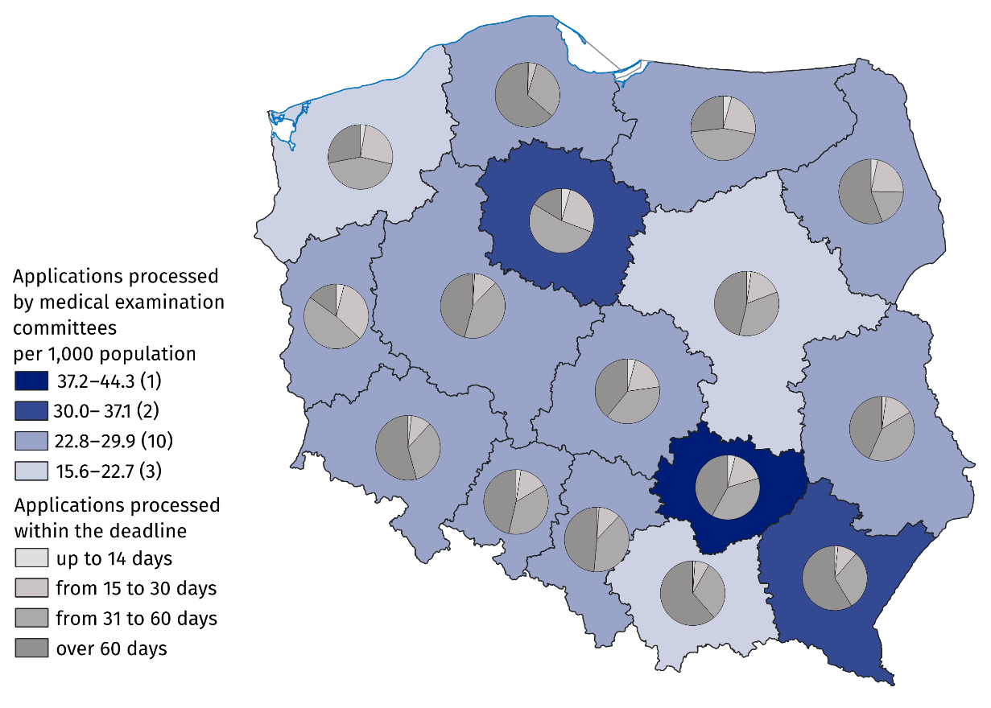
Map 2. Applications processed by medical examination committees by voivodships in 2025
Note. The number of voivodships is given in the brackets.
Source: own development based on the data from EKSMOoN.
893.1 thousand persons with certificate of disability or a level of disability held valid parking card
As of 31 December 2025, there were 893.1 thousand persons with certificate of disability or a level of disability who held valid parking card. The biggest number of such persons per 1 thousand population was recorded in Lubuskie voivodship (37.0) and the smallest one in Mazowieckie voivodship (14.7). The rate for Poland was 23.9.

Chart 3. Persons with a certificate of disability or level of disability with a valid parking card per 1,000 population by voivodships in 2025

As of 31 December

Source: own development based on the data from EKSMOoN.

Educating persons with disabilities and persons with special educational needs
In the 2025/26 school year, there were 393 special nursery schools, attended by 9.2 thousand children with disabilities, out of which the largest number of children was over 7 years old (29.2%). Boys predominated in the group of children in special nursery schools (71.5%). Moreover, during this period there were 158 special nursery sections in primary schools, which were attended by 2.2 thousand children with disabilities. Boys were the majority there as well (68.9%). Other nursery schools and other pre-primary education establishments were attended by 67.1 thousand children with disabilities, who accounted for 4.9% of the total number of children. The majority of children with disabilities attended regular nursery schools (80.3%), including the integrated nursery schools (14.0%).
In school year 2025/2026 314.9 thousand children and youth with special educational needs (excluding adult schools) attended primary, secondary and post-secondary schools), which accounts for 5.9% of students
There were 59.9 thousand children in 960 special primary schools. Moreover, 173.0 thousand children with certified special educational needs attended sections at regular primary schools, out of which 135.4 thousand (78.3%) attended regular sections, 34.7 thousand (20.1%) integrated sections and the other 2.9 thousand attended special sections. The total number of children with disabilities who received special education at primary level was 232.9 thousand (7.1% of the total number of children), out of which 68.9% were boys. Out of 4.3 thousand children who were taught individually, there were 47.4% children with disabilities.
In the 2025/26 school year, there were 349 special care and education centres and special education units. They were assigned for children with special education certificate issued due to their disability, but could not attend kindergarten or school in their place of residence because of their disability. Out of 22.2 thousand available places, 42.7% were used. Persons intellectually disabled accounted for 51.1% students. Moreover, the units provided care for children and youth with combined disabilities (30.6%), deaf or hearing impaired (4.4%) and blind or visually impaired (2.8%).
As of 30 September 2025, there were 194 rehabilitation and educational centres. They provided 8.5 thousand places, of which 71.0% were used. The facilities provided participation in classes for children with combined disabilities (3.4 thousand) and those with profound intellectual disabilities (2.5 thousand).
Education of young people with special educational needs at the secondary level was provided in special schools and in regular schools (excluding post-secondary schools). The largest share of special schools were those that offered preparation for a specific profession: special schools for vocational training and special vocational schools of the first level. Special schools educated 31.9 thousand persons in total. Moreover, 49.8 thousand students with special educational needs of which the largest number in sections at general secondary schools (47.0%). The total number of children and youth covered by special education at the secondary level was 81.7 thousand (4.5%).
Post-secondary schools were attended by 247 students with special educational needs. There were predominantly special schools (210 students).
As of 31 December 2025, 26.2 thousand persons with disabilities were studying at higher education institutions (2.0% of the total number of students). In 2025 5.8 thousand persons with disabilities graduated higher schools (1.9% of the total number of graduates). Out of doctoral students, 2.6% were persons with disabilities (0.5 thousand persons).

Methodological notes
- The disability certification system in Poland is defined by two fundamental legal acts:
- The Act of 27 August 1997 on Vocational and Social Rehabilitation and Employment of Disabled Persons, abridged: The Act on Rehabilitation – in Art. 2, disability is defined as permanent or temporary inability to fulfil social roles due to permanent or long-term impairment of the overall efficiency, in particular resulting in incapacity to work. Art. 3 defines the level of disability: severe, moderate and mild, while Art. 4a mentions children up to 16 years of age who are certified without determining their level of disability. Disability adjudication institutions are powiat and city (first instance) and voivodship (second instance) disability adjudication units. The final instance consists of labour and social security courts;
  - The Act of 17 December 1998 on Retirement and Other Pensions from the Social Insurance Fund – Art. 12 defines person incapable to work as one who has completely or partially lost the ability to work for paid employment due to a deterioration of the physical or psychical health and is not expected to regain the ability to work after retraining. Decisions on: incapacity to work, incapacity to live independent life and on rationale of retraining, issued by the Social Insurance Institution, are converted into verdicts on the level of disability in accordance with Art. 5 of the aforementioned Act on Rehabilitation.
- According to Art. 62(3) and Art. 63 of the Act on Rehabilitation, persons certified as complete incapable to work in an agricultural holding are disabled if the certificates were issued before 1 January 1998, and are still valid, except that:
  - persons who are entitled to care allowance are determined as the ones with severe level of disability;
  - other persons are determined as the ones with mild level of disability.
Certificates of incapacity to work issued by medical expert or a medical examination committee of the Agricultural Social Insurance Fund after 1 January 1998 are not convertible into the levels of disability. Persons who have been issued a certificate of incapacity to work on an agricultural holding in the adjudication system of the Agricultural Social Insurance Fund after 1 January 1998 may apply to the examination committee to determine the level of disability.
- According to Art. 62 (1, 2) and Art. 63 of the Act on Rehabilitation, individuals holding verdicts on assigning to one of the disability groups, issued before 1 January 1998 by medical examination committees subordinated to the minister of competent for internal affairs and the Minister of National Defence on the basis of separate regulations on the assessment of capability to military service - the Act of 10 December 1993 on Retirement Provision for Professional Soldiers and Their Families and the Act of 18 February 1994 on Retirement Provision for Officers of the Police, Internal Security Agency, Intelligence Agency, Military Counterintelligence Agency, Military Intelligence Service, Central Anti–Corruption Office, Border Guard, Marshal Guard, State Protection Service, State Fire Service, Customs and Tax Service, Prison Service and their families – are converted into the following levels of disability:
  - certificate assigning for group I of disability is equal to certificate of severe disability;
  - certificate assigning for group II of disability is equal to certificate of moderate disability;
  - certificate assigning for group III of disability is equal to certificate of mild disability.
The verdicts of medical examination committees issued after 31 December 1997 are not equal to the assessments of disability within the meaning of the Act on Rehabilitation. In compliance to Art. 5a of the Act on Rehabilitation, individuals may apply to the examination committees to determine the level of disability and recommendations for the use of relieves and entitlements.
- The release news uses the datasets of:
    - medical examination committees on persons holding valid verdict on disability or the level of disability (EKSMOoN);
    - Social Insurance Institution on the recipients of retirement and other pensions with the verdict on the level of incapacity to work (ZUS EMIR and RENTIER);
    - Agricultural Social Insurance Fund on recipients of disability benefits;
Information on decisions on complete incapacity to work on an agricultural holding has been stored in the Agricultural Social Insurance Fund system since 2000. The analysed data does not refer to persons who, after 25 years of employment record, had their disability pension converted into retirement benefit (unless it is more favourable to the beneficiary);
    - Ministry of National Defence on persons holding valid verdict on disability group, issued before 1 January 1998 by the medical committee subordinate to the Minister of National Defence;
    - Pension Institution of the Ministry of Internal Affairs and Administration on persons holding valid verdict on disability group, issued before 1 January 1998 by the medical committee subordinate to the acting minister of internal affairs.
- In the release news the data from the Ministry of National Education on children and youth with the certificate of the public psychological and educational counselling centre (including public specialist outpatient clinic) on the need for special education or for individual education were also presented.
Special education is organised for children and youth with disabilities, socially maladjusted and at risk of social maladjustment, requiring special forms of learning and methods of work. It may be organised in the general school system or individually. School children with the certificate of special educational needs are not necessarily disabled in compliance with the provisions of the Act on Rehabilitation, likewise disabled school children do not need a certificate on the need of special education.
Moreover, the data from the Ministry of Science and Higher Education on students and doctoral students with disabilities were used.
- The data presented in this release news on persons holding the valid certificate of disability or the level of disability issued by the Disability Assessment Committee are different from the data included in the quarterly information of the Office of the Government Plenipotentiary for Disabled Persons. The age of individuals was determined as of 31 December 2025, not as of the date of the verdict. The data may not record all verdicts of organs of appeal.
Due to the rounding in some cases the sum of subtotals may slightly differ from the total values.
When quoting this publication, please provide its title and indicate Statistics Poland as the author. When publishing your own calculations based on data from this publication, please include the following statement: Author’s work based on data from Statistics Poland’s publication entitled ‘Disabled persons with legal confirmation in 2025’.

Prepared by:  Statistical Office in Kraków  Director Agnieszka Szlubowska  Phone: (+48 12) 420 40 50 | Issued by:  Press Office  Mobile: (+48) 695 255 032  Phone: (+48 22) 608 38 04, (+48 22) 449 41 45,  (+48 22) 608 30 09  e-mail: obslugaprasowa@stat.gov.pl

stat.gov.pl/en/

@StatPoland

@GlownyUrzadStatystyczny

@gus_stat

@GłównyUrządStatystycznyGUS

@Glówny Urząd Statystyczny
Related information
Social assistance, child and family services in 2025
Disabled persons in 2024
Terms used in official statistics
Disabled person
Disabled person with legal confirmation
Level of disability

Certificate of a level of disability issued by Social Insurance Institution or certificate of an incapacity to work on a farm issued prior to 1 January 1998 by the Agricultural Social Insurance Institution or certificate of level of disability issued prior to 1 January 1998 by the medical committee subordinate to the Ministry of National Defence or to the acting minister of internal affairs.
The change in the methodology since 2025 (inclusion of all valid certificates issued by the medical examination committees, including the ones issued before 2007) has made it not possible to compare the data with the ones on previous reference years.
All those persons had a certificate issued by the medical examination committee before 2007.
Determined by home address. When home address was unknown, determined by the mailing address, and when both addresses were unknown, the registered address was used.
Population as of 31 December.
Population as of 30 June.
Population as of 31 December.
The centres for children with disability combined with autism, with Asperger’s syndrome, motor impairment, mental disability at moderate or severe level, blind, with eyesight impairment, deaf and with hearing impairment.
The centres for children with combined disabilities, with mental disabilities, autism, motor impairment, deaf, with hearing impairment, blind, with eyesight impairment, socially excluded or threatened with social exclusion, who as of 30 September submitted the certificate on the need for special education.
Rehabilitation and educational centres are facilities that enable the implementation of the annual obligation of pre-school preparation, the obligation to attend school and the obligation to learn for children and young people with profound intellectual disabilities, who have a certificate on the need for rehabilitation and educational activities, and with combined disabilities, one of which was an intellectual disability, who have a certificate on the need for special education.

