Social assistance beneficiaries in 2025
In 2025, 1 177.1 thousand people benefited from social assistance at domicile, and the extent of using this support was 3.1%. The assistance was provided to 680.5 thousand poor persons living in households and poor homeless people. The number of disabled beneficiaries with legal confirmation amounted to 286.8 thousand.
1.8 thousand
Increase of the number of social assistance beneficiaries y/y

Extent of using social assistance at domicile
The number of beneficiaries of social assistance at domicile amounted to 1 177.1 thousand and increased by 1.8 thousand (0.1%) compared to 2024. The extent of using social assistance, i.e. the percentage of beneficiaries in the total population, remained unchanged at 3.1%. The number of beneficiaries living in households and homeless people with per capita income below the income threshold amounted to 680.5 thousand, representing 1.8% of the total population, i.e. more by 0.1 pp compared to 2024.
Map 1. Extent of using social assistance at domicile by regions in 2025
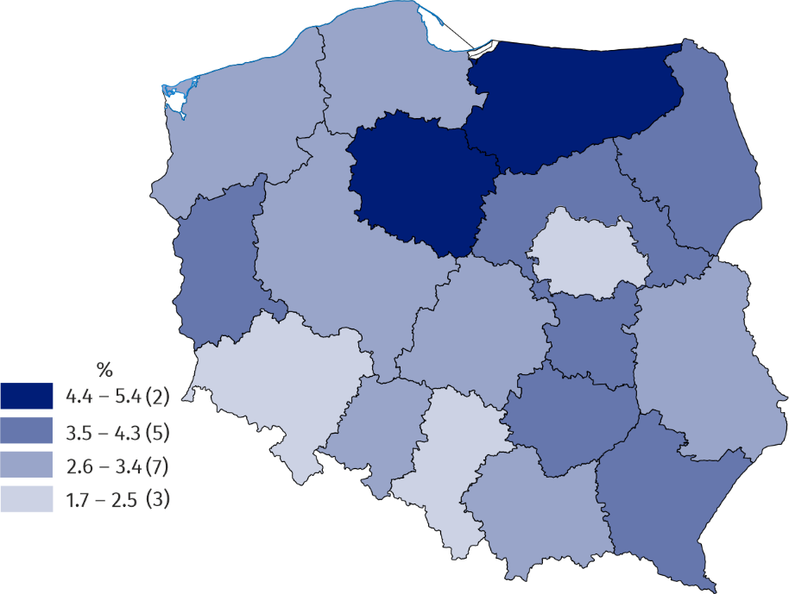
Source: Central Collection of the National Social Assistance Monitoring System of the Ministry of Family, Labour and Social Policy and Statistics Poland.
City residents constituted 54.7% of beneficiaries of social assistance at domicile
In 2025, city residents accounted for 54.7% of all social assistance beneficiaries, and their number amounted to 644.3 thousand persons. In rural areas, the share of beneficiaries in the total number of inhabitants was 3.5%, and in urban areas 2.9%. Compared to the previous year, this indicator decreased by 0.1 pp in rural areas, and in urban areas it increased by 0.1 pp.
The largest share of beneficiaries in the total population occurred in northern and eastern regions
The highest share of beneficiaries of social assistance at domicile in the total number of inhabitants was recorded in the Warmińsko-mazurskie region (5.4%), and the lowest one in the Warsaw capital region (1.7%). A low (less than 2.5%) percentage of beneficiaries of social assistance at domicile occurred in the Dolnośląskie region (2.3%) and the Śląskie region (2.2%).
In 2025, the year-on-year increase of the indicator was recorded in five regions, of which the largest in the Lubuskie and the Warmińsko-mazurskie region (by 0.2 pp each). A decrease occurred in six regions, of which the most in the Opolskie region (by 0.2 pp). In other regions, this indicator remained at the same level.
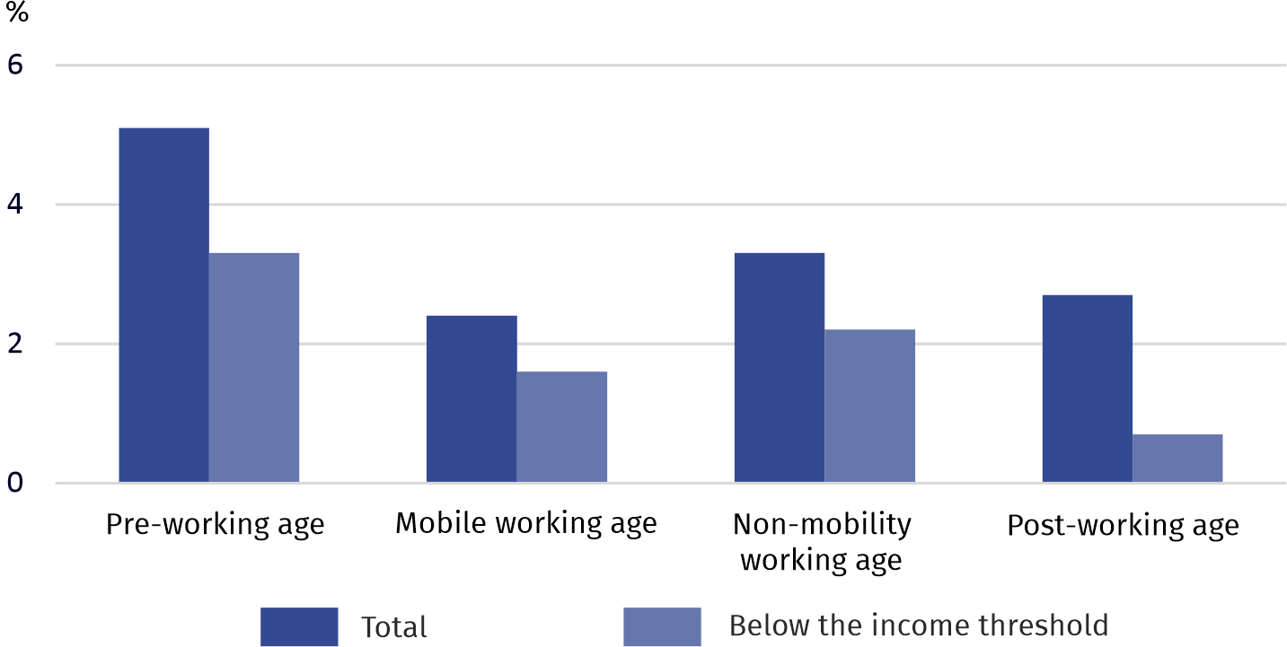
Chart 1. Extent of using social assistance at domicile by economic age groups in 2025
Source: Central Collection of the National Social Assistance Monitoring System of the Ministry of Family, Labour and Social Policy and Statistics Poland.
The extent of using social assistance in the pre-working age group amounted to 5.1%, and children and youth under the age of 18 from poor households accounted for 3.3% of the total population in this age group.
Over 5% of inhabitants under the age of 18 are members of households benefiting from social assistance
In turn, the percentage of persons of post-working age benefiting from social assistance was 2.7%, and of poor beneficiaries of post-working age – 0.7%. The share of beneficiaries in this age group with per capita income above the income threshold was 73.5%.

Persons in single-person and multi-person households
57.5% of the beneficiaries are members of poor households

Among 1 145.7 thousand beneficiaries of social assistance at domicile in households (excluding homeless people), 410.4 thousand (35.8%), are people constituting single-person households, and 735.3 thousand (64.2%) are members of multi-person households. In urban areas the percentage of single-handedly managing beneficiaries amounted to 43.6%, and in rural areas 26.6%. Among beneficiaries of social assistance at domicile in households 658.3 thousand (57.5%) are poor beneficiaries.

Social assistance beneficiaries by economic age groups
Persons of post-working age accounted for the smallest share of the social assistance beneficiary population
Among the beneficiaries, broken down by economic age groups, the largest share consisted of persons of pre-working age (28.9%).
The share of persons of post-working age shaped at the level of 20.5%, among the poor beneficiaries it was 9.4%, and in the group of beneficiaries with income per capita above the income threshold – 35.6%.
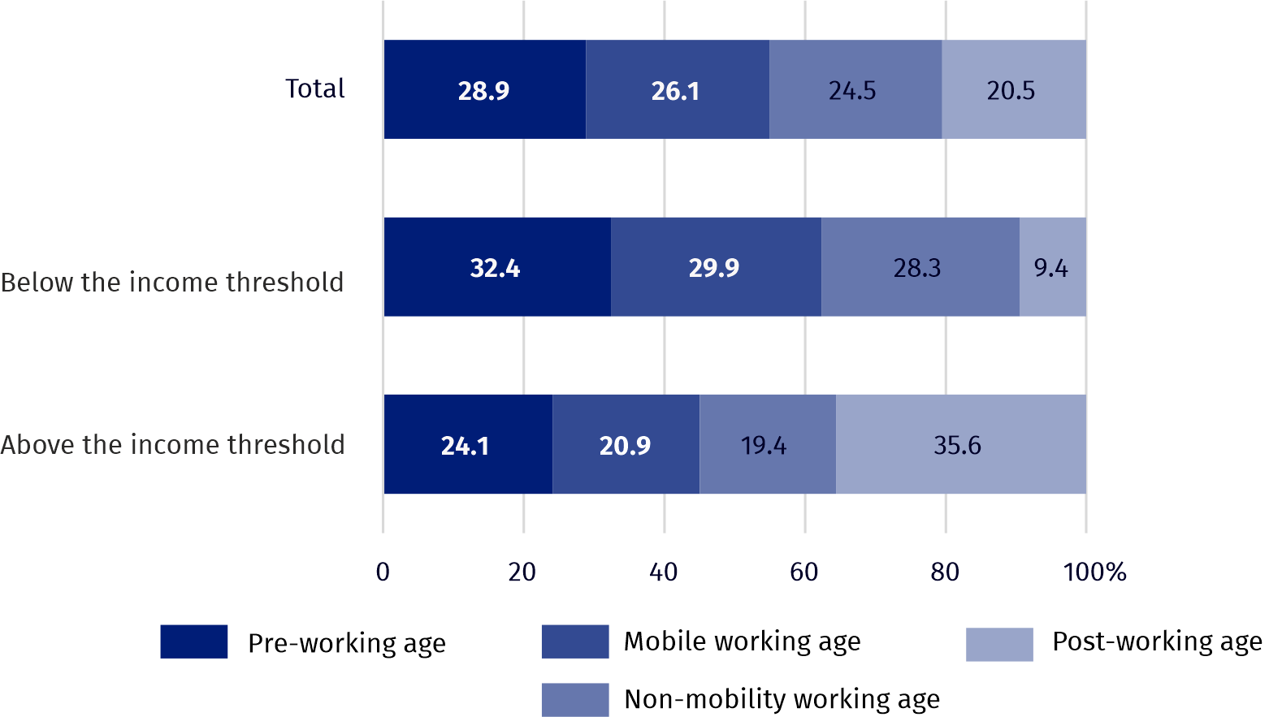
Chart 2. Beneficiaries of social assistance at domicile by economic age groups in 2025
Source: Central Collection of the National Social Assistance Monitoring System of the Ministry of Family, Labour and Social Policy and Satistics Poland.

Poor households
Over 50% of poor households had no sources of income of their own, and more than 30% lived from non-earned income sources
Among 335.9 thousand poor households, 55.5% had no income sources of their own. 33.7% of such households lived from non-earned income sources, predominantly social benefits. Social insurance as well as retirement and other pensions benefits were the primary source of income for 4.3% of poor households, while employment was the main source for 10.8%.
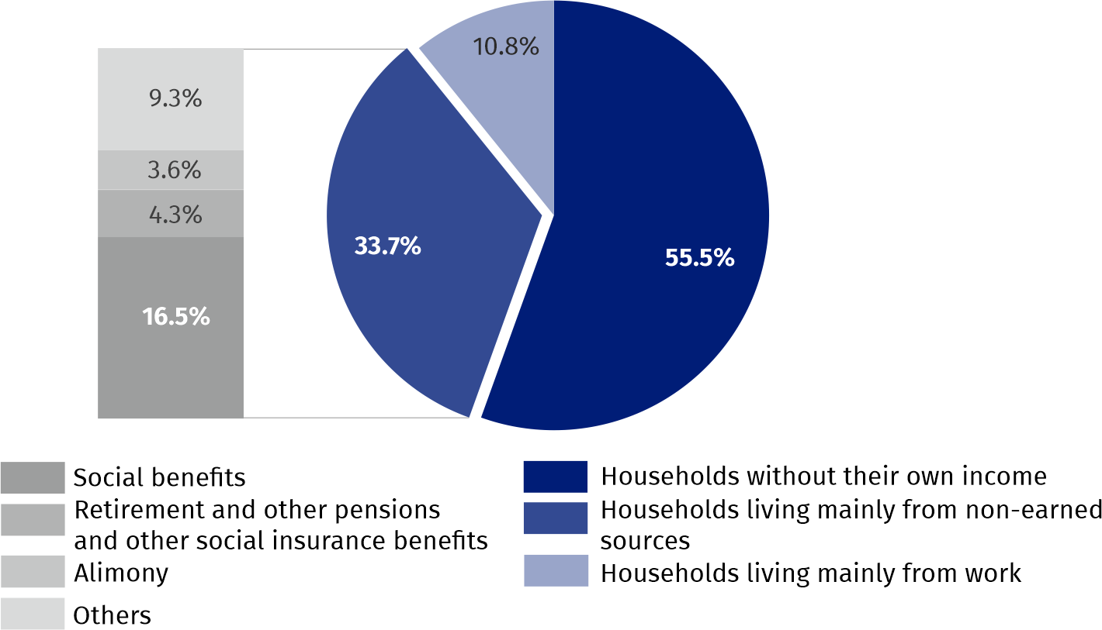
Chart 3. Poor households by main source of income in 2025
Source: Central Collection of the National Social Assistance Monitoring System of the Ministry of Family, Labour and Social Policy.
The largest number of poor households received benefits due to problems related to health or disability and unemployment
Due to problems related to poor health or disability, 62.6% of poor households received social assistance benefits, and due to unemployment – 49.0%. In the case of single-person households, the proportion of beneficiaries with health problems was even higher, reaching 73.6%.
Among multi-person households, the most (58.8%) received benefits due to unemployment. Family problems also played an important role, especially helplessness in matters of care and education in multi-children and single-parent families, which occurred in more than half (55.3%) of poor multi-person households.

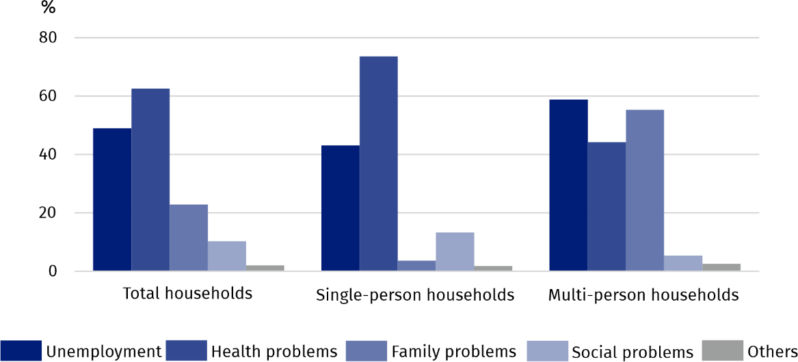
Chart 4. Poor households by selected reasons for granting benefits in 2025ª
a The share of households according to individual causes does not add up to the totals, because more than one problem may occur in one household.
Source: Central Collection of the National Social Assistance Monitoring System of the Ministry of Family, Labour and Social Policy.
In 2025, the number of people of working age in poor households was 375.9 thousand. Among them 13.4% were employed, 44.2% were looking for a job, and 42.4% were economically inactive. The majority of the economically inactive working population (59.8%) consisted of persons studying, disabled or chronically ill.

Homeless people
The number of homeless people who received assistance from social assistance centres amounted to 31.4 thousand
In 2025, the number of homeless people receiving assistance from social assistance centres amounted to 31.4 thousand. Among these beneficiaries, 22.2 thousand (70.7%) had an income that did not exceed the income criterion. Men constituted the vast majority (85.7%) of this group. Homeless people of post-working age accounted for 21.0% of the total, while those of working age were predominantly unemployed or economically inactive – 97.3%. The largest share of homeless beneficiaries (75.1%) had either a basic vocational education or a primary/lower secondary education. Persons suffering from illness or chronic disease constituted 71.8% of this group. Between 2009 and 2024, 49.0% of the homeless beneficiaries first came into contact with social assistance at domicile as members of households, while 24.8% did so as members of multi-person households.

Disabled persons with legal confirmation
Among beneficiaries of social assistance at domicile, there were 286.8 thousand disabled persons with legal confirmation, of which persons with disabilities aged 0–15 accounted for 5.9%, and homeless people for 3.6%. Among 259.4 thousand disabled persons with legal confirmation aged 16 and more living in households, 62.4% are of working age, and 39.7% are poor beneficiaries.
When quoting this publication, please provide its title and indicate Statistics Poland as the author. When publishing your own calculations based on data from this publication, please include the following statement: Author’s work based on data from Statistics Poland’s publication entitled ‘Social assistance beneficiaries in 2025’.

Prepared by:  Statistical Office in Kraków  Director Agnieszka Szlubowska  Phone: (+48 12) 420 40 50 | Issued by:  Press Office  Mobile: (+48) 695 255 032  Phone: (+48 22) 608 38 04, (+48 22) 449 41 45,  (+48 22) 608 30 09  e-mail: obslugaprasowa@stat.gov.pl

stat.gov.pl/en/

@StatPoland

@GlownyUrzadStatystyczny

@gus_stat

@GłównyUrządStatystycznyGUS

@Glówny Urząd Statystyczny
Related information
News releases ‘Social assistance beneficiaries in 2023’
Publication ‘Social assistance beneficiaries in 2024’
Methodological report ‘Social assistance beneficiaries’
Data available in databases
Local Data Bank – Health care, social welfare and benefits to the family – Beneficiaries of social assistance at domicile
Terms used in official statistics
Beneficiaries of social assistance at domicile
Households benefiting from social assistance at domicile
Social assistance at domicile
Extent of using social assistance

Since 1 January 2025, the income eligibility thresholds are PLN 823 for a person in a family and PLN 1 010 for a person living alone. The study uses the term "poor households" to refer to households with income below the aforementioned thresholds (homeless people do not constitute households) and "poor beneficiaries" to refer to members of such households and homeless people with incomes below the income threshold.

