Construction and assembly production in September 2026
The construction and assembly production in September of this year was negatively affected, in particular, by a level of activity in restoration works that was significantly lower than a year ago
According to preliminary data construction and assembly production (in constant prices) carried out domestically was in September 2026 lower by 9.0% an annual. Decreases in construction and assembly production occurred in all divisions of construction; the decrease in construction of buildings was significantly deeper than in the other divisions. Compared to August 2026 an increase was noted by 3.0%.
9.0%
Decrease of construction and assembly production compared to September 2025

Almost 32% of the surveyed enterprises report a lower value of construction and assembly production (at current prices) than a year ago – of these, 34% are in the construction of buildings divisions, almost 39% are dealing mainly with civil engineering works, and over 23% performing specialised construction activities. Enterprises point out that the decreases are linked, among other factors, to significant irregularity in settlements and a base effect (the high production value recorded in September 2025).
After seasonally adjusted, the decrease was noted in construction and assembly production of 7.2% an annual

In Septemeber 2026, after eliminating the seasonal factors, construction and assembly production reached the level by 7.2% lower than in the corresponding month of the previous year and lower by 7.3% in comparison to August 2026.
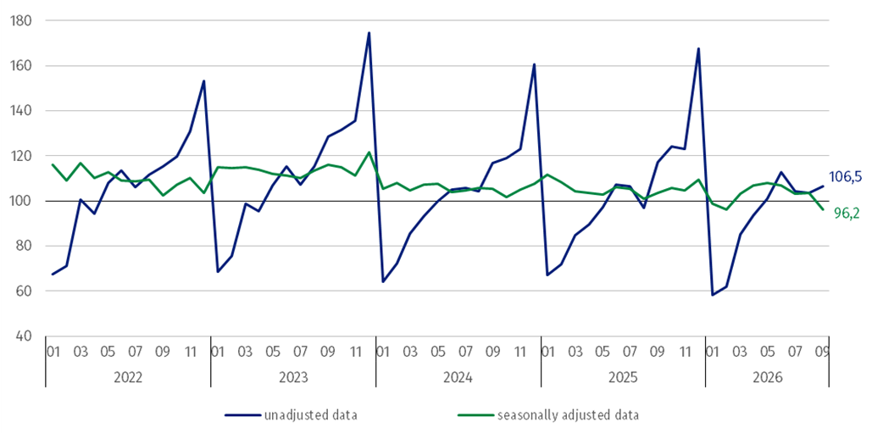
Chart 1. Construction and assembly production (constant prices; average monthly base 2021=100) ª
ª Preliminary data for September 2026.
Compared to the average monthly value of 2021 construction and assembly production in September 2026 (in constant prices), was higher by 6.5%, whereas after eliminating the seasonal factors was lower by 3.8%.
The construction and assembly production in September decreased in all divisions of construction
Construction and assembly production in September 2026 decreased in entities dealing mainly with construction of buildings of 19.2%, performing specialised construction activities of 6.1% and whose basic type of activity was civil engineering works of 4.1%.
In September 2026 compared to August 2026, increases in the sales of construction and assembly production were noted in entities performing specialised construction activities of 11.7% and whose basic type of activity was construction of buildings of 8.1%, whereas decrease was noted in entities dealing mainly with civil engineering works of 4.2%.
Table 1. Construction and assembly production (constant prices) ª
Specification | 2026
Specification | 08 | 09 | 08 | 09 | 01-08 | 01-09
Specification | previous month = 100 |  | corresponding period of the previous year = 100
CONSTRUCTION | 99.4 | 103.0 | 106.6* | 91.0 | 97.9 | 95.3
Construction of buildings ^{Δ} | 83.6* | 108.1 | 80.5* | 80.8 | 93.8 | 91.9
Civil engineering works ^{Δ} | 112.3 | 95.8 | 129.0 | 95.9 | 101.6 | 97.5
Specialised construction activities | 95.3* | 111.7 | 103.9* | 93.9 | 97.3 | 95.8
ª Data including final information on production and prices in August and preliminary data in September 2026.
* The data has been changed compared to what was previously published.
^{Δ} Abbreviated form according to PKD 2007.
In the period January-September 2026 construction and assembly production decreased of 4.7%

In the period January-September 2026, in relation to the same period of the previous year, decreases in the sales of construction and assembly production were noted of 8.1% in entities whose basic type of activity was construction of buildings, in entities performing specialised construction activities of 4.2% and in entities dealing mainly with civil engineering works of 2.5%.
Analyzing the value of construction and assembly production in September 2026 in terms of construction works (investment and restoration works) were observed:
In September 2026, compared to August 2026, restoration works and investment works increased by 7.8% and 1.5% respectively

- an annual decreases for restoration works of 25.2% and for investment works of 2.2% (in September 2025, decrease for restoration works of 4.6% and an increase for investment works of 2.4%),
- compared to August 2026, increases for restoration works of 7.8% and for investment works of 1.5%.
In the period January-September 2026, in relation to the same period of the previous year, a decrease in the sales of construction and assembly production was noted for restoration works by 28.3% and an increase for investment works by 5.7% (in 2025, an increase for restoration works of 0.8% and a decrease for investment works of 1.5%).

When quoting this publication, please provide its title and indicate Statistics Poland as the author. When publishing your own calculations based on data from this publication, please include the following statement: Author’s work based on data from Statistics Poland’s publication entitled ‘Construction and assembly production in September 2026’.
Prepared by:  Statistical Office in Lublin  Director Krzysztof Markowski, Ph.D.  Phone: (+48) 695 255 301 | Issued by:  Press Office  Mobile: (+48) 695 255 032  Phone: (+48 22) 608 38 04, (+48 22) 449 41 45,  (+48 22) 608 30 09  e-mail: obslugaprasowa@stat.gov.pl

stat.gov.pl

@GUS_STAT

@GlownyUrzadStatystyczny

@gus_stat

@GłównyUrządStatystycznyGUS

@Główny Urząd Statystyczny
Related information
Statistical Bulletin
Socio-economic situation of the country
Data available in databases
Knowledge Database - Construction
Macroeconomic Data Bank
Macroeconomic indicators
Local Data Bank

Terms used in official statistics
Sale of construction and assembly production
Seasonally unadjusted index of sale of construction and assembly production in constant prices
Seasonally adjusted index of sale of construction and assembly production
Sale of construction works with an investment character
Sale of construction works with a restoration character and other works

Preliminary data; comprise enterprises employing over 9 persons, whose the main type of activity is included in the section F “Construction” in accordance with the Polish Classification of Activities (PKD 2007).

