Information society in Poland 2025

INFORMATION AND COMMUNICATION TECHNOLOGIES USAGE IN HOUSEHOLDS
AND BY INDIVIDUALS
In 2025, the percentage of individuals aged 16–74 ordering or purchasing goods or services over the Internet in the last
12 months amounted to 69.7%, that
is, by 2.3 p.p. more than in the previous year.
69.7%
The percentage of individuals ordering
or purchasing over the Internet in the last
12 months in 2025

96.2% of households
had access to the Internet
In 2025, 96.2% of households had access to the Internet, that is, by 0.3 p.p. more than in the previous year. The percentage of households with fixed-line broadband access to the Internet decreased by 1.8 p.p. to 70.3%, while access via mobile broadband increased
by 2.3 p.p. to 78.2%.
Both Internet access and the type of Internet connection did not vary significantly depending on the household type, domicile class and the degree of urbanisation. Households with children had Internet access more often than the ones without them. Taking into account domicile classes, the percentage of households with Internet was slightly higher in large cities than in smaller towns and rural areas. Moreover, as for the degree of urbanisation
– the percentage of households with Internet access was slightly higher in densely and intermediate populated areas than in thinly populated areas.
Chart 1. Access to the Internet in households
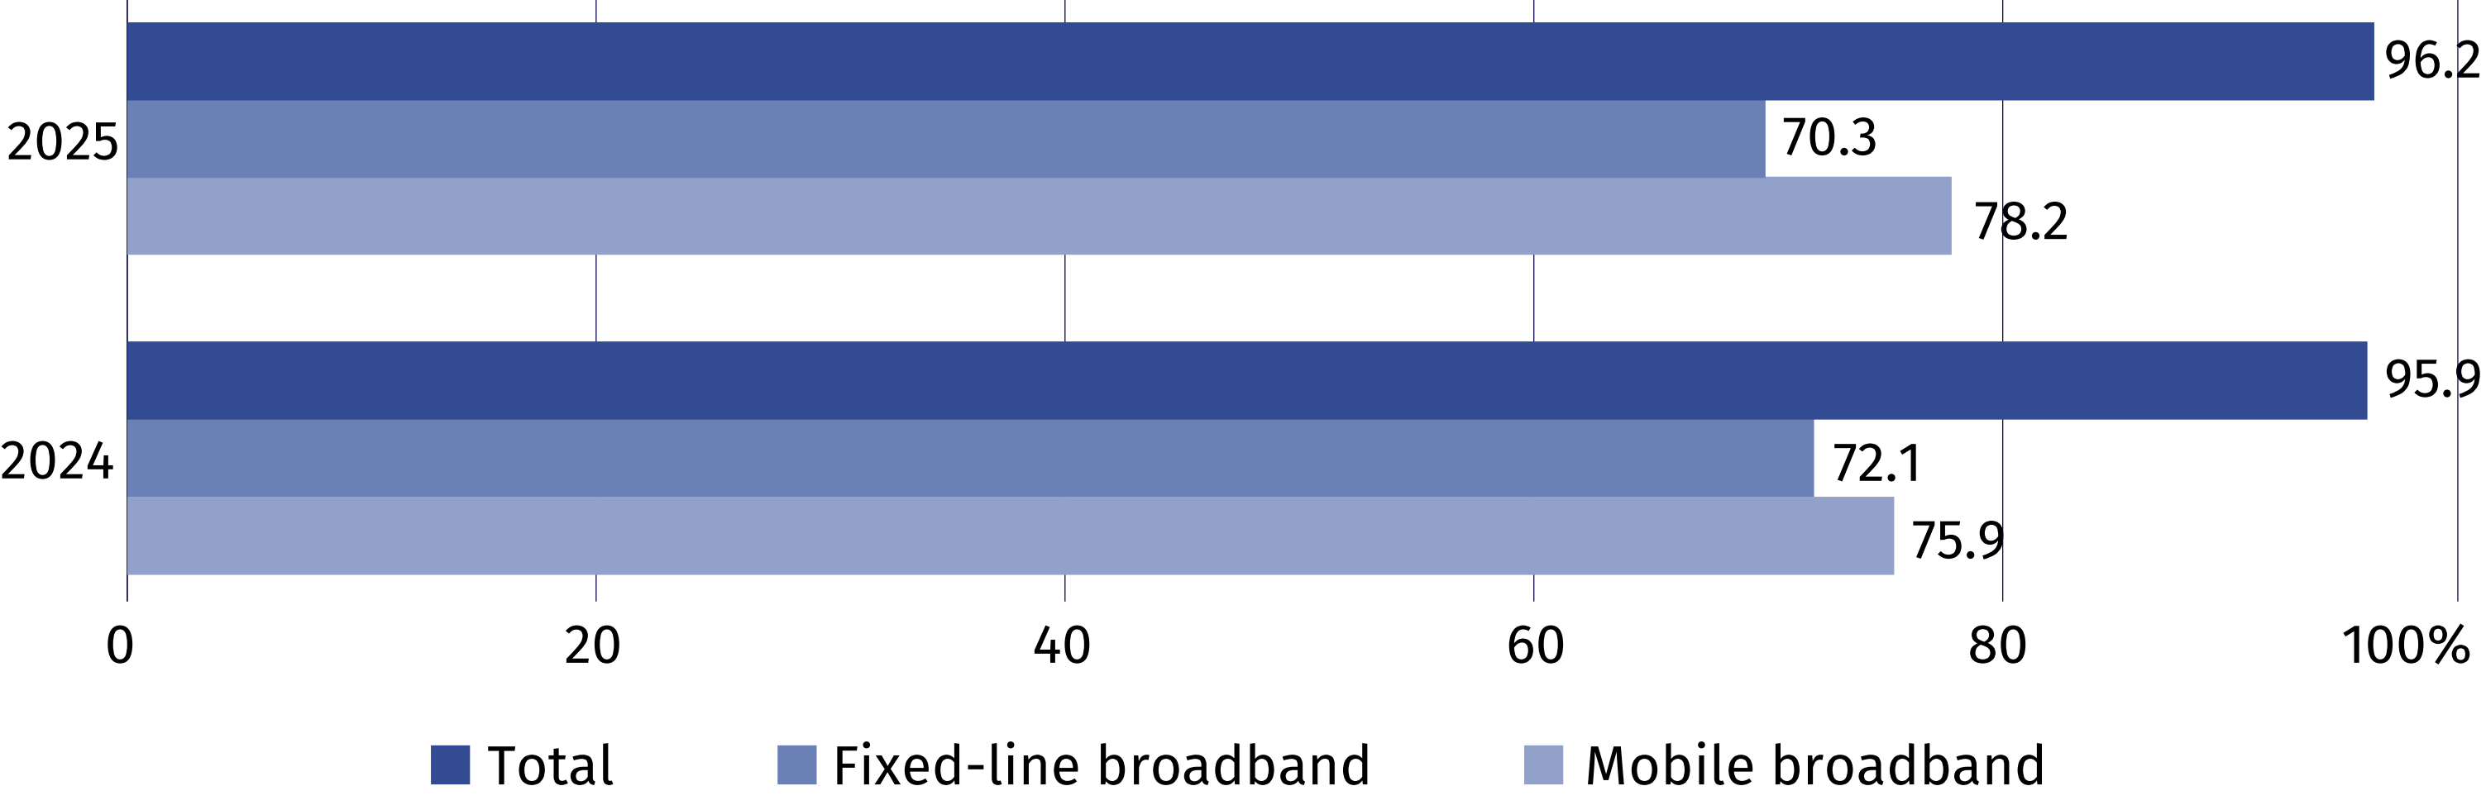
Chart 2. Households with Internet access at home
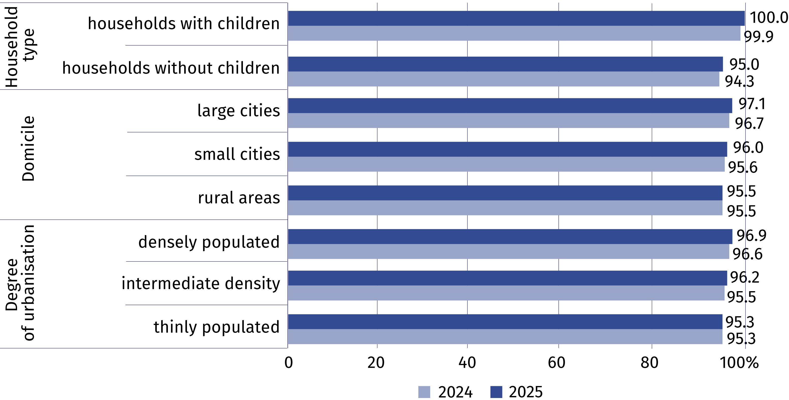
In 2025, 61.1% of persons aged 16–74 declared using public administration services online
in the last 12 months. E-government services were more popular among residents of urban areas – 66.6% of individuals used them, that is, by 13.6 p.p more than residents of rural areas. The most frequently performed activities via the websites or applications of public administration units included sending completed tax declarations, searching for information on websites of public authorities, receiving any official communication/document by public authorities via account on a website or app as well as downloading or printing official forms.
61.1% of individuals aged 16–74 used websites or apps of public administration units
Table 1. Individuals using e-government services in the last 12 months
Specification | Total | Urban areas | Rural areas
Specification | in %
Individuals using e-government services in the last  12 months | 61.1 | 66.6 | 53.0

in order to:
access personal information stored  by public authorities or public services | 28.7 | 33.9 | 21.1
access information from public databases or registers | 10.0 | 12.2 | 6.7
obtain information | 36.2 | 39.0 | 32.0
make an appointment or reservation | 15.4 | 18.7 | 10.5
receive any official communication/document by public authorities via account on a website or app | 30.9 | 34.5 | 25.7
print or download official forms | 28.5 | 31.3 | 24.4
submit tax declaration | 39.4 | 46.9 | 28.4
request official documents or certificates | 7.8 | 9.1 | 6.0
request benefits or entitlements | 15.2 | 15.2 | 15.1
69.7% of individuals aged
16–74 ordered or purchased goods or services over
the Internet
In 2025, 69.7% of individuals aged 16–74 ordered or purchased goods or services over the
Internet in Poland (compared to 67.4% in 2024). Taking into account the domicile, 73.8%
of persons living in urban areas made such purchases, while in rural areas 63.7%. On an annual basis, the disparity between indicators for urban and rural areas decreased (from 11.1 p.p.
to 10.1 p.p.). Considering the territorial division of Poland into macroregions, the highest percentage in urban areas was noted in Mazowieckie Voivodship Macroregion (82.1%), while in rural areas – in Southwest Macroregion (71.7%). The smallest percentage of such individuals in urban areas was observed in Central Macroregion (66.6%), while in rural areas – in East Macroregion (54.2%).
Chart 3. Individuals ordering or purchasing goods or services over the Internet for private
use in the last 12 months
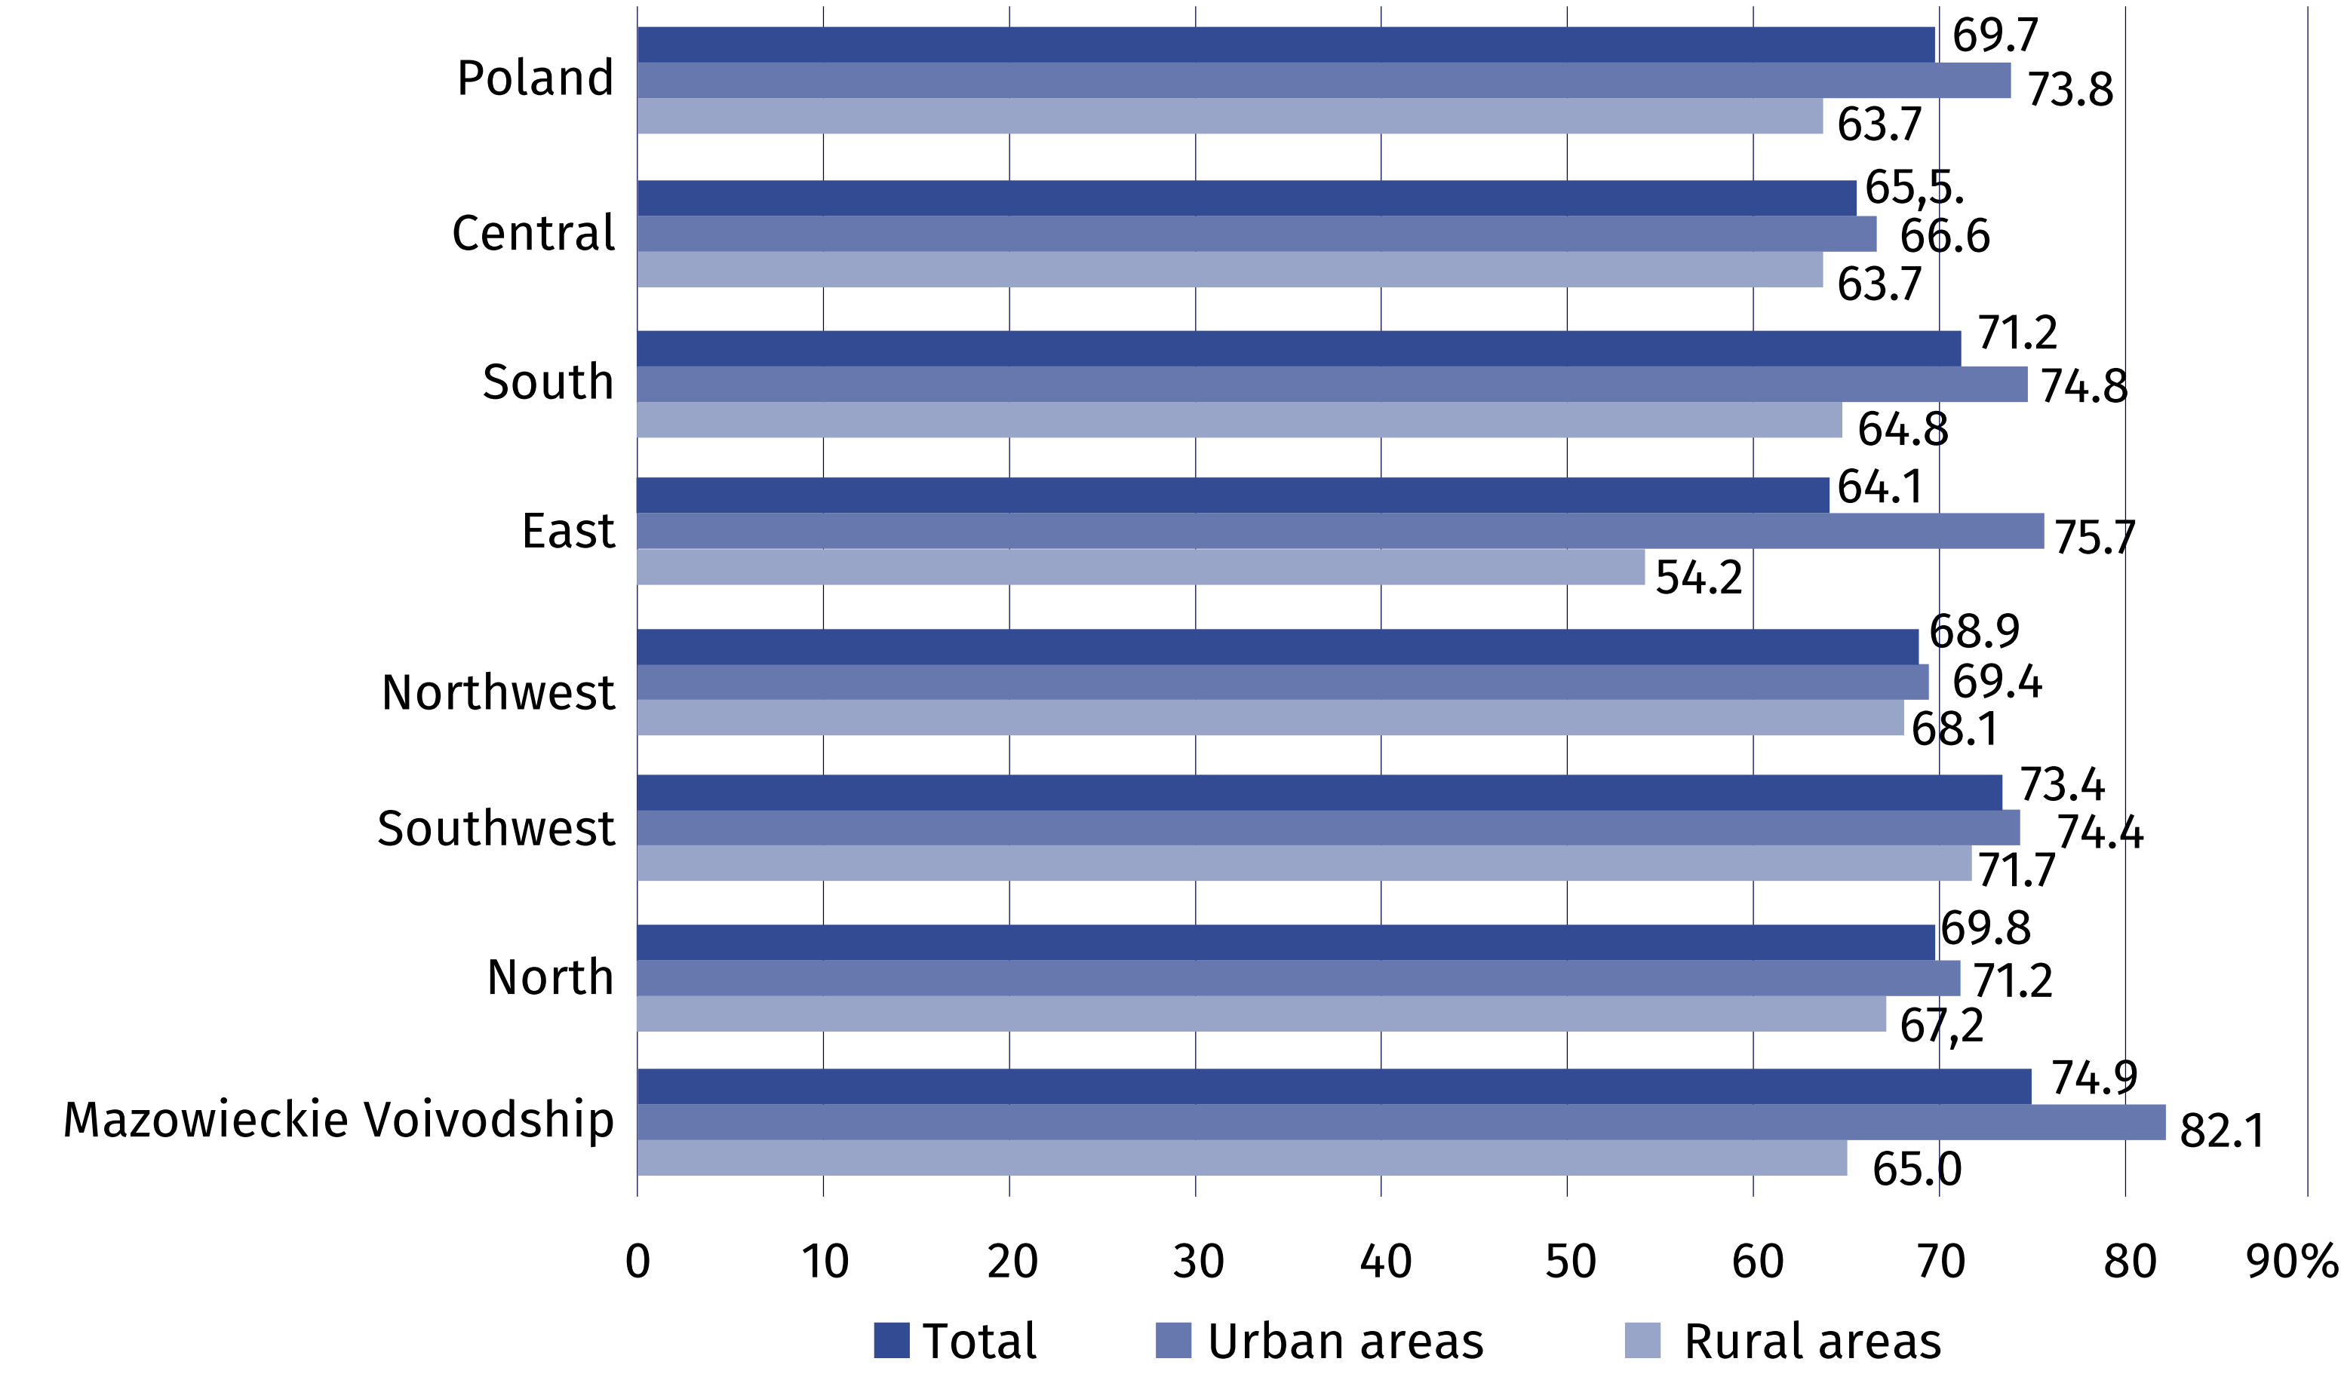

Digital skills of Poles depend on age. The highest percentage of individuals with basic
or above basic digital skills occurred in two age groups: 25–34 years and 16–24 years (75.7% and 73.6%, respectively). The lowest share was found among persons aged 65–74 years (12.3%).
Chart 4. Individuals with basic or above basic digital skills
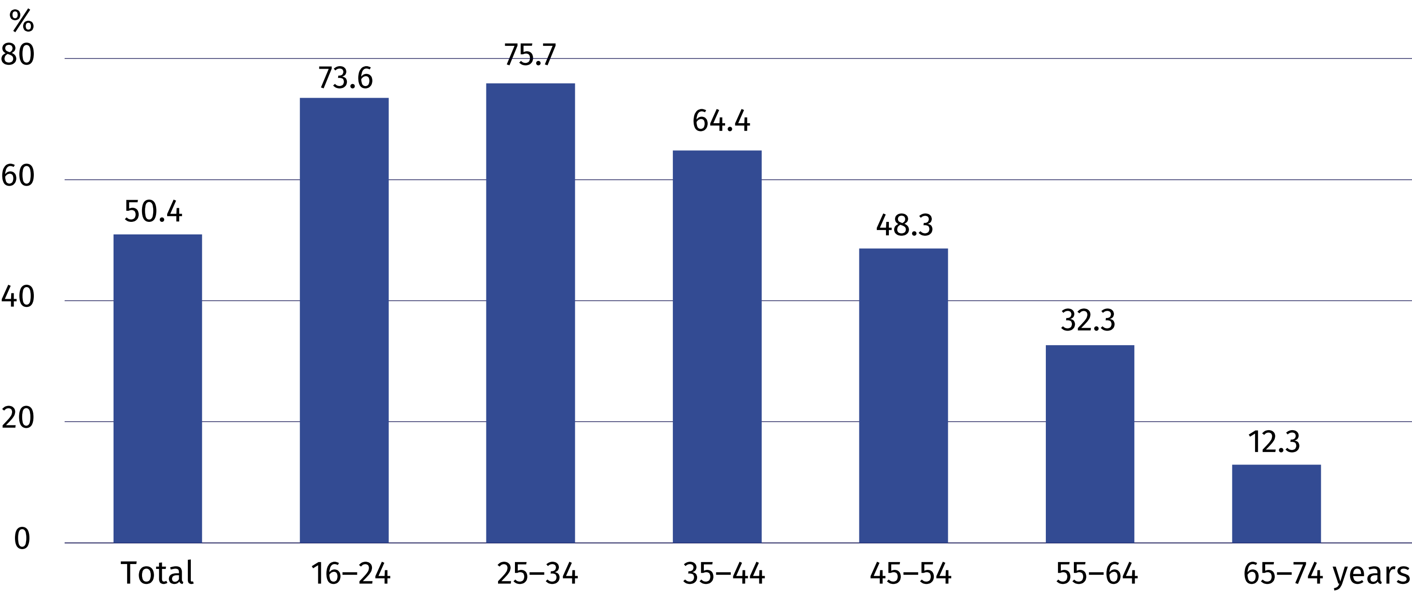

INFORMATION AND COMMUNICATION TECHNOLOGIES USAGE IN ENTERPRISES
In 2025, 67.5% of enterprises had a website. Compared to 2023, the percentage of enterprises conducting data analytics increased by 6.6 p.p.
– to 25.9% in 2025. Two out of five companies used ERP software and the share of entities with
an Internet connection with a capacity
of 500 Mbit/s increased by 2.0 p.p. to 33.3%.
25.9%
The percentage of enterprises conducting data analytics in 2025

20.2% of enterprises indicated that information and communication technologies they used contributed to reducing power consumption or improving energy efficiency in the company
In 2025, over two-thirds of enterprises had a website, 18.2% of enterprises posted information about job vacancies on their websites and 47.8% had a social media account.
Artificial intelligence technologies were used by 8.7% of enterprises, including text or voice generating technologies – 5.3% and text analysis technologies (text mining) – 2.1%.
Artificial intelligence was most often used to support marketing and sales (5.0%) and for office work related to business management (3.7%).
Cloud computing services were purchased by 55.3% of enterprises, including e-mail – 37.3%, office software – 28.0% and file storage – 21.8%.
Chart 5. Enterprises buying cloud computing services (% of total enterprises)
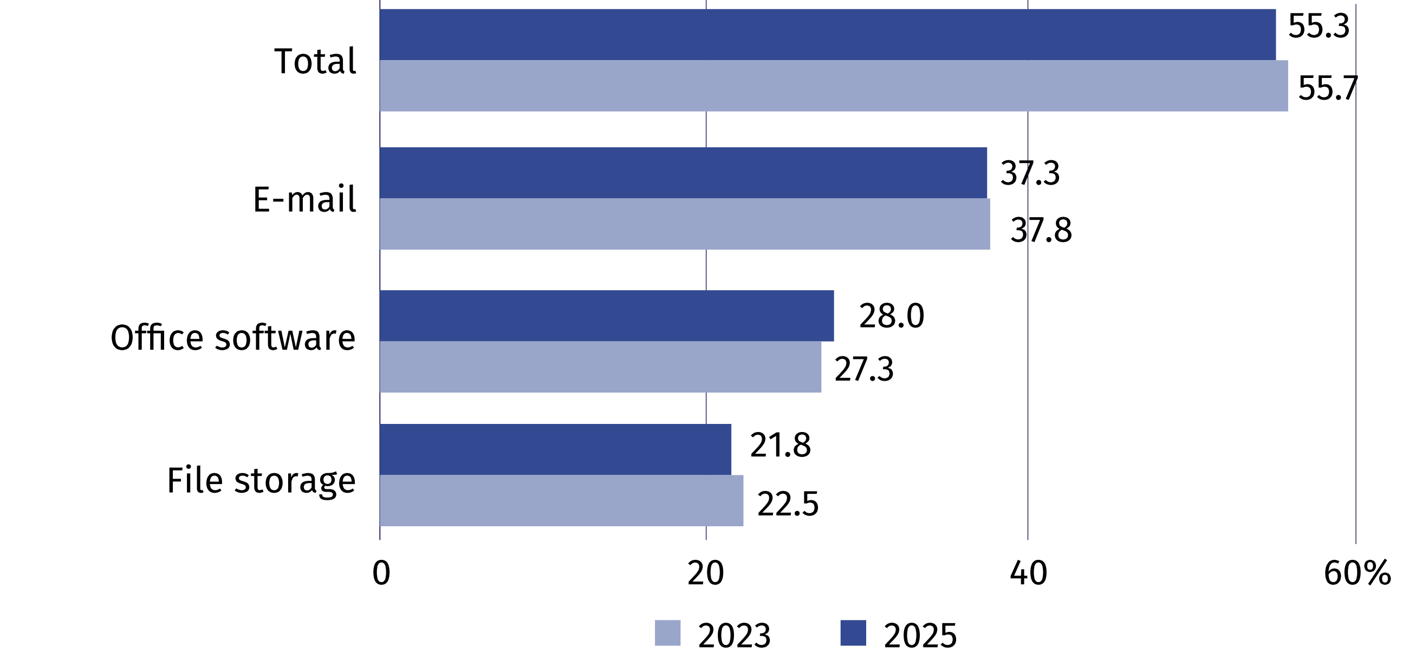
51.3% of enterprises used
e-Delivery in contacts with the state administration
In 2024, 17.4% of enterprises declared using open data. Large entities used this type of data most often (56.6%). Economy and finance were the most popular domain (14.8%).
Chart 6. Enterprises using open data (in % of total enterprises)
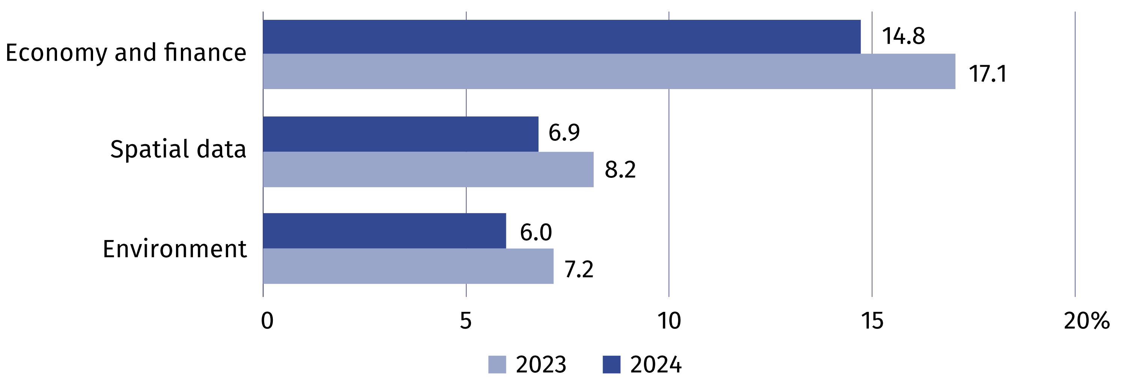

In 2025, over a quarter of businesses conducted data analytics, most frequently by own employees. Less often it was outsourced to other entities.
Chart 7. Enterprises conducting data analytics (in % of total enterprises)
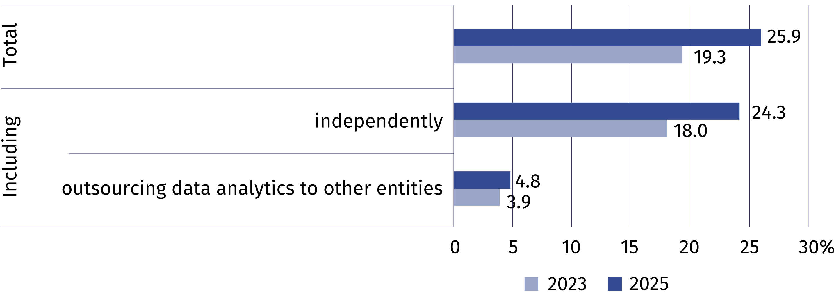

ERP software was used in operations of 40.5% of enterprises, while CRM software – 25.1%.
Chart 8. Enterprises using ERP and CRM software (in % of total enterprises)
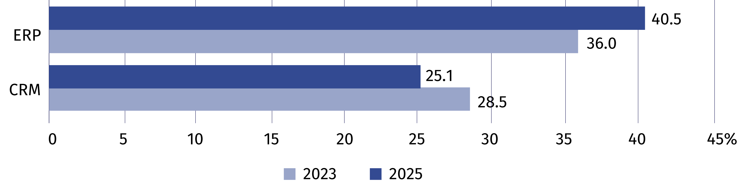
In 2024, 18.3% of enterprises conducted e-commerce. Enterprises usually used their own websites or applications (12.9%), online e-commerce platforms (10.2%) and EDI-type messages (3.3%).
In 2025, 33.3% of enterprises had an Internet connection with a capacity of at least 500 Mbit/s, that is, by 2.0 p.p. more than in the previous year. The largest increase was noted among large enterprises (by 6.1 p.p.).
Chart 9. Enterprises with an Internet connection with a capacity of at least 500 Mbit/s
(in % of total enterprises)
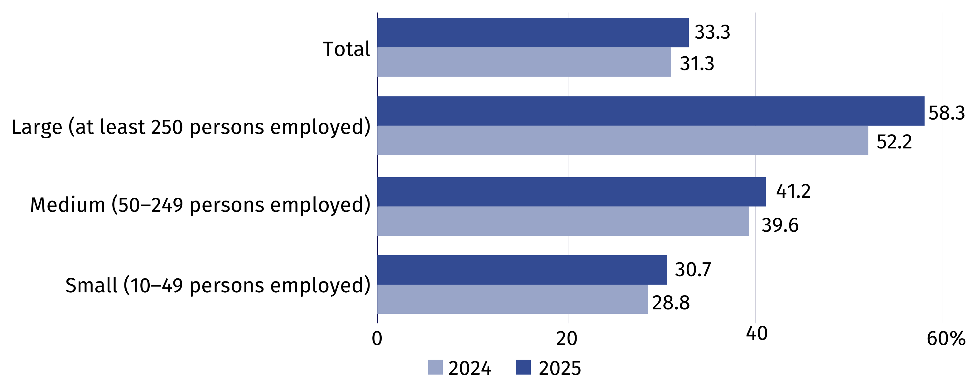

In case of quoting Statistics Poland data, please provide information: “Source of data: Statistics Poland”, and in case of publishing calculations made on data published
by Statistics Poland, please include the following disclaimer: “Own study based on figures from Statistics Poland”.
Prepared by:  Statistical Office in Szczecin  Director Magdalena Wegner  Phone: (+48 91) 459 77 00 | Issued by:  Press Office  Mobile: (+48) 695 255 032  Phone: (+48 22) 608 38 04, (+48 22) 449 41 45, (+48 22) 608 30 09  e-mail: obslugaprasowa@stat.gov.pl

stat.gov.pl/en/

@StatPoland

@GlownyUrzadStatystyczny

gus_stat

glownyurzadstatystycznygus

glownyurzadstatystyczny
Related information
Information society in Poland in 2024
Methodological report. Information society indicators. Surveys on the use of information and communication technologies
Data available in databases
Knowledge Databases – Digital economy and telecommunications
Local Data Bank – Science and technology – Information society in Poland
Terms used in official statistics
E-government
E-commerce
Internet
Broadband connection
Mobile connection to the Internet
Open data
Remote access
Information society

Retrospective data according to the years in which the survey in a given domain was carried out.

