Residential construction in the period of January–September 2026
In the period January– September 2026, 3.1% more dwellings were completed compared to the same period last year. The number of dwellings in which construction began also increased (by 4.5%), as well as the number of dwellings for which permits were granted or which were registered with a construction project (by 12.3%).
3.1%
Increase in the number of dwellings completed compared to the corresponding period of 2025

Dwellings completed
Developers and private
investors completed respectively: 61.6% and 34.3% of the total number of dwellings
According to the preliminary data, 149.2 thousand dwellings were completed in the period January– September 2026, i.e. by 3.1% more than in the corresponding period of 2025. Developers completed 91.9 thousand dwellings – by 1.2% more than a year ago, whereas private investors completed – 51.3 thousand dwellings, i.e. by 5.2% more. Within these two forms of construction, 95.9% of the total number of new dwellings was completed. In other forms, 6.1 thousand dwellings were completed (5.2 thousand in the previous year).
The total useful floor area of newly completed dwellings amounted to 13.2 million m², i.e. by 3.2% more than a year ago and its average value for 1 dwelling was 88.4 m².

Table 1. Dwellings completed
SPECIFICATION | 09 2026 |  |  | 01-09 2026
SPECIFICATION | number  of dwellings | 08 2026=100 | 09 2025=100 | number  of dwellings | 01-09 2025=100
TOTAL | 16 999 | 93.7 | 93.5 | 149 227 | 103.1
Private | 6 050 | 116.1 | 112.3 | 51 265 | 105.2
For sale or rent | 10 410 | 87.7 | 91.8 | 91 909 | 101.2
of which for rent | 38 | 53.5 | 16.5 | 792 | 89.4
Cooperative | 24 | 64.9 | 10.9 | 481 | 78.2
Municipal | 55 | 25.8 | 22.8 | 806 | 64.0
Public building society | 390 | 48.0 | 41.8 | 4 553 | 143.0
Company | 70 | . | 116.7 | 213 | 210.9

Dwellings for which permits have been granted
In the period January– September 2026, building permits were issued for 216.0 thousand dwellings, i.e. by 12.3% more than a year ago, of which 141.9 thousand permits to developers (an increase of 16.6% y/y) and 69.0 thousand to private investors (an increase of 6.7%). Within these two forms of construction, permits were granted for 97.6% of dwellings in total. In other forms of construction, building permits were issued for 5.1 thousand dwellings (6.1 thousand in the previous year).

Table 2. Dwellings for which permits have been granted
SPECIFICATION | 09 2026 |  |  | 01-09 2026
SPECIFICATION | number  of dwellings | 08 2026=100 | 09 2025=100 | number  of dwellings | 01-09 2025=100
TOTAL | 22 675 | 108.6 | 93.9 | 216 006 | 112.3
Private | 7 953 | 113.0 | 102.6 | 68 971 | 106.7
For sale or rent | 14 464 | 106.8 | 90.6 | 141 899 | 116.6
Cooperative | ‒ | . | . | 145 | 43.5
Municipal | 244 | 353.6 | 244.0 | 1 338 | 69.6
Public building society | 14 | 5.7 | 4.2 | 3 553 | 93.3
Company | ‒ | . | . | 100 | 158.7

Dwellings in which construction has begun
In the period January– September 2026, construction of 173.6 thousand dwellings began, i.e. by 4.5% more than a year before. Developers have started construction of 103.2 thousand dwellings (by 3.1% more than in the previous year), and private investors – 65.4 thousand (by 4.1% more). Altogether the share of these forms of construction amounted to 97.1% of the total number of dwellings. In other forms of construction, the number of dwellings in which construction has begun was 5.0 thousand dwellings (3.1 thousand in the previous year).

Table 3. Dwellings in which construction has begun
SPECIFICATION | 09 2026 |  |  | 01-09 2026
SPECIFICATION | number  of dwellings | 08 2026=100 | 09 2025=100 | number  of dwellings | 01-09 2025=100
TOTAL | 20 020 | 106.8 | 102.3 | 173 557 | 104.5
Private | 7 931 | 109.9 | 104.8 | 65 381 | 104.1
For sale or rent | 11 572 | 110.6 | 99.8 | 103 218 | 103.1
of which for rent | 47 | 313.3 | . | 262 | 35.4
Cooperative | 100 | . | 153.8 | 223 | 95.7
Municipal | 171 | 42.9 | 570.0 | 1 623 | 216.7
Public building society | 244 | 36.5 | 80.0 | 3 044 | 147.3
Company | 2 | . | . | 68 | 183.8
It is estimated that at the end of September 2026, there were 863.1 thousand dwellings under construction, i.e. by 0.8% more than in the corresponding month of 2025.

Chart 1. Residential construction in Poland
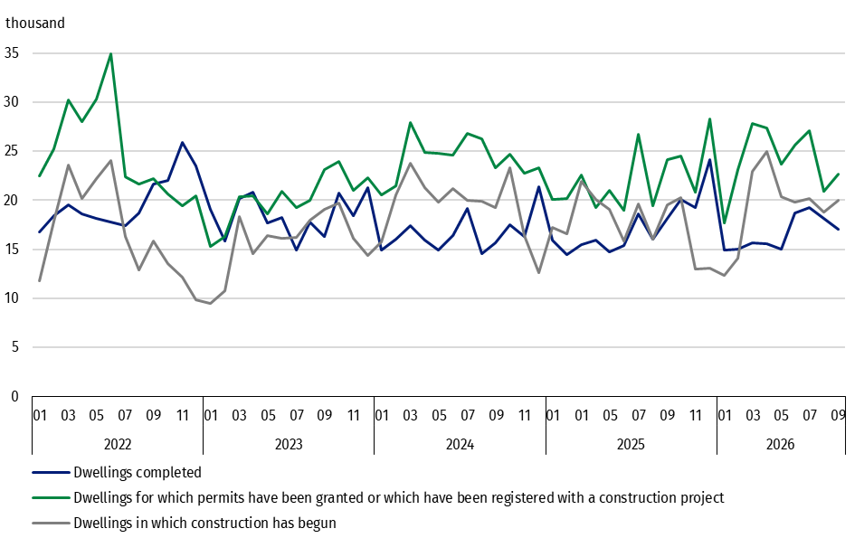
In September 2026, compared to the previous month, the number of dwellings for which permits were granted increased (by 8.6%) as well as the number of dwellings in which construction began (by 6.8%), whereas the number of dwellings completed decreased (by 6.3%)

In the period January- September 2026, the highest total number of dwellings - completed, as well as dwellings for which permits were granted and in which construction began - was recorded in Mazowieckie voivodship (29.3 thousand, 40.3 thousand and 34.1 thousand dwellings, respectively), Małopolskie (15.8 thousand, 21.2 thousand and 18.3 thousand) and Śląskie (12.6 thousand, 23.6 thousand and 14.7 thousand).

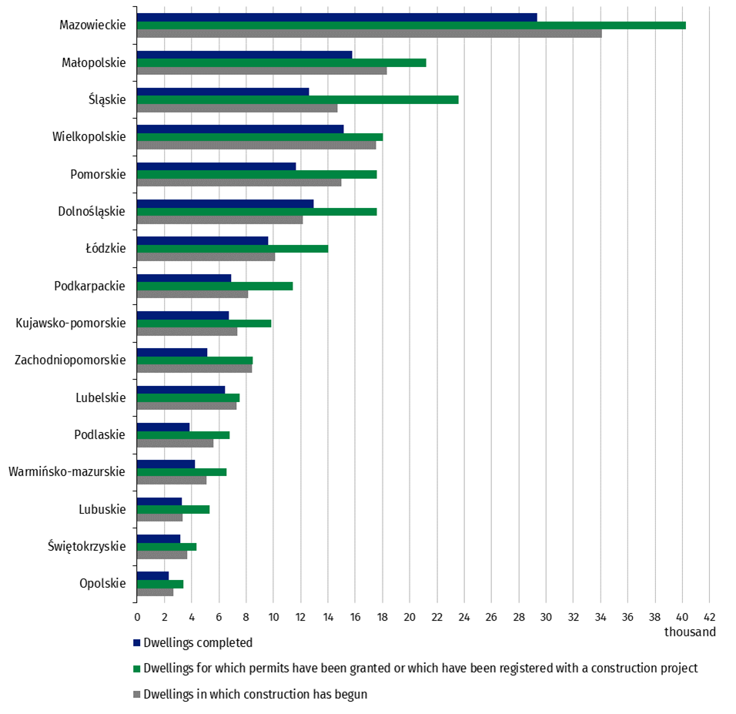
Chart 2. Residential construction by voivodships in January- September 2026

Meaning of symbols:
Dash (–) – means magnitude zero.
Dot ( . ) – means: data not available, classified data (statistical confidentiality) or providing data impossible or purposeless.

When quoting this publication, please provide its title and indicate Statistics Poland as the author. When publishing your own calculations based on data from this publication, please include the following statement: Author’s work based on data from Statistics Poland’s publication entitled ‘Residential construction in the period of January-September 2026’.
Prepared by:  Statistical Office in Lublin  Director Krzysztof Markowski, Ph.D.  Phone: (+48) 695 255 301 | Issued by:  Press Office  Mobile: (+48) 695 255 032  Phone: (+48 22) 608 38 04, (+48 22) 449 41 45,  (+48 22) 608 30 09  e-mail: obslugaprasowa@stat.gov.pl

stat.gov.pl/en/

@StatPoland

@GlownyUrzadStatystyczny

@gus_stat

@GłównyUrządStatystycznyGUS

@Glówny Urząd Statystyczny
Related information
Statistical Bulletin
Socio-economic situation of the country
Construction results
Data available in databases
Macroeconomic Data Bank
Knowledge Databases - Construction
Local Data Bank
Terms used in official statistics
Dwellings for which permits have been granted or which have been registered with a construction project
Dwellings in which construction has begun
Dwellings completed

Preliminary data.
The form of construction - “For sale or rent”.
Including registrations with a construction project and a simplified procedure for single-family residential buildings.

