Tourism satellite account in 2022
In 2022, tourism direct gross domestic product accounted for 1.8% of Poland’s GDP. Among tourism characteristic activities, accommodation (NACE division 55) made the largest contribution to tourism direct gross value added – 19.5%. Food and beverage service activities (NACE division 56) also accounted for a substantial share – 17.4%.
1.8%
Direct contribution of tourism to
Poland’s GDP in 2022
The tourism satellite account (TSA) is a tool for determining tourism’s direct contribution to the national economy. It combines information on demand generated by tourists and same-day visitors, with data on the supply and output of goods and services purchased in connection with tourism trips. This makes it possible to determine, among other things, tourism expenditure, output, value added and tourism direct gross domestic product.

Internal tourism expenditure of tourists and same-day visitors
In 2022, internal tourism expenditure on consumption products, comprising expenditure incurred within Poland by both resident visitors as part of domestic tourism and non-residents as part of inbound tourism, amounted to PLN 111.2 billion. Residents accounted for the larger share – PLN 72.3 billion (65.0%). Non-residents’ expenditure stood at PLN 38.9 billion (35.0%).
Internal tourism expenditure was dominated by tourists, i.e. persons making at least one overnight stay during a trip. Their expenditure totalled PLN 83.1 billion (74.7%), while same-day visitors (i.e. persons not staying overnight) spent PLN 28.1 billion (25.3%).
Of residents’ expenditure, PLN 61.0 billion related to domestic trips, while PLN 11.3 billion was spent in Poland in connection with outbound trips. On domestic trips, tourists spent PLN 52.8 billion and same-day visitors PLN 8.1 billion. For outbound trips, expenditure incurred in Poland amounted to PLN 8.6 billion and PLN 2.7 billion, respectively.
Among non-residents visiting Poland, tourists spent PLN 21.6 billion (55.6% of non-residents’ expenditure), while same-day visitors spent PLN 17.3 billion (44.4%). This means that, amongst non-residents visiting Poland, the share of expenditure by same-day visitors was substantially higher than the share of same-day visitors’ expenditure in total internal tourism expenditure, which stood at 25.3%.

Chart 1. Internal tourism expenditure in 2022 by visitor group
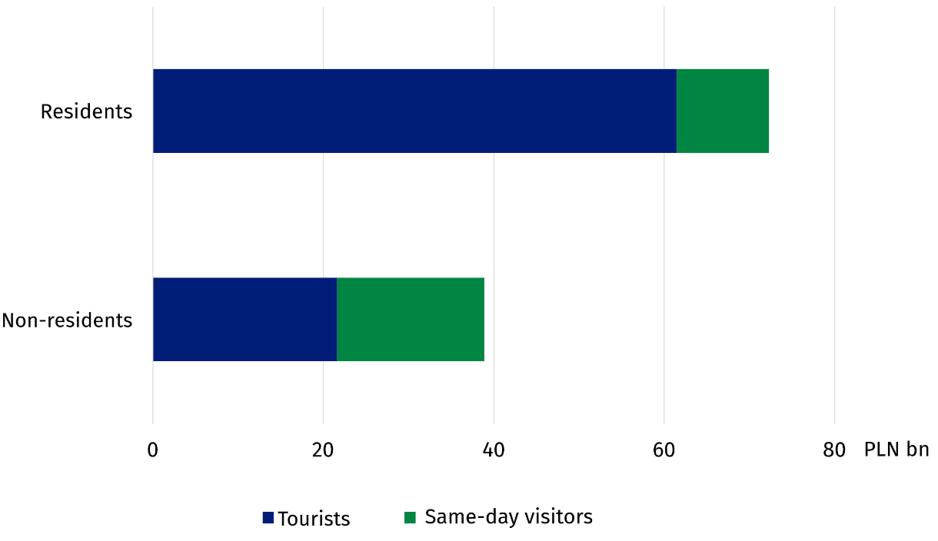
Tourism consumption
Internal tourism consumption in 2022 amounted to PLN 120.2 billion. It comprised expenditure of PLN 111.2 billion (92.5%) incurred in Poland by resident and non-resident visitors, and other components of tourism consumption, which totalled PLN 9.0 billion (7.5%).
Tourism characteristic products accounted for the largest share of internal tourism consumption, with a consumption value of PLN 71.9 billion (59.8% of the total). This amount comprised PLN 62.9 billion in tourism expenditure and PLN 9.0 billion in other components of tourism consumption. Consumption of other consumption products stood at PLN 48.3 billion (40.2%).
Among tourism characteristic products, consumption of accommodation services was the largest, at PLN 23.0 billion (19.1% of total tourism consumption), followed by food and beverage serving services, at PLN 20.5 billion (17.0%). Consumption of passenger transport services totalled PLN 11.9 billion (9.9%). Within this group, road transport recorded the highest value – PLN 4.4 billion, followed by rail transport – PLN 3.8 billion, and air transport
– PLN 3.1 billion.
Among tourism characteristic products, accommodation services accounted for the highest consumption value, amounting to PLN 23.0 billion
Consumption of travel agency and other reservation services amounted to PLN 6.4 billion (5.3%). Passenger transport equipment rental services accounted for PLN 2.8 billion (2.3%). Consumption of cultural services reached PLN 3.6 billion (3.0%), while that of sports and recreational services amounted to PLN 1.6 billion (1.3%).

Chart 2. Internal tourism consumption in 2022 by product
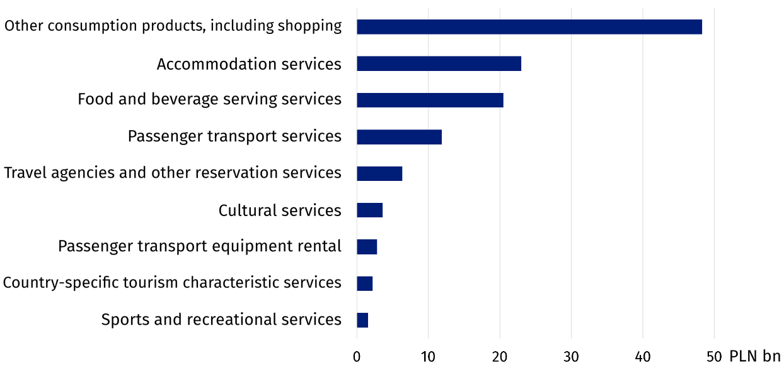

Output and gross value added of tourism-related industries
In 2022, output in the national economy amounted to PLN 6,765.5 billion, while intermediate consumption, comprising the value of goods and services used in production, totalled PLN 3,999.2 billion. As a result, gross value added stood at PLN 2,766.2 billion.
Output in characteristic tourism industries accounted for 3.4% of the total gross output of the national economy
Output in tourism characteristic activities amounted to PLN 227.5 billion, representing 3.4% of output in the national economy. Food and beverage service activities recorded the highest value – PLN 65.5 billion (28.8%), followed by road passenger transport – PLN 37.1 billion (16.3%), and accommodation activities – PLN 25.3 billion (11.1%).
Output of tourism characteristic products amounted to PLN 264.9 billion, of which PLN 212.4 billion (80.2%) was produced in tourism characteristic activities and PLN 52.5 billion (19.8%) in other economic activities. The extent to which the output of individual tourism products was concentrated in their corresponding activities varied. Almost all air passenger transport services and cultural services were produced in their respective industries. For accommodation services, this share was 88.8%, and for food and beverage serving services – 86.2%. Much lower shares were recorded for travel agency and other reservation services (27.4%) and passenger transport equipment rental (40.9%). This means that a substantial share of these services was produced by entities with a different principal activity.
Intermediate consumption in tourism characteristic activities amounted to PLN 133.8 billion, while gross value added totalled PLN 93.8 billion, representing 3.4% of gross value added in the national economy. This value covers all activities of entities classified as belonging to tourism industries, regardless of whether their products were purchased by visitors or by other customers.

Chart 3. Output of tourism products in 2022
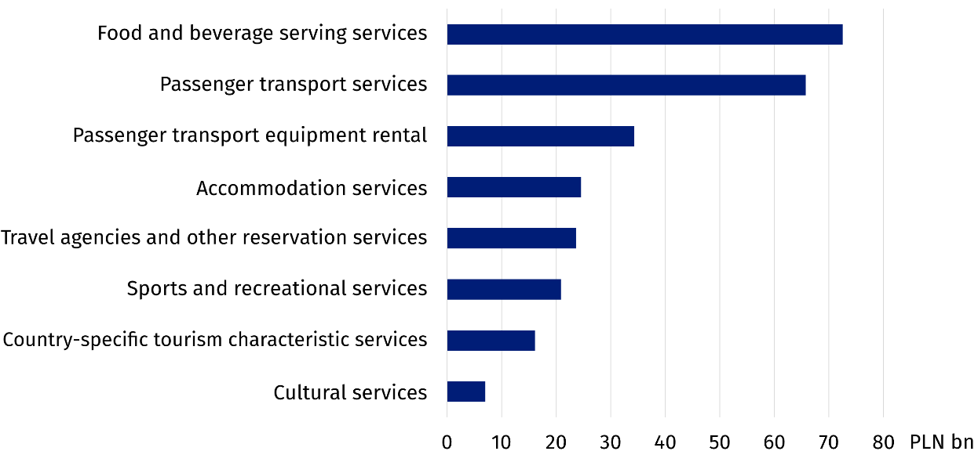
Tourism’s direct contribution to the economy
In 2022, the total domestic supply of goods and services amounted to PLN 8,981.3 billion.
It comprised domestic output, imports and taxes less subsidies on products. Internal tourism consumption stood at PLN 120.2 billion, representing 1.3% of total domestic supply.
Tourism direct gross value added, i.e. value added generated in the economy in response to internal tourism consumption, amounted to PLN 50.7 billion, equivalent to 1.8% of gross value added in the national economy. Of this amount, PLN 26.3 billion was attributable to tourism characteristic activities and PLN 24.4 billion to other economic activities.
Tourism direct gross domestic product, comprising tourism direct gross value added and taxes less subsidies on products attributable to tourism, amounted to PLN 56.2 billion. Tourism’s share of Poland’s gross domestic product, which totalled PLN 3,100.9 billion, stood at 1.8%.
Persons employed in tourism-related industries
In 2022, employees accounted for 83.1% of persons working in tourism-related industries, while self-employed persons accounted for 16.9%
In 2022, 558.6 thousand persons worked in tourism-related industries, representing 3.7% of all persons employed in Poland’s economy. Of these, 464.2 thousand (83.1%) were employees, while 94.4 thousand (16.9%) were self-employed.
Food and beverage serving services had the largest number of persons employed – 237.8 thousand (42.6% of all persons employed in tourism industries). The next largest sectors in terms of the number of persons employed were road passenger transport services – 92.7 thousand (16.6%), followed by accommodation services, with 82.0 thousand (14.7%). Sports and recreational services employed 47.6 thousand persons (8.5%), while cultural services employed
46.3 thousand (8.3%).
Women predominated among persons employed in tourism-related industries, numbering 296.4 thousand (53.1%), compared with 262.2 thousand men (46.9%). Women’s predominance was particularly evident in food and beverage serving and accommodation services, whereas men clearly predominated in passenger transport.

Chart 4. Structure of persons employed in tourism-related industries in 2022
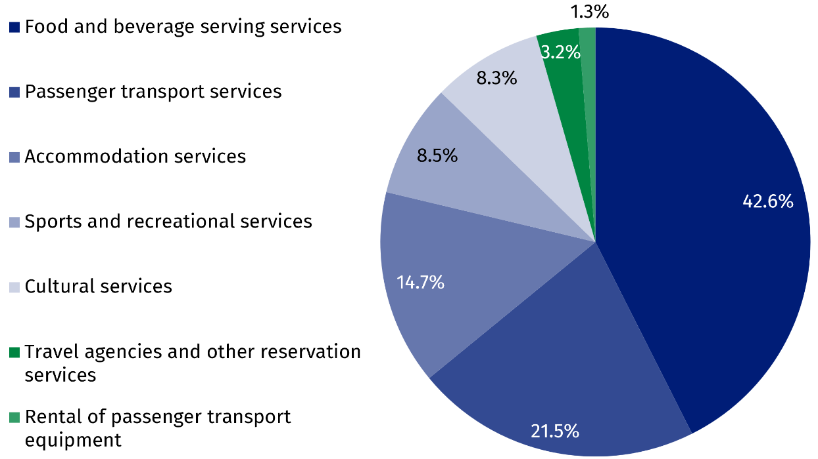
Capital expenditure
Capital expenditure in tourism characteristic activities includes expenditure by entities providing services both to visitors and to other customers. For this reason, the value of capital expenditure in tourism characteristic activities should not in itself be equated with expenditure serving tourism exclusively.
In 2022, gross fixed capital formation in tourism characteristic activities totalled PLN 24.9 billion. Of this amount, PLN 14.5 billion (58.1%) was allocated to tourism-related fixed assets, while PLN 10.4 billion (41.9%) related to other assets not directly associated with tourism.
Investment in tourism-related fixed assets was dominated by expenditure on equipment for transporting persons for tourism purposes, which amounted to PLN 11.6 billion (80.1%). The largest amounts were allocated to passenger transport equipment rental activities – PLN 7.2 billion, rail passenger transport – PLN 2.2 billion, and road passenger transport – PLN 2.0 billion. Expenditure on tourism-related non-residential buildings and other structures totalled PLN 2.3 billion. Within this group, cultural facilities recorded the highest value – PLN 0.8 billion, followed by food and beverage serving facilities – PLN 0.6 billion. PLN 0.4 billion was allocated to hotels and other accommodation establishments.

NOTE: Due to data rounding, in some cases the sum of the components may differ slightly from the reported totals.
When citing this publication, please give its title and acknowledge Statistics Poland (GUS) as the author. When publishing your own calculations based on data from this publication, please add: Own work based on data from the Statistics Poland publication “Tourism satellite account in 2022”.
Prepared by:  Statistical Office in Rzeszów  Acting Director Andżelika Malinowska  Tel.: 17 853 52 10, 17 853 52 19 | Dissemination:  Press Office  Mobile: +48 695 255 032  Landline: +48 22 608 38 04, +48 22 449 41 45,  +48 22 608 30 09  e-mail: obslugaprasowa@stat.gov.pl

stat.gov.pl

@GUS_STAT

@GlownyUrzadStatystyczny

@gus_stat

@GłównyUrządStatystycznyGUS

@Główny Urząd Statystyczny
Related publications
Tourism in 2022
Tourism Satellite Account: Recommended Methodological Framework 2008
Key terms available in the glossary
Tourist
Visitor
Same-day trip
Gross fixed capital formation
Imports of goods and services
Employed persons in the national economy
Output
Gross domestic product (GDP)
Consumption
Gross value added
Intermediate consumption

The value of Poland's gross domestic product (GDP) for 2022 was based on data published by Statistics Poland in the Statistical Bulletin No. 10/2024 (Table 2, “Gross Domestic Product”), as available in November 2024. (https://stat.gov.pl/en/topics/other-studies/informations-on-socio-economic-situation/statistical-bulletin-no-102024,4,168.html).
Value after deducting gross service charges paid to travel agencies, tour operators and other providers of reservation services.
Domestic tourism encompasses the tourist activities of residents within the reference country, as well as the domestic part of a trip abroad.
Other components of tourism consumption – the value of services used by visitors but not paid for directly, e.g. services funded by public institutions or employers.
Tourism characteristic products include services related to accommodation, food and beverage service, passenger transport, rental and leasing of motor vehicles, travel agency and tour operator services, as well as cultural activities, sports and recreational services. In the TSA for Poland, these also include health services, the organisation of trade conventions and trade shows, and service activities incidental to air transportation.
Data on the workforce relate to people who carry out work that provides them with earnings or income. These figures are presented on the basis of the principle that individuals are counted only once at their main place of work.
Tourism-related industries include accommodation services, food and beverage serving services, passenger transport services, rental of passenger transport equipment, travel agencies and other reservation services, cultural services, and sports and recreation services.

