Research and experimental development in Poland in 2024
In 2024, gross domestic expenditure on R&D (GERD) amounted to PLN 51.5 billion which is 3.1% less than in the previous year. R&D intensity indicator defining the share
of intramural R&D expenditure in GDP amounted to 1.41% (in 2023 – 1.56%). Gross domestic expenditure on R&D per capita amounted to PLN 1 370 and was smaller by 2.7% than in the previous year. The number of R&D entities decreased by 3.7% in comparison to the previous year.
1.41%
R&D intensity indicator

Table 1. Selected data on R&D
Specification | 2016 | 2017 | 2018 | 2019 | 2020 | 2021 | 2022 | 2023 | 2024
Number of entities in R&D | 4 871 | 5 102 | 5 779 | 5 863 | 6 381 | 7 370 | 7 431 | 7 549 | 7 272
Gross domestic expenditure on R&D (GERD)  in million PLN | 17 943 | 20 578 | 25 648 | 30 285 | 32 402 | 37 676 | 44 702 | 53 116 | 51 478
Relation of GERD to GDP  in % | 0.96ª | 1.03ª | 1.19ª | 1.31ª | 1.37ª | 1.42ª | 1.44ª | 1.56 | 1.41
a Data changed compared to previously published due to GDP revision.

INTRAMURAL EXPENDITURE ON RESEARCH AND DEVELOPMENT
The structure of intramural expenditure on R&D activities by type of costs was invariably dominated by current expenditure. Their share in all incurred expenditure on scientific
research and experimental development amounted to 90.5%.
Chart 1. Intramural expenditure on R&D by type of costs
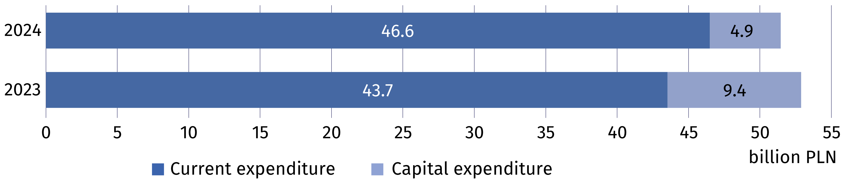
The business enterprise
expenditure on R&D (BERD) accounted for 63.3% of gross domestic expenditure on R&D (GERD)

The highest intramural expenditure on research and experimental development among
the sectors of performance was incurred by the business enterprise sector which allocated PLN 32.6 billion on conducting research and experimental development (5.0% less than
a year earlier), which accounted for 63.3% of gross domestic expenditure on R&D (in 2023 64.6%). The higher education sector accounted for 34.4% of the total domestic expenditure on R&D, the government sector for 2.1% and the private non-profit sector for 0.2% (compared to 33.4%, 1.8% and 0.2% in 2023, respectively).
Table 2. Intramural expenditure on R&D by sectors of performance
Sectors of performance | 2023 | 2024
Sectors of performance | in million PLN
Total (GERD) | 53 115.9 | 51 478.1
Business enterprise (BERD) | 34 288.7 | 32 584.7
Government (GOVERD) | 962.0 | 1 076.3
Higher education (HERD) | 17 751.4 | 17 718.9
Private non-profit (PNPERD) | 113.8 | 98.2

As in the previous years, research and experimental development in Poland was mainly
financed by the business enterprise and government sectors. In 2024, the funds from these sectors accounted for 57.8% and 35.4% of all intramural expenditure on R&D, respectively (compared to 54.8% and 31.9% in 2023).
Chart 2. Intramural expenditure on R&D by funding sectors
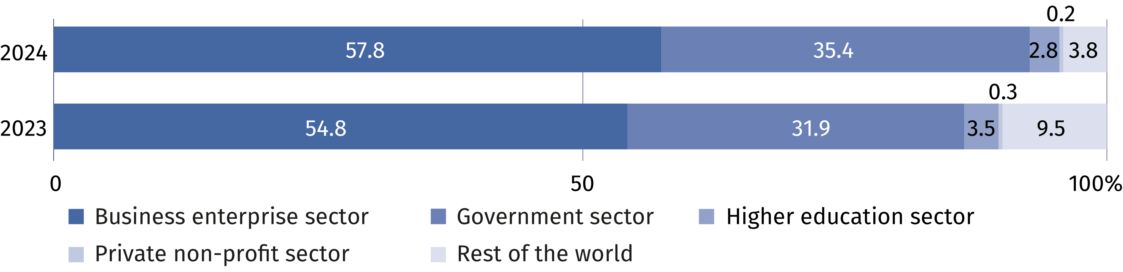

PERSONNEL IN RESEARCH AND DEVELOPMENT
Internal personnel accounted for 84.4% of R&D personnel
in FTE
The number of personnel involved in research and experimental development in 2024 amounted to 320.0 thousand persons, that is, it decreased by 1.9% less than compared
to 2023. Actual involvement of R&D personnel in research and experimental development
in full-time equivalents amounted to 198.2 thousand FTE, i.e. 0.8% less than a year earlier. R&D was mainly performed by internal personnel which accounted for 82.3% of personnel
in headcount and 84.4% – in FTE in 2024 (in 2023 these shares amounted to 81.7% and 83.7%, respectively).
Chart 3. R&D personnel by main groups
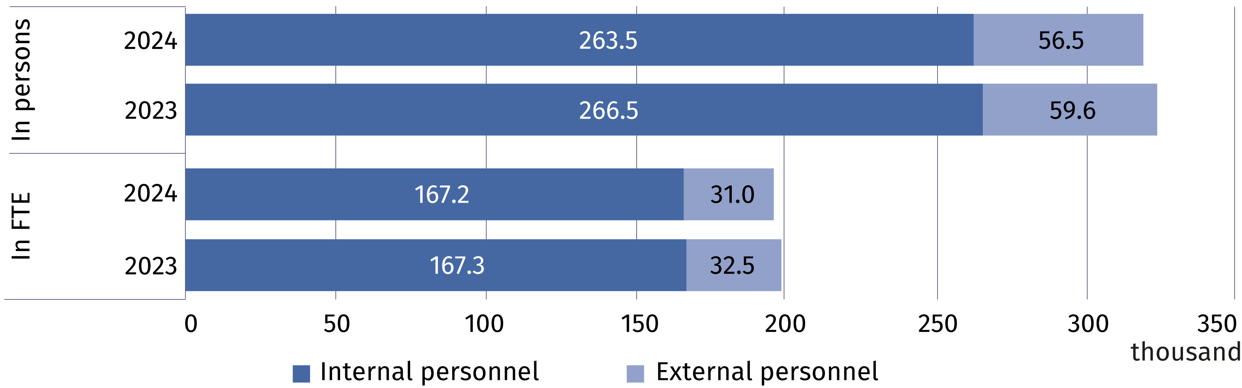

In the structure of persons engaged in research and experimental development by R&D functions, researchers consistently dominated, accounting for 69.2% of internal personnel and 68.6% of external personnel in headcount (compared to 69.1% and 68.3% in 2023). In FTE, researchers as the share of persons employed in R&D accounted for 72.9% and as the share of external contributors 69.9% (compared to 71.9% and 68.5% in 2023).
Table 3. Selected indicators on internal R&D personnel ª
Specification | 2016 | 2017 | 2018 | 2019 | 2020 | 2021 | 2022 | 2023 | 2024
per 1000 active population ^{b}
Internal R&D personnel | 6.6 | 7.1 | 7.8 | 8.1 | 8.6 | 9.0 | 9.5 | 9.4 | 9.4
of which researchers | 5.2 | 5.7 | 5.8 | 5.9 | 6.2 | 6.5 | 6.9 | 6.8 | 6.9
per 1000 persons employed ^{c}
Internal R&D personnel | 7.0 | 7.5 | 8.1 | 8.4 | 8.8 | 9.3 | 9.8 | 9.7 | 9.7
of which researchers | 5.5 | 6.0 | 6.1 | 6.1 | 6.4 | 6.8 | 7.1 | 7.0 | 7.1
a In full-time equivalents (FTE). b Active population aged 15–89 years according to the LFS – average annual data. c Persons employed aged 15–89 years according to the LFS – average annual data.

In the structure of internal R&D personnel by sectors of performance was dominated by persons employed in the business enterprise and higher education sectors. The percentage
of internal personnel in these sectors accounted for 56.2% and 41.1% of total number of internal personnel engaged in conducting research and experimental development. On an annual basis, the number of person included in internal personnel decreased by 3.0% in the business enterprise sector and by 1.3% in the higher education sector. The highest value of full-time equivalent was noted in the business enterprise sector – 103.2 thousand FTE. i.e. 1.3% less than in 2023.
Chart 4. Internal R&D personnel by sectors of performance
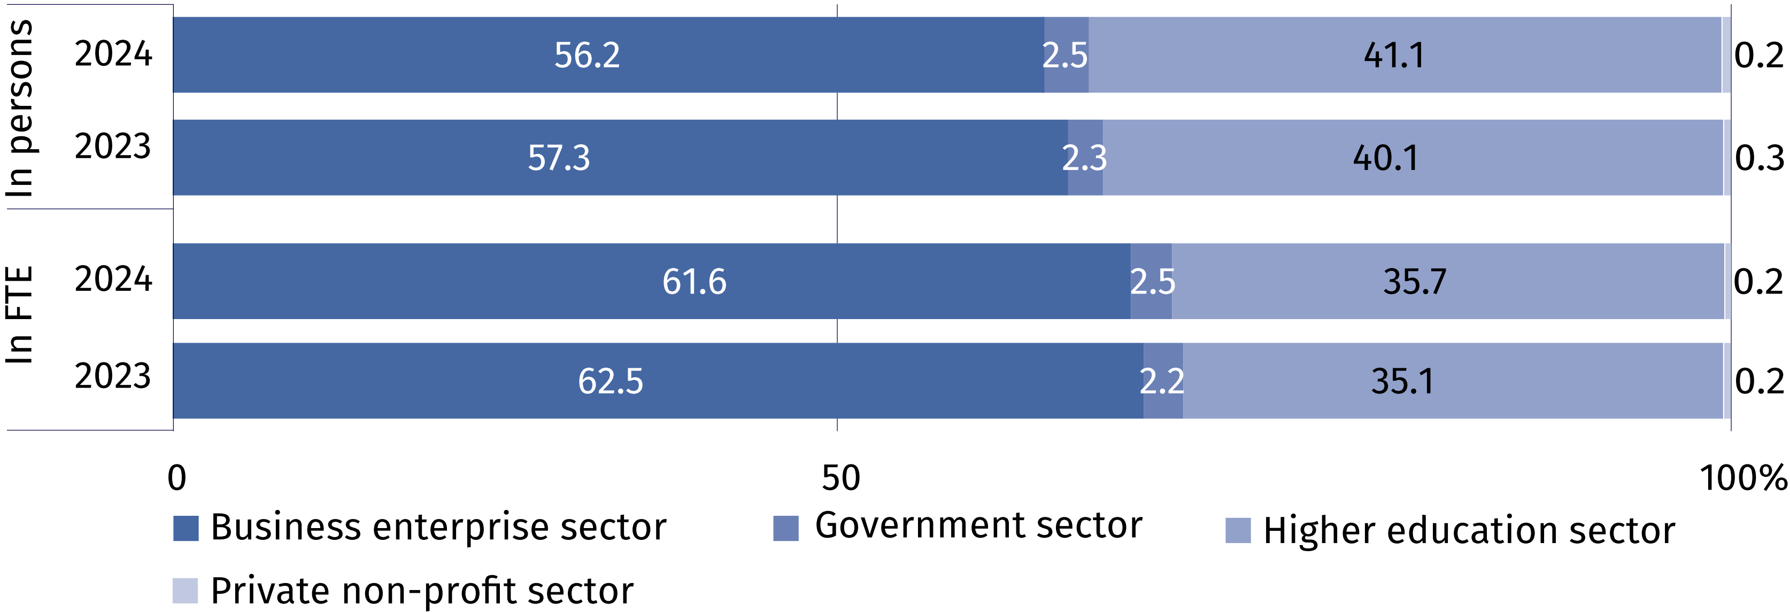

In terms of education level, persons with other higher education dominated accounting for 55.7% of internal and 66.2% of external R&D personnel. Among internal R&D personnel 32.3% of persons held at least the scientific degree of doctor (PhD) and among external personnel – 18.7%.

Table 4. R&D personnel by educational level and main groups
Specification  a – 2023  b – 2024 |  | Total | With tertiary education |  |  |  |  |  |  |  |  | Persons with other  educational level
 |  | Total | with  professor title |  | with scientific degree of |  |  |  |  | other |  | Persons with other  educational level
 |  | Total |  |  | habilitated doctor |  |  | doctor (PhD) |  |  |  | Persons with other  educational level
 |  | in headcount
Total | a | 326 075 |  | 150 94 |  | 25 167 | 55 629 |  | 188 693 |  | 41 492
Total | b | 319 966 |  | 14 956 |  | 25 218 | 55 504 |  | 184 099 |  | 40 189
Internal  personnel | a | 266 452 |  | 11 916 |  | 22 234 | 50 412 |  | 150 103 |  | 31 787
Internal  personnel | b | 263 485 |  | 11 836 |  | 22 266 | 51 026 |  | 146 714 |  | 31 643
External  personnel | a | 59 623 |  | 3 178 |  | 2 933 | 5 217 |  | 38 590 |  | 9 705
External  personnel | b | 56 481 |  | 3 120 |  | 2 952 | 4 478 |  | 37 385 |  | 8 546

When citing data from the Central Statistical Office, please include the following information: "Source of CSO data", and in the case of publishing calculations made on the data published by the Central Statistical Office, please include the following information: "Own study based on GUS data".

Prepared by:  Statistical Office in Szczecin  Director Magdalena Wegner  Phone: (+48 91) 459 77 00 | Issued by:  Press Office  Mobile: (+48) 695 255 032  Phone: (+48 22) 608 38 04, (+48 22) 449 41 45, (+48 22) 608 30 09  e-mail: obslugaprasowa@stat.gov.pl

stat.gov.pl/en/

@StatPoland

@GlownyUrzadStatystyczny

gus_stat

glownyurzadstatystycznygus

glownyurzadstatystyczny
Related information
Research and experimental development in Poland 2023
Science and technology in 2023
Methodological report. Research and experimental development
Data available in databases
Local Data Bank (BDL) – Science and Technology. Information society – Research and development
Macroeconomic Data Bank (BDM) – Research and experimental development, innovation activities
of enterprises and information society
Knowledge Databases (DBW) – Science and technology
Strateg – Statistic by theme – Research and innovation
Terms used inn official statistics
Research and experimental development (R&D)
Gross domestic expenditures on research and development (GERD)
Intramural expenditures on R&D
Basic research
Applied research
Experimental development
R&D personnel
Internal R&D personnel
External R&D personnel

