General government deficit and debt in the years 2022-2025
1 7.2%
General government deficit in 2025 in relation to GDP
In 2025 the general government deficit was equal 283 615 million PLN (7.2% of GDP), while the general government debt amounted to 2 335 137 million PLN (59.6% of GDP).

Statistics Poland presents the general government deficit and debt data for years 2022-2025 developed as part of October EDP notification.
The data have been developed in accordance with the methodology of the European System of National and Regional Accounts in the European Union introduced by the Regulation (EU) No. 549/2013 of the European Parliament and of the Council of 21 May 2013 (ESA2010) with amendments and the guidelines contained in the Manual on Government Deficit and Debt, Implementation of ESA2010 (MGDD, 2022 edition).

Table 1. General government deficit and debt (million PLN)
The ratios of deficit and debt to GDP in 2025 have changed compared to the data published in April 2026, respectively:

– from -7.3% to -7.2%,
– from 59.7% to 59.6%.
These changes are mainly due to a revision of GDP data.

Specification | 2022 | 2023 | 2024 | 2025
Gross domestic product (GDP) | 3 100 850 | 3 415 274 | 3 669 531 | 3 915 394*
General government deficit/surplus | -104 475 | -177 442 | -236 562* | -283 615*
% GDP | -3.4% | -5.2% | -6.4% | -7.2%*
Central government deficit/surplus | -92 162 | -138 610 | -243 872* | -280 455*
% GDP | -3.0% | -4.1% | -6.6% | -7.2%
Local government deficit/surplus | -13 274 | -24 811 | 14 105 | 1 881*
% GDP | -0.4% | -0.7% | 0.4% | 0.0%
Social security funds deficit/surplus | 961 | -14 021 | -6 795 | -5 041*
% GDP | 0.0% | -0.4% | -0.2% | -0.1%
General government debt | 1 512 812 | 1 691 261 | 2 012 620* | 2 335 137*
% GDP | 48.8% | 49.5% | 54.8% | 59.6%*
Chart 1. General government deficit in % of GDP
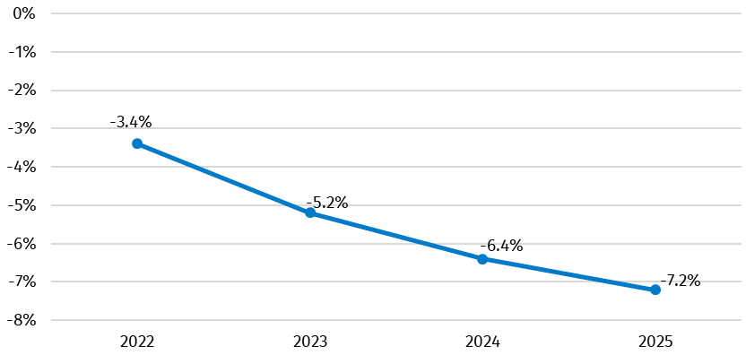

Chart 2. General government debt in % of GDP
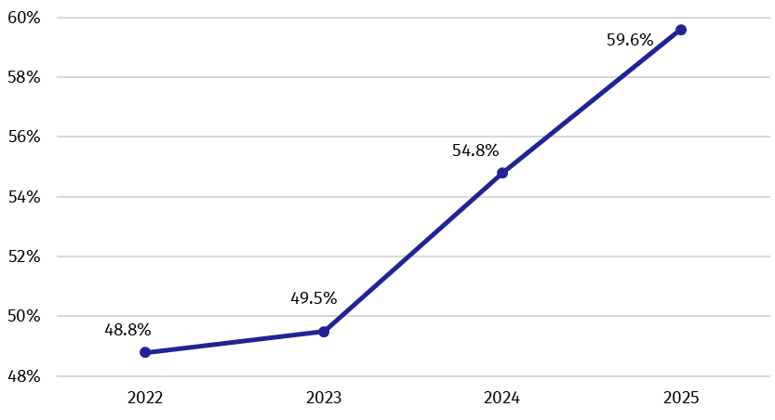
Data on the deficit and debt for the years 2022-2023 remained unchanged compared to those previously published (in April 2026). The general government deficit and debt for 2024-2025 were revised due to updated data sources and the reclassification of units into the general government sector.

Table 2. Total revenues and expenditures of the general government sector according to ESA2010 (million PLN)
Specification | 2022 | 2023 | 2024 | 2025
Total revenues | 1 236 579 | 1 422 920 | 1 569 887 | 1 707 618*
% GDP | 39.9% | 41.7% | 42.8% | 43.6%
Total expenditures | 1 341 054 | 1 600 363 | 1 806 449* | 1 991 233*
% GDP | 43.2% | 46.9% | 49.2% | 50.9%

Chart 3. Total revenues and expenditures of the general government sector in % of GDP
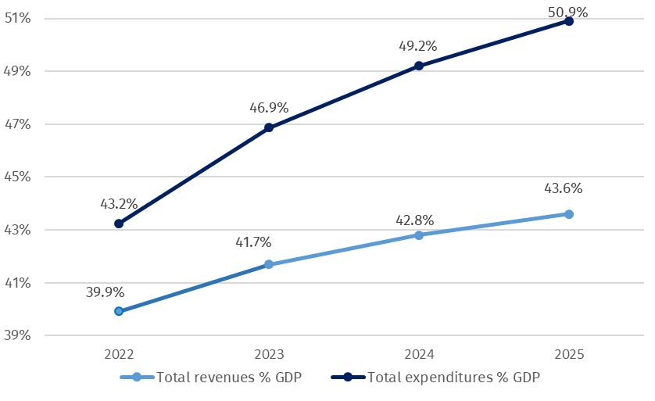

Total revenue and expenditure figures for the sector for the years 2022-2023 remained unchanged compared to those previously published (in April 2026). A minor revision to the 2024 expenditure resulted from a correction in the recording of National Recovery Plan funds and was done in the capital transfers transaction.
Detailed data on revenues and expenditures of the general government sector divided into ESA2010 transactions are presented in Annex 1.
Information on the general government deficit and debt of all EU Member States will be available on 21 October 2026 at 11 a.m. on the Eurostat website:
https://ec.europa.eu/eurostat/en/web/main/news/euro-indicators
Inventory of the methods, procedures and sources used for the compilation of deficit and debt data and the underlying government sector accounts according to ESA2010 prepared according to the European Commission’s guidelines in English version is available on Eurostat website:
http://ec.europa.eu/eurostat/web/government-finance-statistics/excessive-deficit-procedure/edp-inventories
In case of quoting Statistics Poland data, please provide information: “Source of data: Statistics Poland”, and in case of publishing calculations made on data published by Statistics Poland, please include the following disclaimer: “Own study based on figures from Statistics Poland”.

Prepared by:  National Accounts Department  Director Ewa Soroczyńska  Phone: (+48 22) 608 31 17 | Issued by:  Press Office  Mobile +48 695 255 032  Phone +48 22 608 38 04, +48 22 449 41 45,  +48 22 608 30 09  e-mail: obslugaprasowa@stat.gov.pl

stat.gov.pl/en/

@StatPoland

@GlownyUrzadStatystyczny

@gus_stat

@GłównyUrządStatystycznyGUS

@Glówny Urząd Statystyczny
Related studies
General government deficyt and debt in the years 2022-2025

Subject available in databases
Knowledge Databases – National Accounts

Important concepts available in the dictionary
Gross domestic product

* Data have been revised in relation to the previously published on 22.04.2026. The manual is available on the website: https://ec.europa.eu/eurostat/documents/3859598/16029761/KS-GQ-23-002-EN-N.pdf/77a75b07-61c3-7d34-5243-70d09bc00e44?version=3.0&t=1677163672121

