Information society in Poland 2026

Information and communication technologies usage in households and by individuals
In 2026, the percentage of individuals aged 16–74 years using artificial intelligence tools in the last 3 months amounted to 39.8%, that is, by 17.1 p.p. more than in the previous year.
39.8%
The percentage of individuals using artificial intelligence tools

In 2026, 97.2% In 2026, 96.6% of households have access to the Internet, that is, by 0.4 p.p. more than in the previous year. The percentage of households with fixed-line broadband access to the Internet increased by 1.6 p.p. to 71.9% while access via mobile broadband increased by 0.3 p.p. to 78.5%.
Chart 1. Access to the Internet in households
96.6% of households have access to the Internet
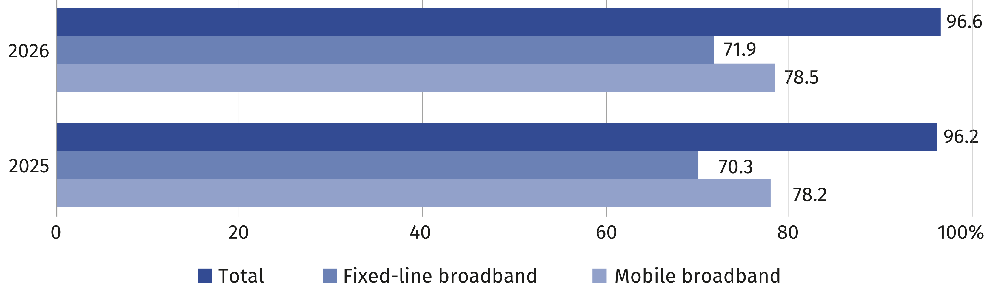

In the 2026 survey, 39.8% of individuals reported having used artificial intelligence (AI) tools in the last 3 months, that is, 17.1 p.p. more than in the previous year. The highest percentage of AI users was recorded in the youngest age group (16–24 years) – 72.5%. This percentage decreases significantly with age, reaching 9.0% among individuals aged 65–74.
Chart 2. Individuals using artificial intelligence tools by age group
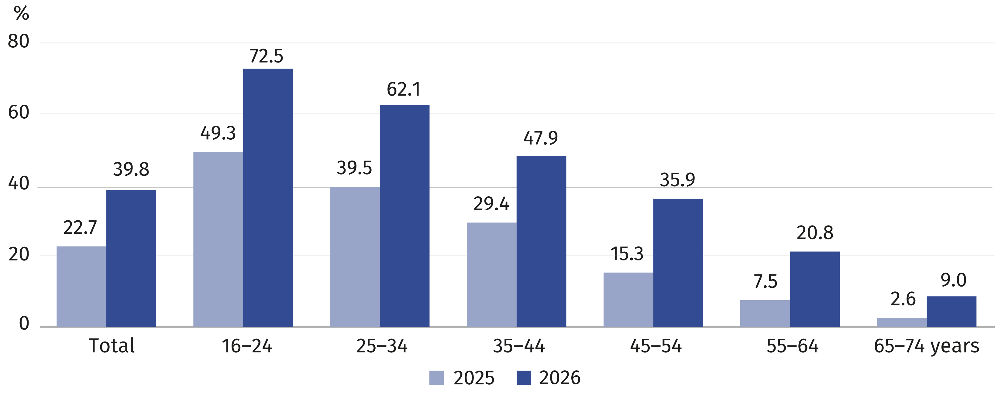

72.9% of individuals ordered or purchased goods or services over the Internet in 12 months before the 2026 survey (compared to 69.7% in 2025). Taking into account the domicile, 75.8%
of persons living in urban areas made such purchases (2.0 p.p. more than in 2025) while
in rural areas 68.6% (4.9 p.p. more than in 2025). The percentage of individuals making such purchases increased both in urban areas – by 2.0 p.p. to 75.8%, and in rural areas – by 4.9 p.p. to 68.6%. The disparity between indicators for urban and rural areas decreased from 10.1 p.p. to 7.2 p.p. Considering the territorial division of Poland into macroregions, the highest percentage of individuals purchasing over the Internet in urban areas was noted
in Mazowieckie Voivodship Macroregion (85.1%) while in rural areas – in Southwest Macroregion (79.4%). The smallest percentage of such individuals in urban areas was observed in Northwest Macroregion (71.1%) while in rural areas – in Central Macroregion (64.9%).
72.9% of individuals made purchases over the Internet
Chart 3. Individuals ordering or purchasing goods or services over the Internet for private
use in the last 12 months by macroregions and domicile
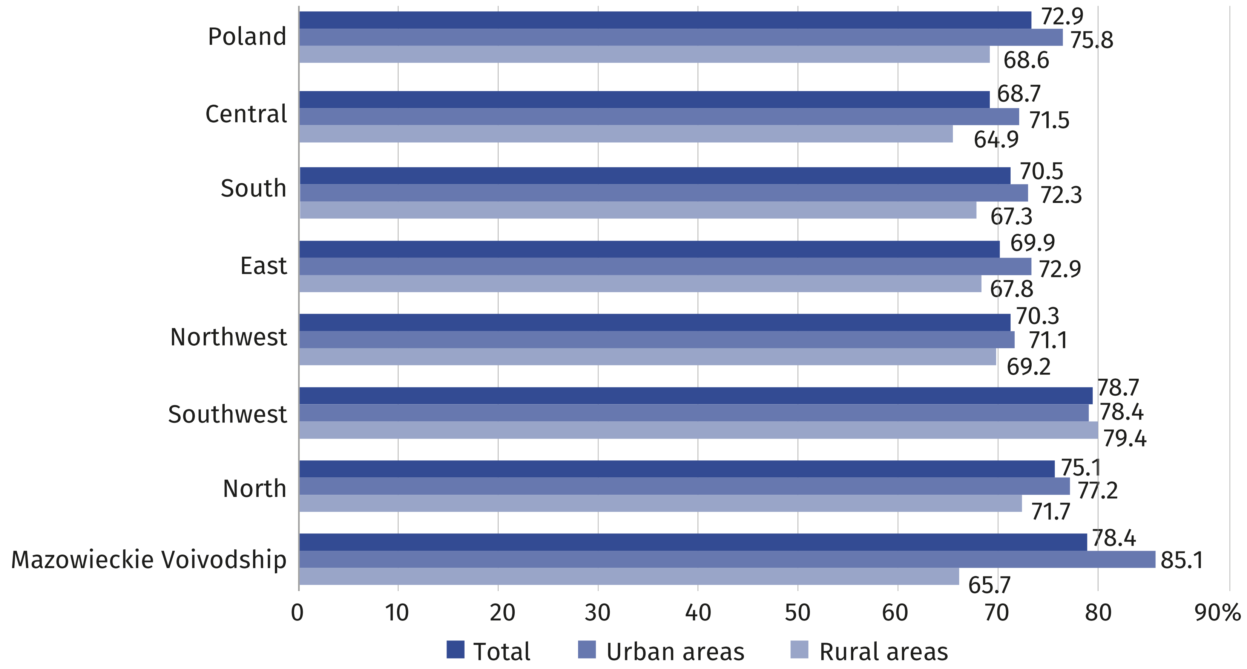
62.1% of individuals use websites or apps of public administration units
In 2026, using public administration services online in the last 12 months was declared
by 62.1% of individuals. E-government services were more popular in urban areas where 68.3% of individuals used them ( 15.5 p.p. more than in rural areas). The most frequently performed activities via the websites or applications of public administration units included sending completed tax declarations, searching for information on websites of public authorities, receiving any official communication/document by public authorities via account on a website or app as well as downloading or printing official forms.
Table 1. Individuals using e-government services by domicile and purpose of use
Specification | Total | Urban areas | Rural areas
Specification | in %
Total | 62.1 | 68.3 | 52.8
Submit tax declaration | 39.2 | 47.3 | 27.2
Obtain information | 35.3 | 40.2 | 28.0
Table 1. Individuals using e-government services by domicile and purpose of use (cont.)
Specification | Total | Urban areas | Rural areas
Specification | in %
Receive any official communication/document by public authorities via account on a website or app | 33.0 | 37.6 | 26.2
Print or download official forms | 29.9 | 33.2 | 24.9
Access personal information stored by public authorities or public services | 28.9 | 34.3 | 20.8
Request benefits or entitlements | 18.8 | 18.9 | 18.7
Make an appointment or reservation | 15.8 | 19.6 | 10.1
Access information from public databases or registers | 9.9 | 12.2 | 6.5
Request official documents or certificates | 9.0 | 11.2 | 5.7

The 2026 survey confirms that the digital skills of Polish residents depend on their age. The highest percentage of individuals with basic or above basic digital skills remains within the age group 25–34 years (82.6%), the lowest share among persons aged 65–74 (22.8%). Digital skills are more widespread across all age groups than in 2025. The biggest increase
of persons with basic or above basic digital skills in comparison to the previous year was reported among persons aged 55–64 – by 16.8 p.p.
Chart 4. Individuals with basic or above basic digital skills by age group
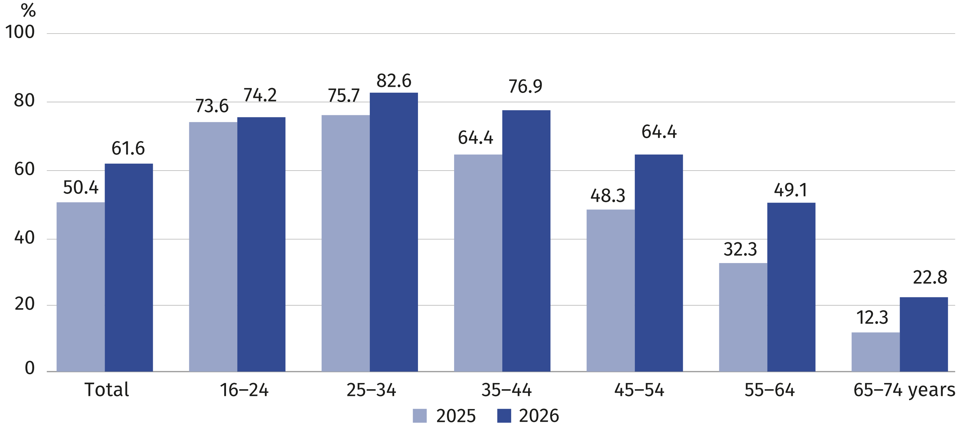

Information and communication technologies usage in enterprises
Compared to 2025, the percentage of enterprises purchasing cloud computing services increased by 3.3 percentage points — to 58.6% in 2026. Over one-quarter of enterprises employ ICT specialists.
17.8%
The percentage of enterprises using artificial intelligence technologies

28.2% of enterprises pay for online advertising

According to ICT usage in enterprises survey in 2026, 98.7% of enterprises have Internet access, including 92.8% with a fixed broadband connection. Furthermore 60.3% of employees hve access to the Internet.
The survey revealed that 70.7% of businesses have their own website, while 48.6%
of enterprises use social media.
Cloud computing services are purchased by 58.6% of enterprises, including e-mail – 41,5%, file storage – 36,4% and office software – 35.8%
Chart 5. Enterprises buying cloud computing services (% of total enterprises)
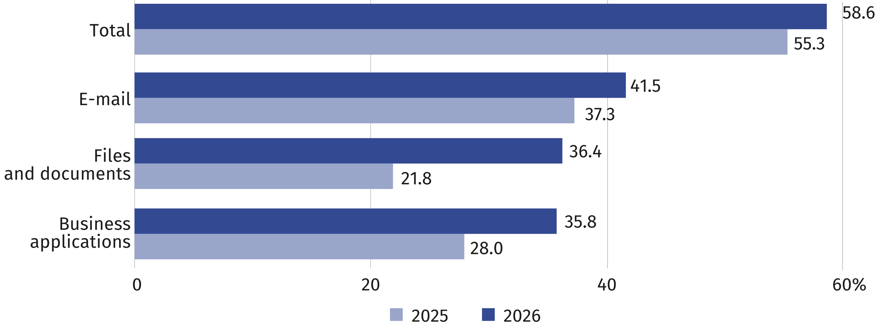
Compared to 2025, the share of enterprises using artificial intelligence technologies has doubled (an increase of 9.1 percentage points, reaching 17.8%), including technologies that generate images, sound, or video (up by 7.0 percentage points to 9.9%) and technologies that generate text or voice (up by 4.4 percentage points to 9.7%).
Artificial intelligence is most frequently used in marketing or sales (by 11.1% of enterprises). It also supports office tasks and management processes related to decision-making (used
by 9.6% of enterprises).
Chart 6. Enterprises using artificial intelligence technologies (in % of total enterprises)
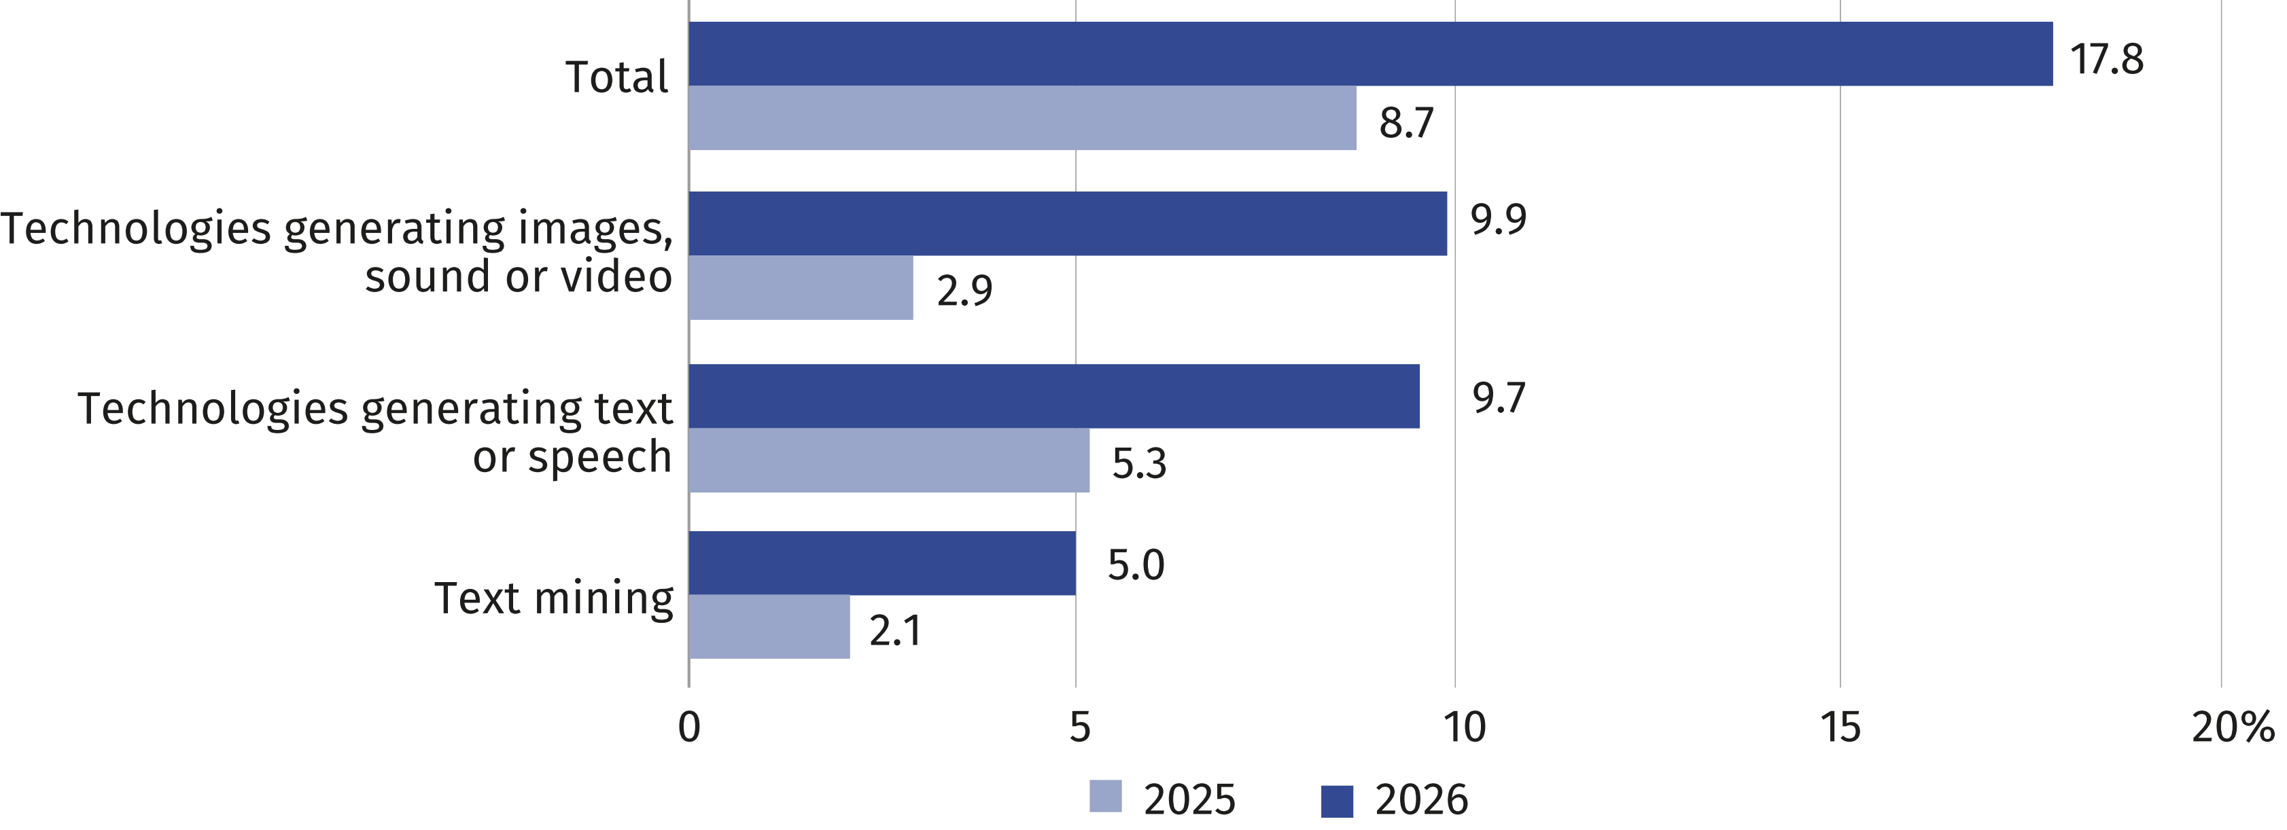
In 2026, 25.7% of enterprises employ ICT specialists. This figure varies according to the size
of the enterprise—ranging from 18.8% for businesses with 10–49 persons employed to 87.7% for those with 250 or more persons employed.
25.8% of enterprises provided
their employees with training
to enhance ICT skills in 2025
Chart 7. Enterprises employing ICT specialists (in % of total enterprises)
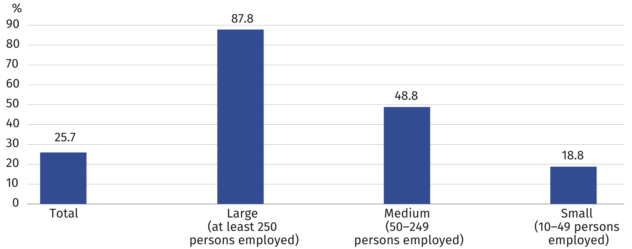
Over 91% of enterprises implement ICT security measures, the most commonly used security method is identification and authentication using a strong password (81.1%).
Chart 8. Enterprises implementing ICT security measures (in % of total enterprises)
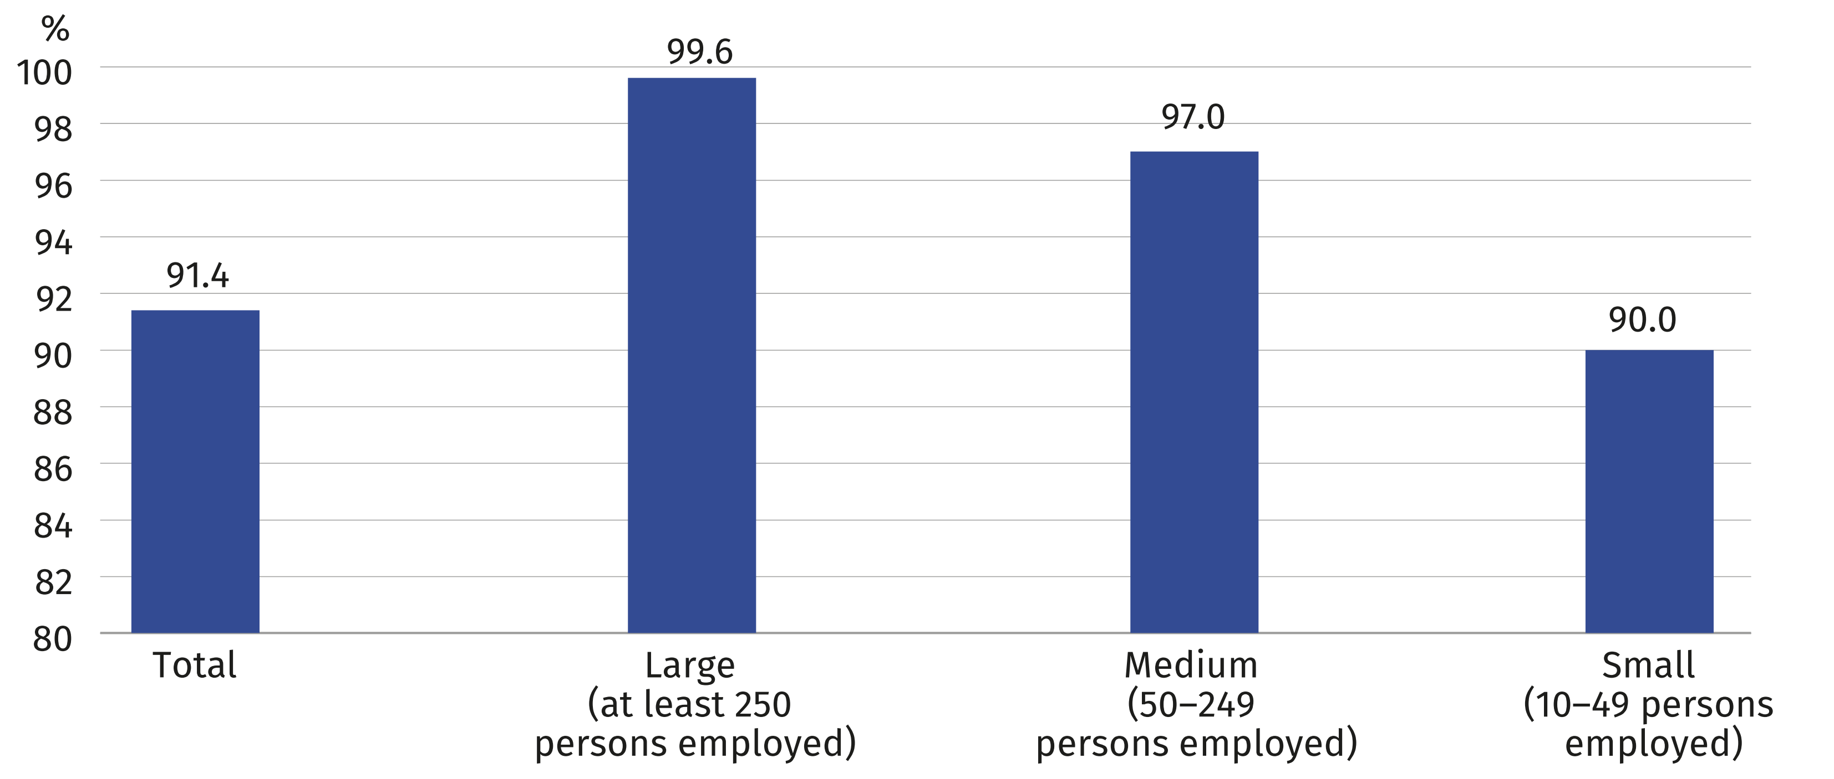
In 2026, 36.6% of enterprises have an Internet connection with a capacity of at least 500 Mb/s, that is, by 3.3 p.p. more than in the previous year. The proportion of enterprises with such
a connection remains highest among large entities (those with 250 or more persons employed). This group reached the largest increase year-on -year (by 5.1 p.p. to 63.4%).
Chart 9. Enterprises with an Internet connection with a capacity of at least 500 Mbit/s
(in % of total enterprises)
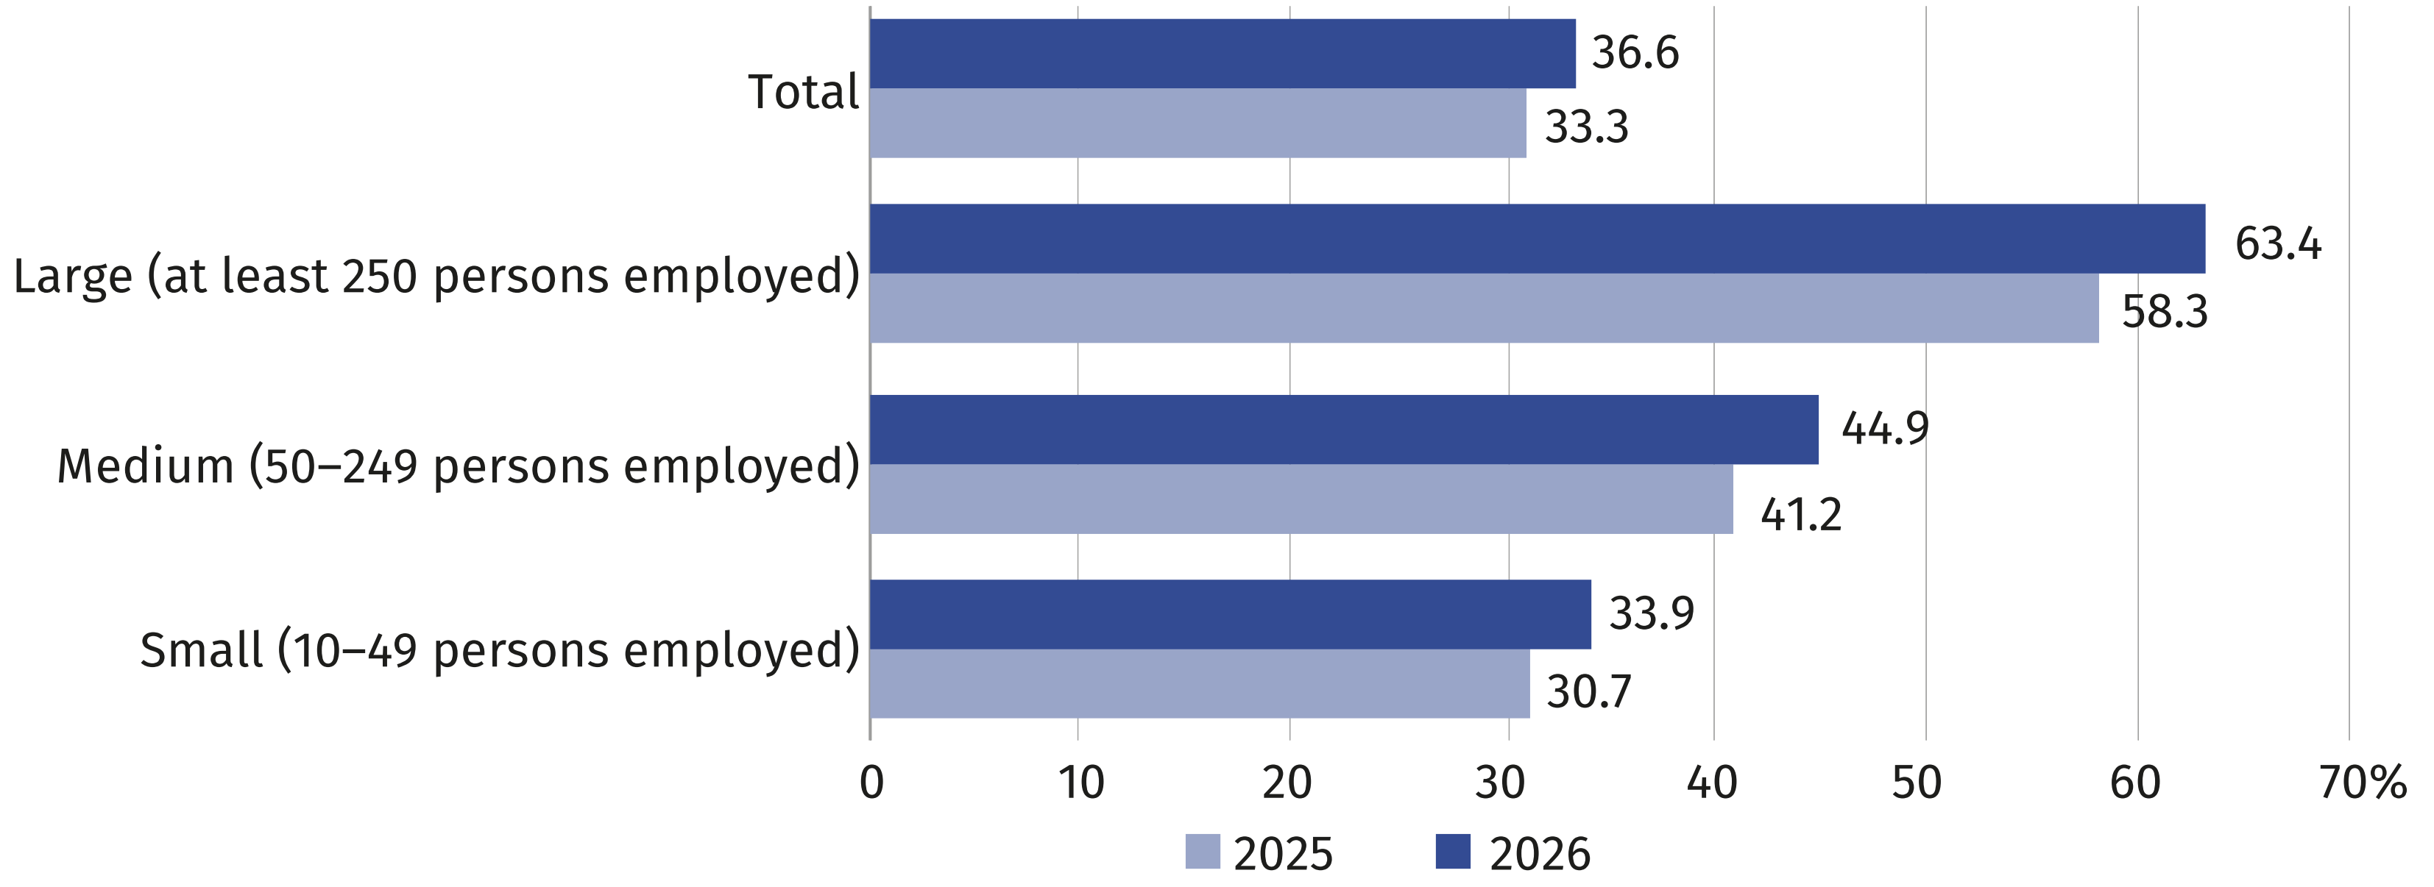
In 2025 (i.e., the year preceding the survey), 18.2% of enterprises engaged in electronic sales. One in ten companies conducted such sales via online marketplaces (10.4%) or through their own websites or applications (12.4%).

When citing this publication, please provide its title and indicate Statistics Poland (GUS) as the author. If you publish your own calculations based on data from this publication, please include the following note: "Own study based on data from the Statistics Poland (GUS) publication entitled 'Information Society in Poland in 2026'.

Prepared by:  Statistical Office in Szczecin  Director Magdalena Wegner  Phone: (+48 91) 459 77 00 | Issued by:  Press Office  Mobile: (+48) 695 255 032  Phone: (+48 22) 608 38 04, (+48 22) 449 41 45, (+48 22) 608 30 09  e-mail: obslugaprasowa@stat.gov.pl

stat.gov.pl/en/

@StatPoland

@GlownyUrzadStatystyczny

@gus_stat

@GłównyUrządStatystycznyGUS

@Główny Urząd Statystyczny
Related information
Information society in Poland in 2025
Methodological report. Information society.
Data available in databases
Knowledge Databases – Digital economy and telecommunications
Local Data Bank – Science and technology – Information society in Poland
Terms used in official statistics
E-government
E-commerce
Internet
Broadband connection
Mobile connection to the Internet
Open data
Remote access
Information society

Concerns individuals aged 16–74.

