Prices of agricultural products in September 2026
Procurement prices of basic agricultural products increased in September 2026 in comparison with the previous month (by 0.3%), but decreased compared to the corresponding period of 2025 (by 12.6%).
12.6%
decrease in procurement prices of basic agricultural products in comparison with September 2025

Chart 1. Changes in procurement prices of basic agricultural products in relation to the previous month
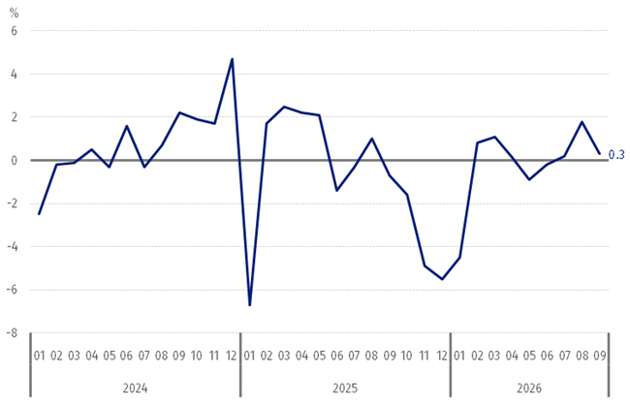
In September 2026, procurement prices of basic agricultural products increased compared to August 2026, except for animals for slaughter

Chart 2. Changes in procurement prices of basic agricultural products in relation to the corresponding month of the previous year
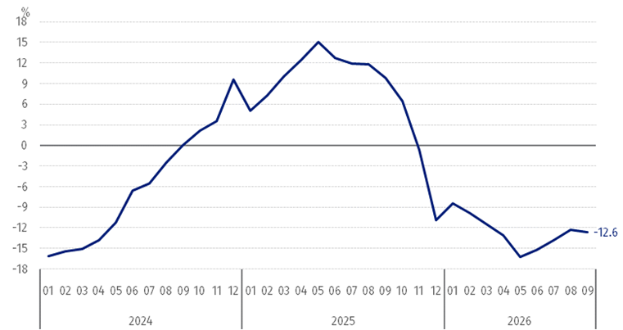
Procurement prices of basic agricultural products were lower in September 2026 than those recorded in September 2025, except for wheat and rye

Procurement prices and marketplace prices received by farmers
In September 2026, most agricultural products were sold at higher procurement prices than in the previous month and at marketplaces, more was paid for them. At both markets, prices of most cereals, while the prices of potatoes and cattle for slaughter decreased.
Compared to the corresponding month of 2025, a decrease was recorded in prices of most agricultural products in September 2026 both in procurement and at marketplaces, except for cereals (excluding maize and oat) in procurement as well as cattle for slaughter at marketplaces.

Table 1. Prices of agricultural products (excluding VAT) in September 2026
Specification | Procurement prices |  |  | Marketplace prices
Specification | in zloty | 08 2026 =100 | 09 2025 =100 | in zloty | 08 2026 =100 | 09 2025 =100
Cereal grainª – per dt
Wheat | 89.80 | 108.4 | 119.9 | 106.11 | 104.4 | 98.3
Rye | 65.73 | 106.4 | 109.7 | 81.23 | 104.8 | 93.9
Barley | 76.07 | 110.3 | 101.8 | 100.36 | 103.2 | 97.5
Triticale | 75.66 | 107.7 | 109.3 | 91.42 | 103.6 | 97.0
Oat | 56.54 | 112.6 | 96.0 | 86.26 | 103.2 | 92.1
Maize | 84.88 | 92.8 | 97.8 | 122.19 | 101.7 | 95.0
Potatoes^{b} – per dt | 44.41 | 70.6 | 80.5 | 188.19 | 94.1 | 97.9
Animals for slaughter – per kg
Cattle (excl. calves)^{c} | 13.59 | 98.0 | 84.7 | 12.14 | 99.8 | 101.8
Pigs | 5.28 | 91.5 | 81.7 | . | . | .
Poultry | 5.80 | 95.1 | 86.7 | . | . | .
Cows’ milk – per hl | 187.11 | 106.0 | 83.7 | . | . | .
a Procurement prices – excluding sowing seed. b Procurement prices – total (edible early; seed potatoes; edible late; industrial. including starchy). Marketplace prices – edible excluding early kinds. c Marketplace prices – weighted mean of price of cattle for slaughter calculated on the basis of the share of procurement quantity of young cattle and cows for slaughter.

Prices of major agricultural products in September 2026
In September 2026, PLN 89.80 was paid per dt of wheat in procurement. i.e. 8.4% more than in the previous month and 19.9% more than a year ago. At the marketplaces, the price of wheat (PLN 106.11 per dt) increased by 4.4% in comparison with August 2026, while the price decreased by 1.7% compared to September last year.
The procurement price of rye (PLN 65.73 per dt) was 6.4% higher than in August 2026 and 9.7% higher than in September 2025. The price of rye at the marketplace (PLN 81.23 per dt) increased by 4.8% on a monthly basis, but decreased by 6.1% on an annual basis.
In September 2026, PLN 44.41 was paid per dt of potatoes in procurement. i.e. 29.4% less than in the previous month and 19.5% less than in the corresponding period of 2025. At the marketplaces, the price of potatoes (PLN 188.19 per dt) decreased both in comparison with August 2026 (by 5.9%) and compared to September 2025 (by 2.1%).
The procurement price of cattle of slaughter (PLN 13.59 per kg) was 2.0% less on a monthly basis and 15.3% less on an annual basis. At the marketplaces, cattle for slaughter (PLN 12.14 per kg) were sold 0.2% less than in the previous month, but 1.8% more than a year ago.
In September 2026, PLN 5.28 was paid per kg of pigs for slaughter in procurement. i.e. 8.5% less than a month ago and 18.3% less than a year ago.
The procurement price of poultry for slaughter (PLN 5.80 per kg) decreased both compared to August 2026 (by 4.9%) as well as to the corresponding period of the previous year (by 13.3%).
PLN 187.11 was paid in procurement per hl of cows’ milk. i.e. 6.0% more than in the previous month, but 16.3% less than a year ago.

Chart 3. Procurement and marketplace prices of wheat and rye
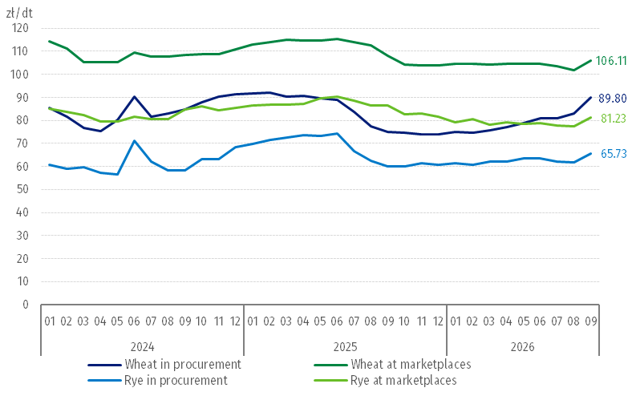

Chart 4. Procurement and marketplace prices of potatoes
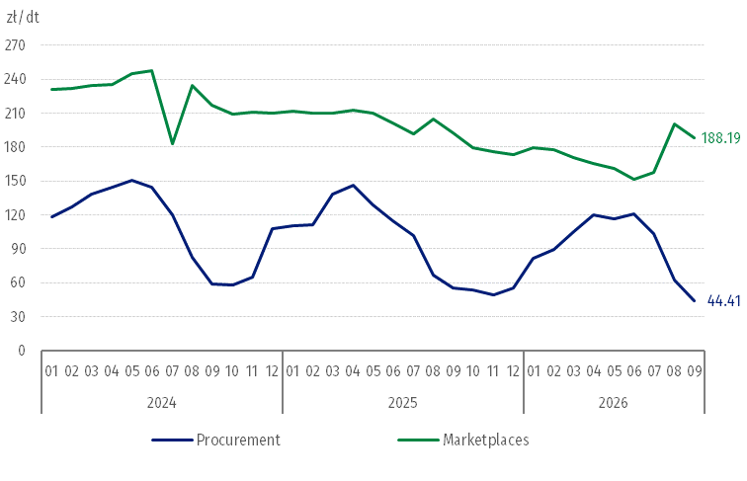

Chart 5. Procurement and marketplace prices of cattle for slaughter and procurement prices of pigs for slaughter
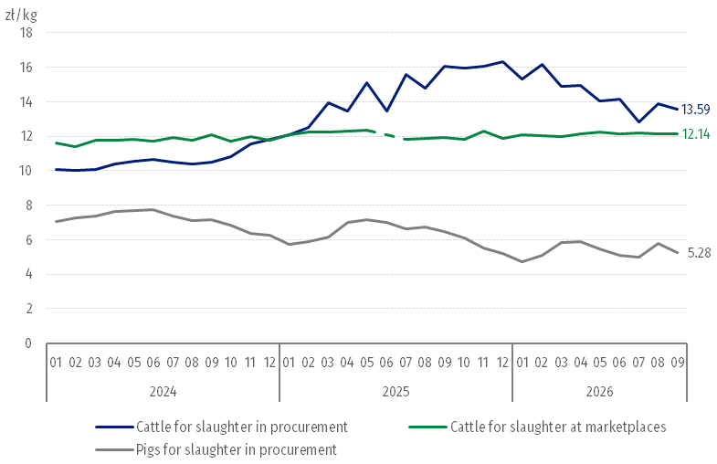

Chart 6. Procurement prices of poultry for slaughter and cows’ milk
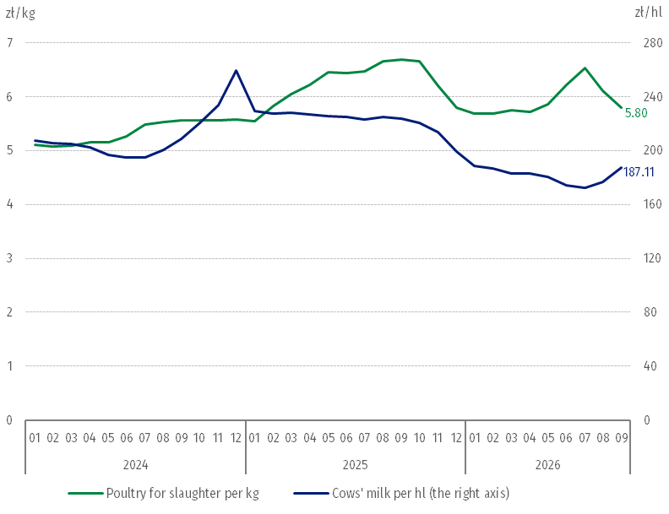
The differentiation of the level of prices of basic agricultural products in particular voivodships is presented in Table 2 for procurement prices and in Table 3 for prices obtained by farmers at marketplaces (Excel sheet).
When quoting this publication. please provide its title and indicate Statistics Poland as the author. When publishing your own calculations based on data from this publication. please include the following statement: Author’s work based on data from Statistics Poland’s publication entitled ‘Prices of agricultural products in September 2026’.

Prepared by:  Prices and Services Statistics Department  Director Ewa Adach-Stankiewicz  Phone: (+48 22) 608 31 24 | Issued by:  Press Office  Mobile: (+48) 695 255 032  Phone: (+48 22) 608 38 04. (+48 22) 449 41 45.  (+48 22) 608 30 09  e-mail: obslugaprasowa@stat.gov.pl

stat.gov.pl/en/

@StatPoland

@GlownyUrzadStatystyczny

@gus_stat

@GłównyUrządStatystycznyGUS

@Glówny Urząd Statystyczny
Related information
Socio-economic situation of the country in 2026
Procurement and prices of agricultural products in 2025
Data available in databases
BDL – Prices - Prices in agriculture
Knowledge Databases – Economy - Prices – Producer prices - Agricultural prices
Terms used in official statistics
Procurement of agricultural products
Procurement prices
Marketplace
Marketplace prices

Wheat and rye grain, animals for slaughter: cattle, pigs and poultry, cow's milk
Data on procurement prices were calculated on the basis of information on value and quantity of procurement by legal persons and independent organizational entities without legal persona-lity (excluding natural persons). Indices of procurement prices and prices received by farmers at marketplaces were calculated on the basis of absolute data expressed with more precision than in the tables.
In August 2025, the price of cattle for slaughter at marketplaces was classified as a statistical confidentiality due to the low number of quotations.

