Financial results of investment fund companies
in the first half of 2026
The value of total assets accumulated by investment fund companies at the end of June 2026 amounted to PLN 4.0 billion (PLN 3.4 billion in the previous year).
⇧ 18.4%
Increase in the value of assets of investment fund companies

The financial results achieved were better than those of the previous year.

At the end of June 2026, 54 investment fund companies (TFI) were in operation compared to 56 the previous year. They managed a total of 407 investment funds (excluding funds in liquidation).
Balance sheets of investment fund companies
Assets of investment fund companies at the end of June 2026 amounted to PLN 4,024.0 million (PLN 625.6 million more than at the end of June 2025), including current assets which increased to PLN 2,870.9 million and accounted for 71.3% of total assets. In the structure of current assets, the largest share (80.3%) was held by short-term investments, which amounted to PLN 2,305.0 million (growth of 16.2% year‑on‑year). Fixed assets accounted for 27.2% of total assets and amounted to PLN 1,096.0 million. In the structure of fixed assets, the largest share (71.4%) was held by long-term investments, which amounted to PLN 782.9 million (an increase of 26.3%).
The value of current assets of investment fund companies increased by 16.2% over the year, and fixed assets by 26.6%.
In the liabilities of investment fund companies, equity (funds) amounted to PLN 2,682.6 million (increase of 16.9% compared to the state as of 30 June 2025) and represented the largest part of the total liabilities (66.7%). The value of share capital was PLN 721.2 million (decreased by 1,2%).
The value of foreign capital in the share capital of TFI decreased to PLN 131.0 million (the share of foreign investors decreased by 3.1 pp to 18.2%). Nine investment fund companies had a share of foreign capital, of which seven exceeded 50%, one had an equal share of foreign and Polish capital (50% each), and one had a share of less than 50%.

Table 1. Selected items of the balance sheets of investment fund companies
Specification | 1st half of 2025 | 1st half of 2026
Specification | in PLN million |  | 1st half of 2025=100
Total assets: | 3 398,4 | 4 024,0 | 118,4
Fixed assets | 865,8 | 1 096,0 | 126,6
of which:
long-term investments | 619,8 | 782,9 | 126,3
Current assets | 2 471,7 | 2 870,9 | 116,2
of which:
short-term investments | 1 984,5 | 2 305,0 | 116,2
Total equity and liabilities: | 3 398,4 | 4 024,0 | 118,4
Equity capital | 2 293,9 | 2 682,6 | 116,9
of which:
share capital | 729,7 | 721,2 | 98,8
supplementary capital | 999,8 | 1 035,7 | 103,6
Liabilities and provisions for liabilities | 1 104,5 | 1 341,4 | 121,4
Profit and loss account of investment fund companies
TFI's net operating income in the 1st half of 2026 rose to PLN 0.9 billion
In the 1st half of 2026, revenues from TFI's operating activities amounted to PLN 2,606.3 million and were by 21.1% higher compared to the value recorded in the 1st half of previous year. The increase was mainly influenced by the change in revenue from the management of investment funds, value of which amounted to PLN 2,516.6 million and was higher by 19.3%. The operating costs of TFI at the end of June 2026 amounted to PLN 1,731.3 million and were higher by 10.2% compared to the corresponding period last year. In the cost structure, the main items were external services (56.0% of the value of operating costs), which increased by 12.8% and remuneration with other related expenses (17.1%), the growth of which amounted to 11.1%. The operating result of TFI in the 1st half of 2026 amounted to PLN 889.4 million and was 51.2% higher than in the 1st half of the previous year.

Chart 1. Selected financial data of investment fund companies
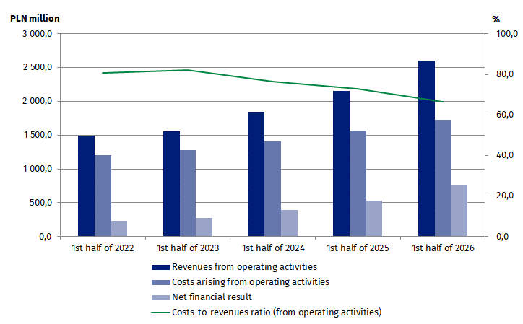
The gross financial result of TFI at the end of June 2026 amounted to PLN 951.6 million and was higher by 45.8% compared to the end of the corresponding period of previous year. The net financial result of PLN 768.8 million was made up of the profits of 47 investment fund companies with a total value of PLN 779.6 million and of the loss of 8 investment fund companies amounting to PLN 10.8 million.

Table 2. Selected items of the profit and loss account of investment fund companies
TFI's net profit in the 1st half of 2026 amounted to PLN 0.8 billion
Specification | 1st half of 2025 | 1st half of 2026
Specification | in PLN million |  | 1st half of 2025=100
Revenues from operating activities | 2 152,6 | 2 606,3 | 121,1
of which:
remunerations for managing the funds | 2 110,0 | 2 516,6 | 119,3
Costs arising from operating activities | 1 571,1 | 1 731,3 | 110,2
of which:
external services | 859,9 | 969,8 | 112,8
Gross profit | 652,7 | 951,6 | 145,8
Net profit | 526,9 | 768,8 | 145,9

When quoting Statistics Poland data, please provide the information: “Source of data: Statistics Poland”, and when publishing calculations made on data published by Statistics Poland, please include the following disclaimer: “Own study based on figures from Statistics Poland”.

Prepared by:  Enterprise Statistics Department  Director Katarzyna Walkowska-Macias  Phone: (+48 22) 608 35 66 | Issued by:  Press Office  Mobile (+48) 695 255 032  Phone (+48 22) 608 38 04, (+48 22) 449 41 45,  (+48 22) 608 30 09  e-mail: obslugaprasowa@stat.gov.pl

stat.gov.pl/en/

@StatPoland

@GlownyUrzadStatystyczny

@gus_stat

@GłównyUrządStatystycznyGUS

@Glówny Urząd Statystyczny
Related information
Financial results of investment fund companies

Data available in databases
Macroeconomic Data Bank

Terms used in official statistics
Investment fund
Investment fund company

According to the data provided by the Polish Financial Supervision Authority on 07.10.2026 the total number of investment funds at the end of June 2026 (including funds in liquidation) was 548, compared to 570 funds at the end of June 2025. The decrease in the number of funds resulted mainly from the liquidation of closed-end investment funds.
The financial data presented in this news release concern 55 investment fund companies (TFI), including one investment fund company that was liquidated in April 2026.

