Average paid employment and wages and salaries in the national economy in 2025 – final data
According to final data, the average paid employment in the national economy amounted to 11 042.2 thousand full-time equivalents and remained at a similar level to the previous year.
11.0 million full-time equivalents
Average paid employment in the national economy in 2025
Average paid employment in the national economy
Average paid employment includes full-time employees and part-time employees converted into full-time equivalents
In 2025, the largest number of full-time equivalents was concentrated in the Manufacturing section (Section C), accounting for 22.4% of total average paid employment. Compared with 2024, the average paid employment increased in most sections, with the largest increases recorded in the Other service activities section (Section S), at 3.8%, and the Real estate
activities section (Section L), at 3.0%. A decrease in the average paid employment was
recorded in six sections, with the largest decreases observed in the Mining and quarrying section (Section B) and the Trade; repair of motor vehicles∆ section (Section G), both down by 2.9%.
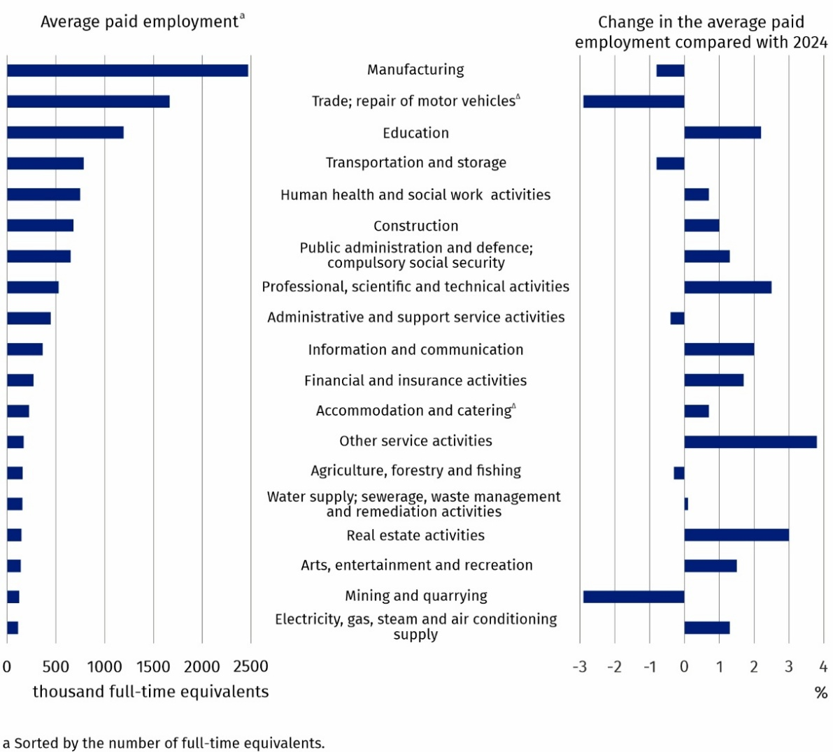
Chart 1. Average paid employment in the national economy by PKD 2007/NACE Rev. 2 section in 2025 – final data
Average monthly gross wages and salaries in the national economy
In 2025, compared with
2024, the average monthly gross wage and salary
in the national economy
increased by 8.8% in nominal terms
According to final data, the average monthly gross wage and salary in the national economy in Poland in 2025 amounted to PLN 8 872.34. Compared with 2024, it increased nominally by 8.8%. The average monthly gross wage and salary varied by PKD/NACE section, ranging from PLN 5 873.62 in the Accommodation and catering∆ section (Section I) to PLN 14 421.98 in the Information and communication section (Section J). These figures were 33.8% below and 62.5% above the national average, respectively.
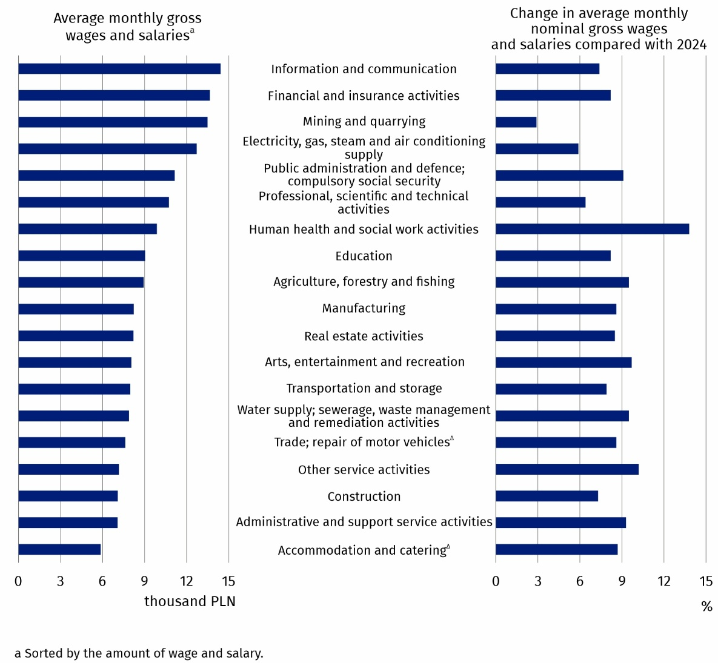
Chart 2. Average monthly gross wages and salaries in the national economy by PKD 2007/NACE Rev. 2 section in 2025 – final data
Compared with 2024, the average monthly gross wage and salary increased in all PKD/NACE sections. The highest increase, 13.8%, was recorded in the Human health and social work
activities section (Section Q), while the lowest, 2.9%, occurred in the Mining and quarrying section (Section B).
The minimum wage is the lowest wage that an employee working under an employment contract can receive,
calculated on a full-time basis
Minimum gross wage
In 2025, the minimum gross wage increased by PLN 366.00 compared with 2024 and stood
at PLN 4 666. This represented 53.2% of the average monthly gross wage and salary in the national economy, excluding annual awards.
As at 31 December 2025, 1.5 million employees were receiving a gross wage or salary not
exceeding the minimum wage, representing 11.9% of the total number of employees.
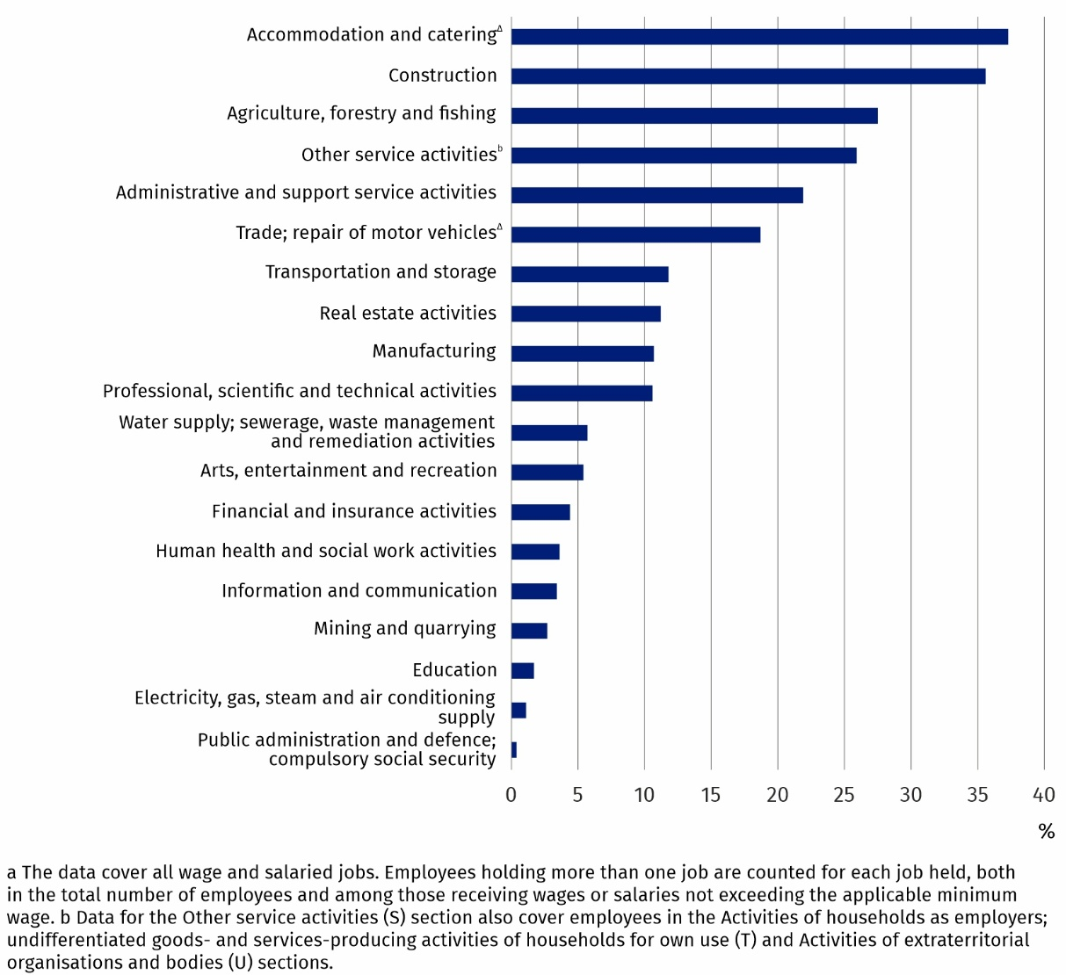
Chart 3. Share of employees receiving a gross wage or salary not exceeding the applicable
minimum wage out of the total number of employees in a given PKD 2007/NACE Rev. 2 section in December 2025
As at the end of the month
A breakdown by economic activity shows that, the highest share was recorded in the Accommodation and catering∆ section (Section I), at 37.3% of all employees working in this section, whilst the lowest was recorded in the Public administration and defence; compulsory social security section (Section O), at 0.4% of all employees working in this section.
Symbol (∆) — means that abbreviated names of NACE Rev. 2 sections were used. Full names are available on the Eurostat website at:
https://ec.europa.eu/eurostat/web/metadata/classifications
When quoting this publication, please provide its title and indicate Statistics Poland as the author. When publishing your own calculations, based on data from this publication, please include the following statement: Author’s work based on data from Statistics Poland’s publication entitled ‘Average paid employment and wages and salaries in the national economy in 2025 – final data’.

Prepared by:  Statistical Office in Bydgoszcz  Acting Director Katarzyna Klamrowska  Phone: (+48 52) 366 93 90 | Issued by:  Press Office  Mobile phone: +48 695 255 032  Landline phones: +48 22 608 38 04, +48 22 449 41 45, +48 22 608 30 09  e-mail: obslugaprasowa@stat.gov.pl

stat.gov.pl/en/

@StatPoland

@GlownyUrzadStatystyczny

@gus_stat

@GłównyUrządStatystycznyGUS

@Glówny Urząd Statystyczny
Related information
Average paid employment, wages and salaries in the national economy in 2025 – preliminary data
Methodological report. Wages and salaries in the national economy
Yearbook of Labour Statistics 2025
Other publications related to the labour market
Data available in databases
Local Data Bank -> Labour market
Strateg -> Statistics by theme -> Labour market
Knowledge Databases -> Labour market
Terms used in official statistics
Average paid employment
Average monthly gross wages and salaries

From profit sharing and from balance sheet surplus in cooperatives and extra annual wages and salaries for employees of budgetary sphere units.
The data cover all wage and salaried jobs. Employees holding more than one job are counted for each job held, both in the total number of employees and among those receiving wages or salaries not exceeding the applicable minimum wage.

