Research and experimental development in Poland in 2025
In 2025, gross domestic expenditure on R&D (GERD) amounted to PLN 58.8 billion which is 14.2% more than
in the previous year. R&D intensity indicator, which defines the share of intramural R&D expenditure in GDP, increased to 1.50% (in 2024 – 1.41%). Gross domestic expenditure
on R&D per capita amounted to PLN 1 571 and was higher
by 14.6% than in the previous year.
1.50%
R&D intensity indicator

Table 1. Selected data on R&D
Gross domestic expenditure on R&D increased by 14.2% compared to the previous year, while the number of entities decreased by 3.5%
Specification | 2020 | 2021 | 2022 | 2023 | 2024 | 2025
Number of entities in R&D | 6 381 | 7 370 | 7 431 | 7 549 | 7 272 | 7 018
Gross domestic expenditure on R&D (GERD) in million PLN | 32 402 | 37 676 | 44 702 | 53 116 | 51 478 | 58 763
Relation of GERD to GDP (in %) | 1.37 | 1.42 | 1.44 | 1.56 | 1.41 | 1.50

Intramural expenditure on research and development
The structure of intramural expenditure on R&D activities by type of costs was invariably dominated by current expenditure. They accounted for 89.7% of all gross domestic expenditure incurred on research and development projects.
Chart 1. Intramural expenditure on R&D by type of costs
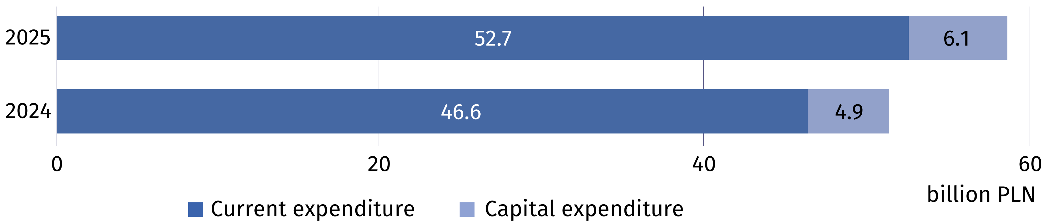
The business enterprise
expenditure on R&D (BERD) accounted for 64.9% of gross domestic expenditure on R&D (GERD)

The business enterprise sector was the performing sector with the highest level of intramural R&D expenditure. In 2025, it spent PLN 38.2 billion for this purpose (17.1% more than
a year earlier), which constituted 64.9% of the gross domestic expenditure on R&D activities (in 2024 – 63.3%). The higher education sector accounted for 32.8% of the total domestic
expenditure on R&D (compared to 34.4% in 2024), the government sector for 2.2% (respectively 2.1%) and the private non-profit sector for 0.1% (respectively 0.2%).

Table 2. Intramural expenditure on R&D by sectors of performance
Sectors of performance | 2024 | 2025
Sectors of performance | in million PLN
Total (GERD) | 51 478.1 | 58 763.2
Business enterprise sector (BERD) | 32 584.7 | 38 155.1
Government sector (GOVERD) | 1 076.3 | 1 271.7
Higher education sector (HERD) | 17 718.9 | 19 251.1
Private non-profit sector (PNPERD) | 98.2 | 85.3
As in the previous years, research and experimental development in Poland was mainly
financed by the business enterprise and government sectors. In 2025, the funds from these sectors accounted for 58.8% and 32.7% of total gross domestic expenditure on R&D (compared to 57.8% and 35.4%, respectively, in 2024).
Chart 2. Intramural expenditure on R&D by funding sectors
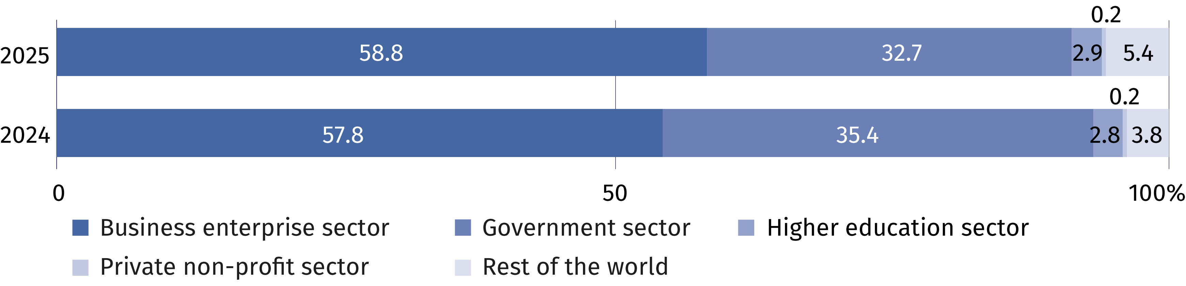

Personnel in research and development
Internal personnel accounted for 83.9% of R&D personnel
in FTE
The number of personnel involved in research and experimental development in 2025 amounted to 329.1 thousand persons, that is, it increased by 2.9% more than compared
to 2024. Actual involvement of R&D personnel in research and experimental development
in full-time equivalents amounted to 206.7 thousand FTE, i.e. 4.3% more than a year earlier. R&D was mainly performed by internal personnel which accounted for 82.2% of personnel
in headcount and 83.9% – measured in FTE (in 2024 these shares amounted to 82.3% and 84.4%, respectively).
Chart 3. R&D personnel by main groups
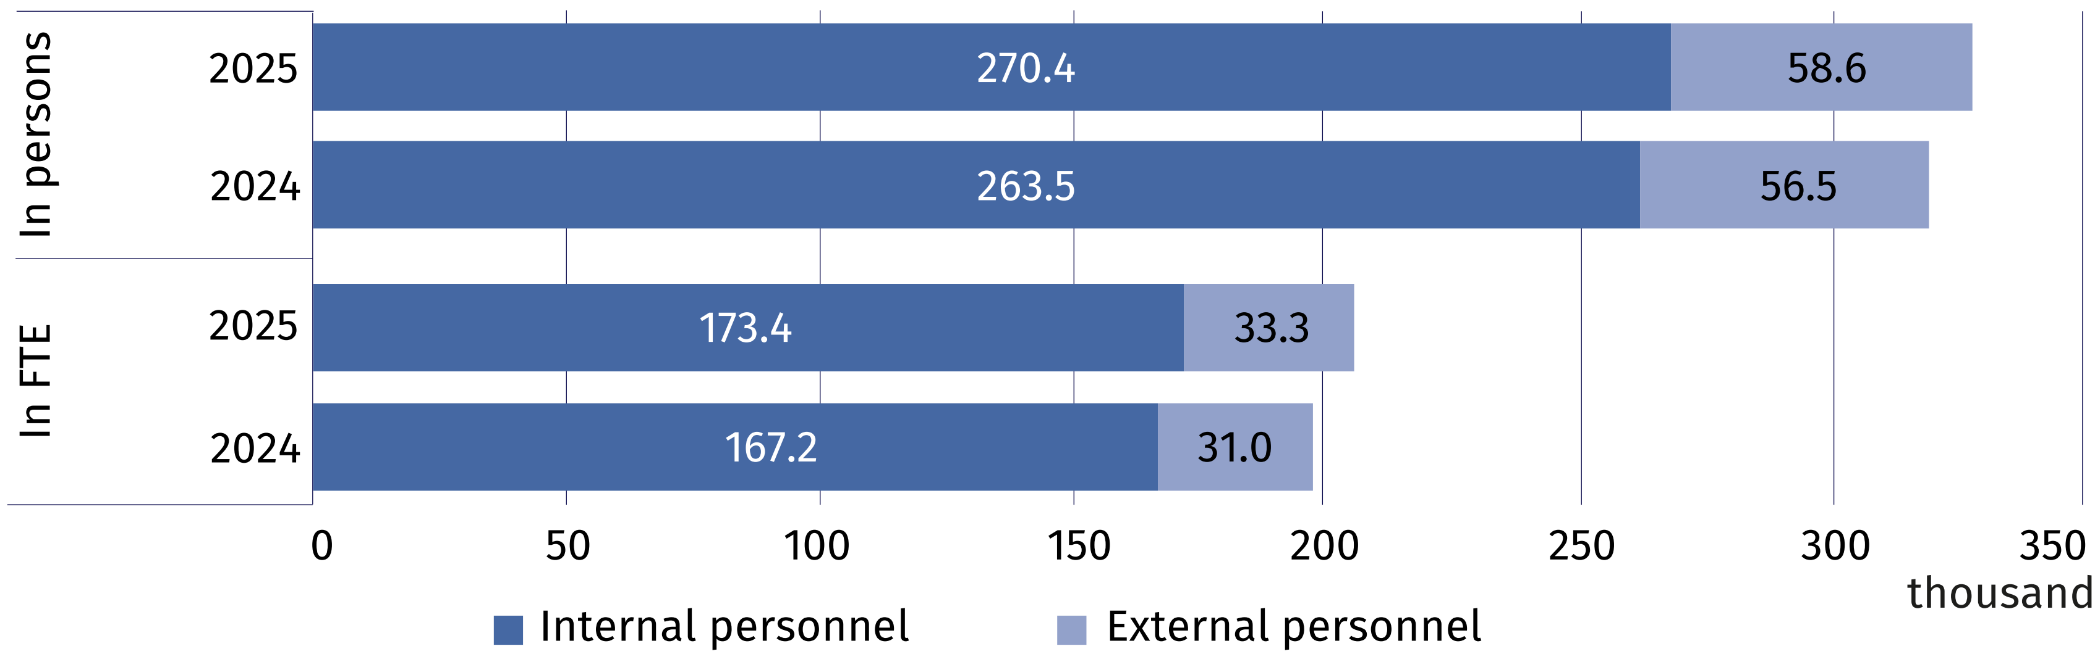

In the structure of persons engaged in research and experimental development by R&D functions, researchers consistently dominated. Accounting for 69.6% of internal personnel and 68.3% of external personnel in headcount (compared to 69.2% and 68.6% in 2024).
In FTE, researchers as the share of persons employed in R&D accounted for 73.5% and as the share of external contributors 68.6% (compared to 72.9% and 69.9% in 2024).
In the structure of internal R&D personnel by sectors of performance was dominated by persons employed in the business enterprise and higher education sectors. The highest value
of full-time equivalent was noted in the business enterprise sector – 108.6 thousand FTE. i.e. 5.2% more than in 2024.
Chart 4. Internal R&D personnel by sectors of performance
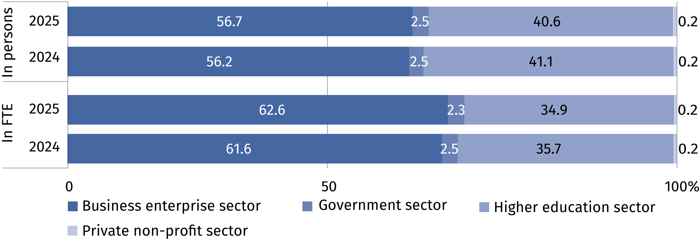

When citing this publication, please provide its title and indicate Statistics Poland (GUS) as the author. If you publish your own calculations based on data from this publication, please include the following note: "Own study based on data from the Statistics Poland (GUS) publication entitled “Research and experimental development in Poland in 2025."

Prepared by:  Statistical Office in Szczecin  Director Magdalena Wegner  Phone: (+48 91) 459 77 00 | Issued by:  Press Office  Mobile: (+48) 695 255 032  Phone: (+48 22) 608 38 04, (+48 22) 449 41 45, (+48 22) 608 30 09  e-mail: obslugaprasowa@stat.gov.pl

stat.gov.pl/en/

@StatPoland

@GlownyUrzadStatystyczny

@gus_stat

@GłównyUrządStatystycznyGUS

@Główny Urząd Statystyczny
Related information
Research and experimental development in Poland 2024
Science and technology in 2024
Methodological report. Research and experimental development
Data available in databases
Local Data Bank (BDL) – Science and Technology. Information society – Research and development
Macroeconomic Data Bank (BDM) – Research and experimental development, innovation activities
of enterprises and information society
Knowledge Databases (DBW) – Science and technology
Strateg – Statistic by theme – Research and innovation
Terms used inn official statistics
Research and experimental development (R&D)
Gross domestic expenditures on research and development (GERD)
Intramural expenditures on R&D
Basic research
Applied research
Experimental development
R&D personnel
Internal R&D personnel
External R&D personnel

