Budgets of local government units in Opolskie Voivodship in 2025

In 2025, budgets of local government units in Opolskie Voivodship collectively closed with a surplus. It was achieved by all kinds of local government units, excluding city with powiat status. On annual scale, there was an increase in own revenue, while grants and general subsidies decreased. Current and capital expenditure was higher than in the year before.
+PLN 4.5 million
The result of budgets of local government units in 2025
In 2025, revenue of local government units in Opolskie Voivodship amounted to PLN 11117.7 million and increased by 3.3% in comparison with the previous year. Revenue per capita amounted to PLN 11995, i.e. higher by 4.0% than in 2024. Over a half of the total revenue was achieved by gminas (59.4%), of which mostly urban-rural (37.3%).
Table 1. Revenue of budgets of local government units
Specification | 2024 | 2025
Specification | in million PLN |  | 2024=100 | in percentage
T o t a l | 10765.4 | 11117.7 | 103.3 | 100.0
Total gminasª | 6529.3 | 6602.1 | 101.1 | 59.4
urban | 706.6 | 726.3 | 102.8 | 6.5
urban-rural | 4186.6 | 4143.9 | 99.0 | 37.3
rural | 1636.1 | 1731.8 | 105.8 | 15.6
Powiats | 1765.3 | 1907.3 | 108.0 | 17.2
City with powiat status – Opole | 1530.6 | 1659.3 | 108.4 | 14.9
Voivodship | 940.1 | 949.1 | 101.0 | 8.5
a Excluding revenue of gmina which is also city with powiat status.
In relation to 2024, significant changes in the level of own revenue and general subsidies were observed, resulting from change of rules of financing local budgets. Traditional general subvention was limited, and in exchange, considerably higher, more stable shares in PIT and CIT taxes were granted to local governments, resulting in an increase of own revenue.
In 2025, rules of financing local governments units changed.
The main source of revenue of local government units is own revenue – in 2025 it amounted to PLN 7311.2 million and compared to the previous year increased by 49.3%.
Grants amounted to PLN 2432.1 million and on a yearly basis decreased by 7.9%. In total grants, PLN 418.4 million were grants provided under programmes financed with the participation of EU funds and other non-returnable foreign funds, as well payments from the budget of European funds (paragraphs 200 and 620, as well as 205 and 625), which, in relation to 2024, increased by 42.4%.
General subvention from the state budget compared to the previous year decreased by 57.4% and was at the level of PLN 1374.5 million.
The largest share of own revenue in total revenue was recorded respectively in the budget of city with a powiat status (77.4%). In the meantime, grants and general subvention supplied budget of local government of the voivodship by largest margin (26.8% and 30.0%, respectively).
Chart 1. Revenue and expenditure of budgets of local government units by type in 2025
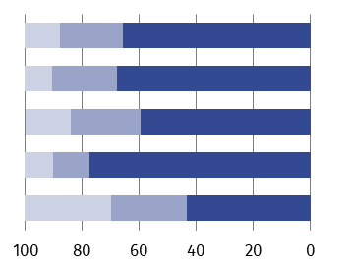
REVENUE EXPENDITURE
% | Total  Gminasª  Powiats  City with powiat status  Voivodship | 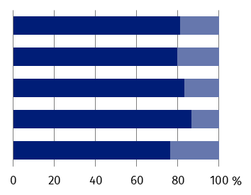
Current expenditure
Own revenue
Grants
General subsidies
Property expenditure

a Excluding revenue and expenditure of gmina which is also city with powiat status.
Over 1/3 of expenditure of budgets of local government units was incurred by urban-rural gminas
In 2025, expenditure of budgets of local government units amounted to PLN 11113.2 million and compared to the previous year increased by 4.4%. Expenditure per capita amounted to PLN 11990, i.e. higher by 5.1% than in 2024. Most of total expenditure was incurred by gminas (59.0%), of which mostly urban-rural (37.1%).
Table 2. Expenditure of budgets of local government units
Specification | 2024 | 2025
Specification | in million PLN |  | 2024=100 | in percentage
T o t a l | 10647.0 | 11113.2 | 104.4 | 100.0
Total gminasª | 6438.6 | 6561.1 | 101.9 | 59.0
urban | 712.9 | 741.7 | 104.0 | 6.7
urban-rural | 4118.6 | 4118.0 | 100.0 | 37.1
rural | 1607.2 | 1701.4 | 105.9 | 15.3
Powiats | 1681.6 | 1878.6 | 111.7 | 16.9
City with powiat status – Opole | 1605.3 | 1735.8 | 108.1 | 15.6
Voivodship | 921.5 | 937.6 | 101.7 | 8.4
a Excluding expenditure of gmina which is also city with powiat status.
The main burden of local government units is current expenditure. In 2025, it amounted to PLN 9029.1 million, and accounted for 81.2% of total expenditure. In relation to 2024, the level of current expenditure was by 5.2% higher.
Property expenditure was equal to PLN 2084.1 million and compared with 2024 increased by 1.1%. The share of property expenditure in total expenditure amounted to 18.8%, while in several types of local government units it valued from 13.3% (budget of city with powiat status) to 23.6% (budget of voivodship local government). PLN 1991.9 million was allocated on investments i.e. by 5.2% more than in 2024.
In 2025, budgets of local government units of Opolskie Voivodship closed with a surplus of PLN 4.5 million versus PLN 118.4 million. Surplus was determined by the positive result of budget of gminas, powiats and the local government of the voivodship, with a deficit recorded for the budget of the city with powiat status. The largest positive result in relation to total revenue was recorded in budget of powiats (1.5%).
Positive result was recorded in budgets of gminas and powiats as well as in the budget of the local government of the voivodship
Table 3. Budget results of local government units
Specification | Total | Gminasª | Powiats | City with powiat status – Opole | Voivodship
Surplus (+) or deficit (–) in million PLN  2024 | +118.4 | +90.8 | +83.8 | –74.7 | +18.6
2025 | +4.5 | +41.0 | +28.7 | –76.6 | +11.5
a Excluding result of gmina which is also city with powiat status.
Budgets of gminas
The highest revenue of budgets of gminas per capita was recorded in urban gminas
In 2025 revenue of gminas’ budgets amounted to PLN 6602.1 million and increased by 1.1% compared to the previous year. Revenue of urban-rural gminas accounted for 62.8% of total revenue, rural – 26.2%, urban – 11.0%. Revenue of gminas’ budgets per capita amounted to PLN 8235 and were by 1.8% higher in relation to 2024. In urban gminas this rate amounted to PLN 8408, in urban-rural – PLN 8261, and in rural – PLN 8103. The highest level of revenue per capita was recorded in gmina Gogolin (PLN 13064), and the lowest – in gmina Komprachcice (PLN 6271).
Chart 2. Revenue of budgets of gminasª by type in 2025
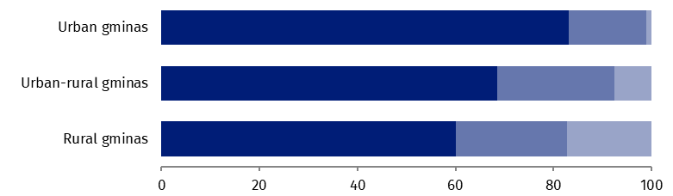
%

General subvention
Grants
Own revenue

a Excluding revenue of gmina which is also city with powiat status.
In 2025, own revenue was at the level of PLN 4481.5 million and increased by 49.9% compared with the previous year. Own revenue accounted for 67.9% of total revenue. The largest share of own revenue in total revenue was recorded in gmina Zdzieszowice (87.3%), and the lowest – in gmina Radłów (40.2%).
In own revenue group of gminas, personal income tax revenue had the highest value – PLN 2425.5 million (54.1% of own revenue). Revenue from property tax also had a high value which accounted for PLN 822.6 million (18.4%). Compared to 2024, value of personal income tax twice-and-a-half times higher, while the value of property tax – by 7.5%.

Map 1. Own revenue of gminasª in % of total revenue in 2025
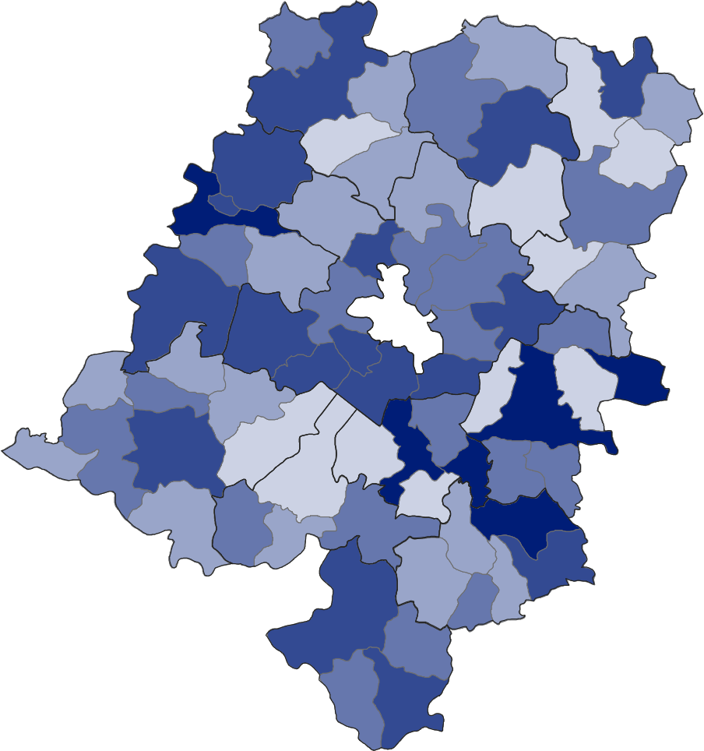

in %:
80.0 – 87.3 (6)

70.0 – 79.9 (17)

50.0 – 59.9 (17)
60.0 – 69.9 (19)
40.2 – 49.9 (11)
Number of gminas is given in the brackets

City with powiat status

a Excluding revenue of gmina which is also city with powiat status.

Grants that amounted to PLN 1496.5 million (22.7% of total revenue) decreased on an annual basis by 17.2% in relation to 2024. Most revenue in form of grants were targeted grants (88.6%), which decreased by 22.6% on annual scale. Grants from paragraphs 200 and 620, as well as 205 and 625, were by 79.6% higher compared to 2024 and were at the level of PLN 169.9 million (11.4% of total grants).
In 2025, general subvention strengthened budgets of gminas with PLN 624.0 million accounting for 9.5% of total revenue. On an annual basis it decreased by 64.0%.
Expenditure of budgets of gminas in 2025 amounted to PLN 6561.1 million and were by 1.9% higher than the year before. In the expenditure structure, expenditure of urban-rural gminas had the largest share (62.8%). Expenditure of rural and urban gminas were: 25.9% and 11.3% of total expenditure, respectively. Expenditure of gmina budgets per capita amounted to PLN 8183 and were by 2.6% higher in relation to 2024. In urban gminas this rate amounted to PLN 8586, in urban-rural – PLN 8209, and in rural – PLN 7961. The highest expenditure per capita was recorded in gmina Gogolin (PLN 13776), and the lowest – in gmina Tarnów Opolski (PLN 6060).

Map 2. Budget expenditure of gminasª per capita in 2025
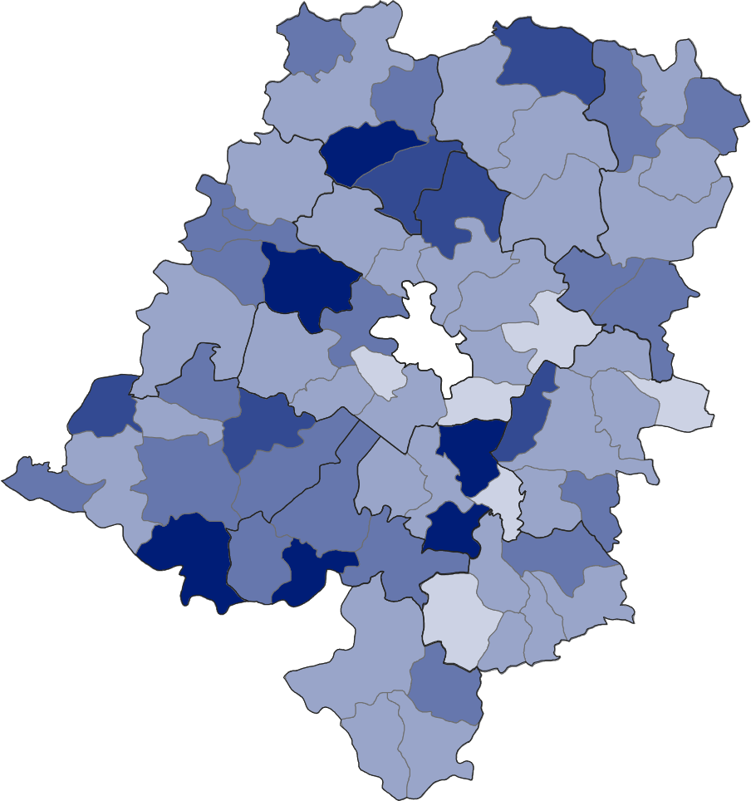

In PLN:
10000 – 13776 (6)
9000 – 9999 (6)

7000 – 7999 (32)
8000 – 8999 (20)
6060 – 6999 (6)
Number of gminas is given in the bracket
City with powiat status

a Excluding expenditure of gmina which is also city with powiat status.

Gminas spent PLN 5244.2 million on current expenditure (79.9% of total expenditure), i.e. more by 1.2% than in 2024. In the structure of current expenditure, a significant share were wages and salaries (41.2%) as well as purchase of goods and services (24.2%), which, on annual basis, increased by: 10.9% and 4.0%, respectively.
Property expenditure of budgets of gminas amounted to PLN 1316.9 million (20.1% of total expenditure) and were by 4.9% higher in relation to 2024 r. Investment expenditure increased by 9.0% to the level of PLN 1256.2 million and accounted for 95.4% of property expenditure.
Over 60% of gminas closed the budget year with a surplus
In 2025, gminas of Opolskie Voivodship closed the budget year with a surplus of PLN 41.0 million versus PLN 90.8 million in the year before. A positive result of budgets was recorded in 43 gminas, while the largest, accounting for over 10% of total revenues, in gminas: Jemielnica (14.6%), Strzeleczki (14.1%), Kolonowskie (11.9%) and Popielów (10.3%). Among 27 gminas with a deficit in a budget, the highest relation of a negative result to total revenue was achieved by gminas: Łambinowice (21.6%), Lubrza (13.3%) and Zębowice (11.5%).
Budgets of powiats
In 2025, powiats of Opolskie Voivodship achieved revenue amounting to PLN 1907.3 million, i.e. by 8.0% higher compared to the previous year. Revenue of budgets of powiats per capita amounted to PLN 2379 and increased by 8.8% in relation to 2024. The highest revenue per capita was recorded in Głubczycki Powiat (PLN 3885), while the lowest – in Opolski Powiat (PLN 1526).
Own revenue of budgets of powiats amounted to PLN 1135.4 million, i.e. by 99.8% higher in relation to 2024. The percentage of own revenue in total revenue amounted to 59.5% and in several powiats it valued from 47.7% (Nyski Powiat) to 82.0% (Opolski Powiat). The largest part in own revenue was revenue from personal income tax (61.0%) which amounted to PLN 692.4 million and in relation to the previous year income from personal income tax increased by 172.8%.
In the budgets of powiats, a significant increase of grants from paragraphs 200 and 620 as well as 205 and 625 was observed
In 2025, powiats of Opolskie Voivodship, as part of the tasks carried out, received in the form of grants PLN 470.0 million (24.6% of total revenue). This income was of 20.4% higher compared to the previous year. In the structure of grants, predominant were targeted grants (90.3%), which increased by 15.9% compared with 2024. Grants provided under programmes financed with the participation of EU funds and other non-returnables, and payments from the budget of EU funds (paragraphs 200 and 620, as well as 205 and 625 of budget classification) amounted to PLN 45.8 million (9.7% of total grants) and were by 87.8% higher than the year before.
General subvention increased budgets of powiats by PLN 302.0 million and was by 62.6% lower than in 2024. Revenue from subvention constituted 15.8% of total revenue.
Map 3. Revenue and expenditure of budgets of powiats per capita in 2025
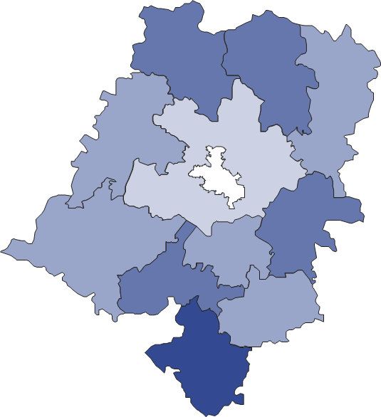
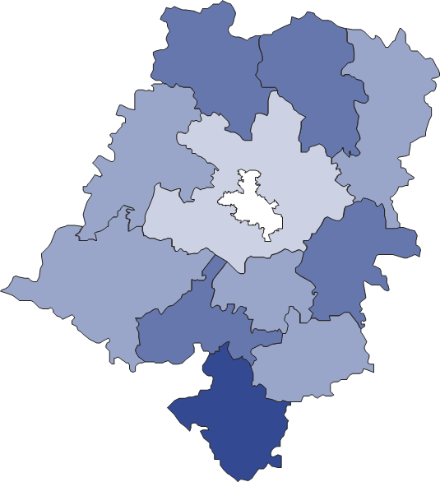
REVENUE EXPENDITURE


City with powiat status
In PLN:
2000 – 2499 (5)
1444 – 1999 (1)
2500 – 2999 (4)
3000 – 3745 (1)
In PLN:
2000 – 2499 (5)
1526 – 1999 (1)
3000 – 3885 (1)
2500 – 2999 (4)

Number of powiats given in the brackets Number of powiats given in the brackets
Expenditure of budgets of powiats in relation to 2024 increased by 11.7% and amounted to PLN 1878.6 million. Per capita, it amounted to PLN 2343, i.e. by 12.5% more than the year before. The most funds per capita were spent in Głubczycki Powiat (PLN 3745), and the least – in Opolski Powiat (PLN 1444).
In the structure of expenditure of budgets of powiats, current expenditure accounted for 83.2%, while property expenditure – 16.8%. Compared to 2024, current expenditure increased by 13.0% to the level of PLN 1563.9 million. Current expenditure was generated mainly by wages and salaries (PLN 885.7 million – increase of 9.9% on annual basis) as well as the purchase of goods and services (PLN 304.5 million – increase of 27.0%). Property expenditure amounted to PLN 314.7 million and increased by 5.9% in relation to the previous year. Among property expenditure, 98.0% was for investment purposes. For investments, PLN 308.5 million was allocated, i.e. by 4.9% more than in 2024.
In 2025, result of budgets of powiats in Opolskie Voivodship was positive and amounted to PLN 28.7 million (in 2024 – negative result amounting to PLN 83.8 million). Surplus was observed in 9 powiats and the highest, in relation to total revenue, occurred in powiats: Namysłowski (5.8%), Opolski (5.4%) and Oleski (5.1%). Deficit in the budget occurred in powiats: Krapkowicki (12.7% of total revenue) and Kędzierzyńsko-Kozielski (0,6%).
Budget of city with powiat status – Opole
In 2025, revenue of budget of city with powiat status achieved PLN 1659.3 million and compared to the previous year increased by 8.4%. Total revenue per capita amounted to PLN 13264 and were by 9.0% higher in relation to 2024.
In the budget of city with powiat status – Opole, own revenue accounted for the largest percentage of the total revenue
In the structure of revenue by type own revenue constituted for 77.4%, grants – 12.7%, and general subvention – 9.9%.
Own revenue accounted for PLN 1283.8 million and were by 42.5% higher in relation to 2024. Over a half of own revenue was constituted by revenue from personal income tax (52.0%). The revenue for the budget of the city with powiat status on this account was at the level of PLN 668.1 million i.e. by 102.4% more than in 2024.
As part of grants, city with powiat status obtained PLN 211.3 million (lower by 2.1% compared with the previous year). Targeted grants amounted to PLN 192.7 million (91.2% of total grants) and increased by 0.5% in relation to 2024. Grants from paragraphs 200 and 620 as well as 205 and 625 decreased by 23.0% on annual basis, to the level of PLN 18.6 million (8.8% of total grants).
General subvention increased city’s budget by PLN 164.2 million and was lower by 60.4% in relation to 2024.
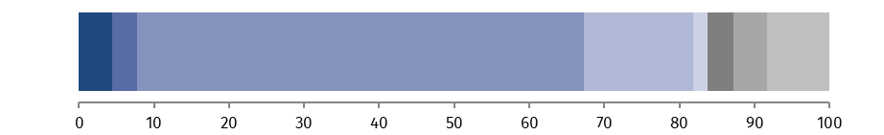
Chart 3. Revenue of budget of city with powiat status by type in 2025
%

Transport and communication
Other
Dwelling economy
Revenue from legal persons, natural persons and other entities without legal personality and expenditure related to their collection
Miscellaneous settlements
Education
Municipal economy and environmental protect.
Family

In 2025, expenditure of budget of city with powiat status amounted to PLN 1735.8 million and increased by 8.1% compared to the previous year. Total expenditure per capita amounted to PLN 13876 and were by 8.8% higher than in 2024.
In the structure of expenditure of budget of city with powiat status, current expenditure accounted for 86.7% and property expenditure – 13.3%. Current expenditure amounted to PLN 1504.5 million, i.e. by 9.5% more than the year before. Out of current expenditure, the most resources were spent on wages and salaries (PLN 656.2 million – by 10.6% more than in 2024) as well as purchase of goods and services (PLN 412.6 million – by 11.1%). Property expenditure amounted to PLN 231.3 million and in relation to 2024 decreased by 0.2%. In property expenditure, predominant was investment expenditure (89.1%), which was at the level of PLN 206.0 million, i.e. by 21.0% higher compared to the previous year.
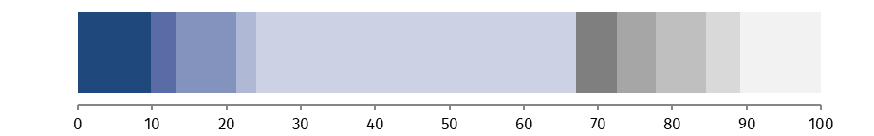
Chart 4. Expenditure of budget of city with powiat status by type in 2025
%

Transport and communication
Dwelling economy
Public administration
Education
Other
Family
Municipal economy and environmental protect.
Physical education
Social welfare

Public safety and fire protection

In 2025, city with powiat status ended the budget year with a deficit of PLN 76.6 million (in the previous year PLN 74.7 million, respectively). A negative result accounted for 4.6% of the total revenue (in 2024 – 4.9%).
City with powiat status - Opole, similarly as in the previous year, ended a budget year with a deficit
Budget of voivodship local government
In 2025, revenue of budget of Opolskie Voivodship local government amounted to PLN 949.1 million and compared to the previous year increased by 1.0%. Total revenue per capita of PLN 1024 was by 1.7% higher than in relation to 2024.
Over 80% of own revenue of voivodship local government budget was revenue from income tax from legal and natural persons
Own revenue decreased by 6.4% compared to 2024 and was at the level of PLN 410.5 million (43.2% of revenue of the budget of voivodship local government). The largest share in this revenue group was corporate income tax (45.2%). These amounted to PLN 185.7 million and in relation to 2024 decreased by 34.9%. A significant portion was also revenue from income tax from natural persons (36.6%), which, on annual basis increased almost threefold to PLN 150.2 million.
As part of the grants, voivodship local government received PLN 254.3 million (26.8% of the total revenue). Value of the grant was by 12.8% higher than in 2024. The highest percentage (72.4% of the total subsidies, i.e. PLN 184.1 million) were subsidies from paragraphs 200 and 620, as well as 205 and 625, which increased by 22.2% in relation to 2024.
General subvention in the budget of voivodship local government in 2025 amounted to PLN 284.3 million (30.0% of the total revenue) and was by 3.0% higher than in the previous year.
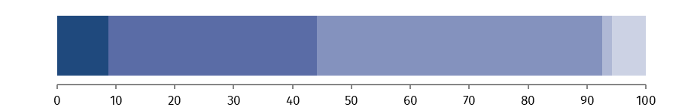
Chart 5. Revenue of budget of voivodship local government by type in 2025
%

Miscellaneous settlements
Transport and communication
Other
Healthcare
Revenue from legal persons, natural persons and other entities without legal personality and expenditure related to their collection

Expenditure of budget of voivodship local government increased on a yearly basis by 1.7% to the level of PLN 937.6 million. It amounted to PLN 1012 per capita and was by 2.5% higher than in 2024.
Current expenditure increased by 11.0% in relation to 2024 and was at the level of PLN 716.4 million (76.4% of total expenditure of voivodship local government). Out of current expenditure, PLN 172.1 million (by 11.8% more than in the previous year) was spent on wages and salaries, while on purchase of goods and services – PLN 107.3 million (by 6.0%).
In the budget of voivodship local government, all of property expenditure was allocated on investments
Property expenditure of budget of voivodship local government amounted to PLN 221.2 million (23.6% of total expenditure of voivodship local government) and compared with 2024 decreased by 19.8%. All of property expenditure had investment purposes.
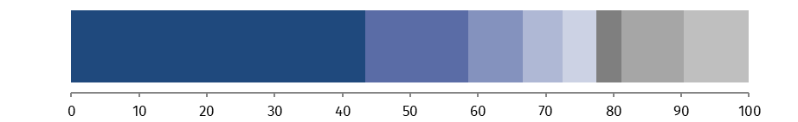
Chart 6. Expenditure of budget of voivodship local government by type in 2025
%

Social services
Transport and communication
Public administration
Education
Healthcare
Other tasks in sphere of social policy
Other
Culture and national heritage

In 2025, local government of Opolskie Voivodship closed the financial year with a positive result of 11.5 million accounting for 1.2% total revenue (in 2024: PLN 18.6 million and 2.0%, respectively).

* * *
In case of quoting this publication, please provide the title and point out Statistical Office in Opole as an author. In case of publishing own calculations based on this publication, please include the following note: Own study based of figures of Statistical Office in Opole titled “Budgets of local government units in Opolskie Voivodship in 2025”.

Issued by:
Opolski Centre for Regional Surveys

Statistical Information Centre
Phone: 77 423 10 00, 510 993 218

Prepared by:
Statistical Office in Opole
Director Renata Wasilewska
Phone: 77 453 14 52




opole.stat.gov.pl
@USOpole
@Opole_STAT
Media contact person
in Statistical Office in Opole
Phone: 514 901 001
e-mail: H.Sterniuk-Moscicka@stat.gov.pl

Related information
Budgets of local government units in Opolskie Voivodship in 2024
Financial economy of local government units 2024

Data available in databases
Local Data Bank – Database – Public finances
Knowledge databases – Economy – Public finances

Terms used in official statistics
Budget of local government
Revenue of local government units
Local government own revenue
Targeted grants
Personal income tax
Corporate income tax

