Balance sheet data of non-financial enterprises in 2025
The value of assets (total equity and liabilities) of non-financial enterprises as of 31 December 2025 was 5,015.0 bn PLN (by 5.0% more comparing to the end of 2024), of which 2,760.6 bn PLN were fixed assets and 2,250.6 bn PLN were current assets. Total revenues and total costs were higher than in 2024. The net financial result amounted to 202.8 bn PLN (a decrease of 1.4% compared to 2024).
5.0%
year-to-year increase in assets (total equity and liabilities)

Table 1. Basic data concerning surveyed entities
Specification | 2024 | 2025
Specification | in billion PLN |  | 2024=100
Assets (total equity and liabilities) | 4,776.7 | 5,015.0 | 105.0
Total revenues | 6,024.1 | 6,187.0 | 102.7
Total costs | 5,767.1 | 5,930.5 | 102.8
Gross financial result | 257.0 | 256.5 | 99.8
Net financial result | 205.8 | 202.8 | 98.6
Compared to 2024, net fixed assets of non-financial enterprises as well as current assets increased, respectively by 5.5% and 4.3%
Net fixed assets amounted to 2,760.6 bn PLN (by 5.5% more than at the end of 2024).
In the structure of net fixed assets, an increase was recorded in the share of long-term investments (from 23.4% to 24.2%) and long-term prepayments and accruals (from 3.1% to 3.2%). A decrease was recorded in the share of tangible fixed assets (from 64.5% to 64.0%), intangible fixed assets (from 5.6% to 5.4%), long-term receivables (from 1.8% to 1.7%) and right-of-use assets (from 1.6% to 1.5%).
Current assets amounted to 2,250.6 bn PLN and increased by 4.3% compared to the end of 2024.
In the structure of these assets, 38.4% were short-term receivables (dominated by receivables from deliveries and services), 30.6% were short-term investments (the largest share occurred for short-term financial assets), 27.6% – stocks and 3.4% – short-term prepayments and accruals.

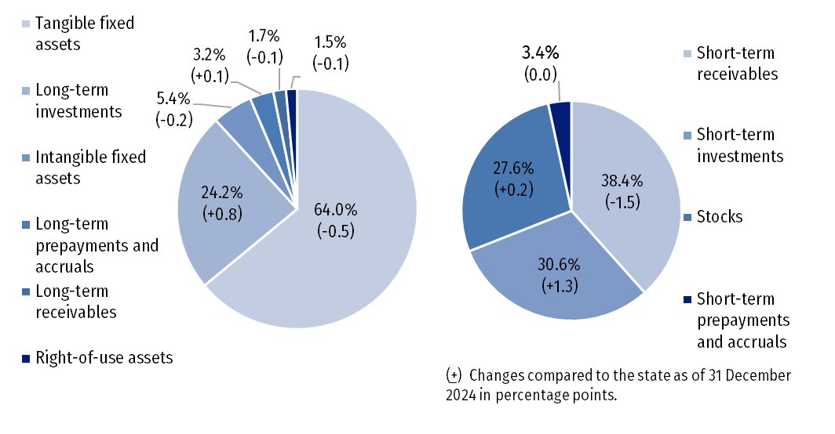
Chart 1. Structure of fixed and current assets (as of 31 December 2025)

In the structure of total equity and liabilities, 48.3% was equity, while 51.7% were liabilities and provisions for liabilities.
The equity (fund) of the surveyed enterprises at the end of 2025 amounted to 2,421.1 bn PLN (i.e. by 5.5% more than at the end of 2024).
Liabilities and provisions for liabilities amounted to 2,593.9 bn PLN at the end of the year (an increase by 4.5% compared to 2024). Current liabilities constituted 55.4% of total liabilities and provisions for liabilities, while long-term liabilities – 24.9%. Provisions for liabilities amounted to 237.5 bn PLN (including 41.2 bn PLN of deferred income tax).

Chart 2. Structure of total equity and liabilities (as of 31 December 2025)
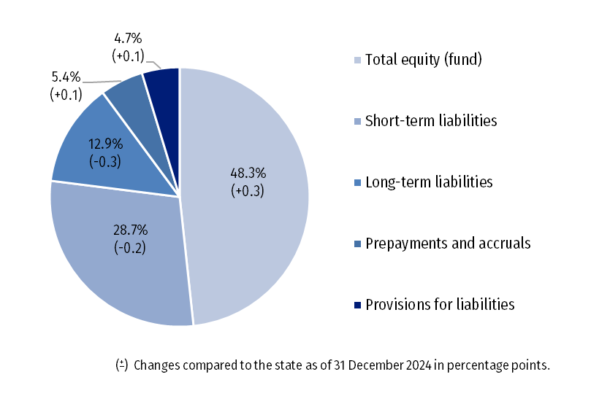

Compared to 2024, total revenues of surveyed entities as well as total costs increased by 2.7% and 2.8%, respectively
In 2025, total revenues of the surveyed entities were higher by 2.7% compared to 2024 and amounted to 6,187.0 bn PLN. In the structure of these revenues, 57.8% accounted for net revenues from sale of products (goods and services), 38.8% were net revenues from sale of goods for resale, whereas 3.5% constituted other operating revenues and financial revenues.
In 2025, total costs were higher by 2.8% than in 2024 and amounted to 5,930.5 bn PLN. In the structure of these costs, 96.1% were costs of products and goods sold, 2.1% – financial costs and 1.8% – other operating costs.
The gross financial result amounted to 256.5 bn PLN (profit was 352.8 bn PLN while loss – 96.4 bn PLN). Encumbrances on gross financial result due to income tax increased by 4.7% compared to 2024 and amounted to 53.6 bn PLN.
In 2025, net financial result was by 1.4% lower than in the previous year

The net financial result amounted to 202.8 bn PLN compared to 205.8 bn PLN in 2024, with an increase by 3.5% in net profit and 15.3% in net loss. In 2025, net profit was reported by 79.9% of the total number of surveyed entities (compared to 79.7% in 2024) and their revenues accounted for 81.4% of total revenues (compared to 84.6% in 2024).
The total cost level indicator deteriorated slightly in 2025 reaching 95.9% compared to 95.7% in 2024, similarly to the gross turnover profitability indicator - 4.1% in 2025 (4.3% in 2024) and the net turnover profitability indicator, respectively 3.3% and 3.4%.
The diversity of levels of economic and financial indicators depending on the type of activity conducted by the surveyed enterprises was recorded. Deterioration in the net turnover profitability indicator occurred in sections i.a.: other service activities (from 7.6% in 2024 to 6.1%), information and communication (from 7.5% to 6.6%), manufacturing (from 3.6% to 2.8%), electricity, gas, steam and air conditioning supply (from 2.6% to 2.1%) and construction (from 6.0% to 5.8%). Improvement in the net turnover profitability indicator occurred in sections i.a.: transport and storage (from 2.8% to 4.5%), professional, scientific and technical activities (from 8.4% to 9.1%), mining and quarrying (from -10.1% in 2024 to -9.7%), water supply; sewerage, waste management and remediation activities (from 6.2% to 6.6%) and trade; repair of motor vehicles (from 2.6% to 2.7%).
The first degree financial liquidity indicator improved in 2025 and amounted to 48.3% (compared to 46.2% in 2024), while the second degree financial liquidity indicator decreased to 108.9% (compared to 109.0% in the previous year). The third degree financial liquidity indicator was 157.8% (157.5%).

Chart 3. Basic data for selected NACE sections in 2025
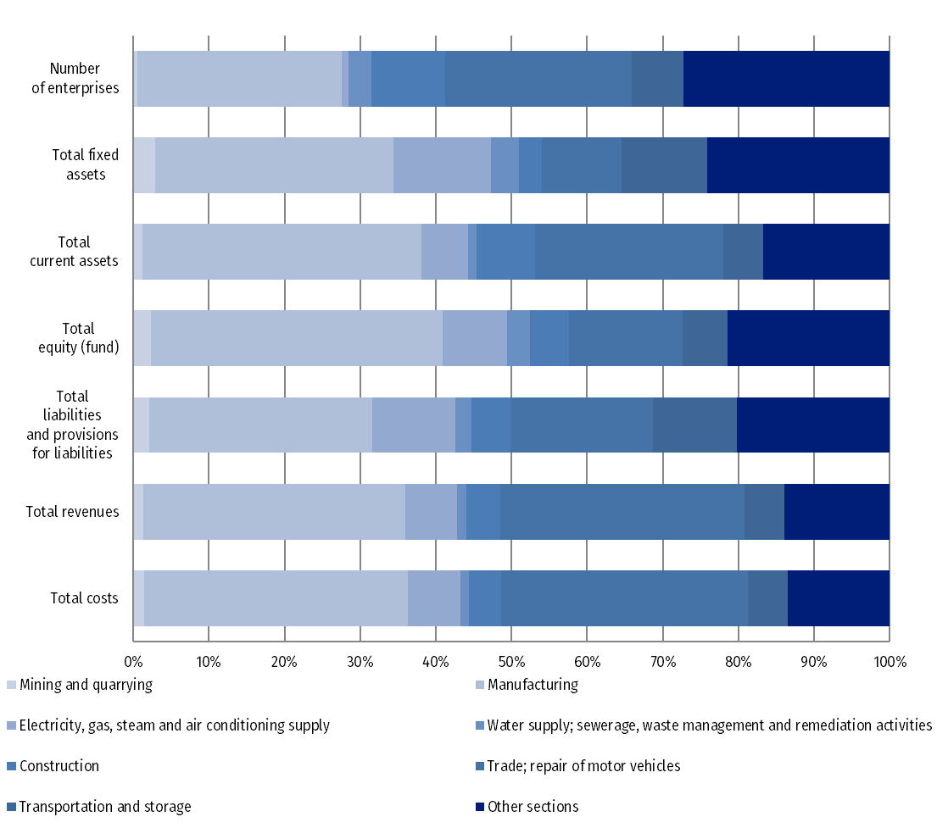

Table 2. Balance sheet data, financial results and basic economic indicators in 2025
Specification | Total | Enterprises with per-sons employed |  | 2024=100
Specification | Total |  |  | Total | Enterprises with persons employed
Specification | Total | 10-249 | 250 or more | Total | 10-249 | 250 or more
Number of enterprises | 52,128 | 48,266 | 3,862 | 99.5 | 99.5 | 99.8
 | in billion PLN
Assets (total equity and liabilities) | 5,015.0 | 1,775.4 | 3,239.6 | 105.0 | 102.2 | 106.6
including:
fixed assets | 2,760.6 | 836.7 | 1,923.9 | 105.5 | 105.9 | 105.4
current assets | 2,250.6 | 937.3 | 1,313.3 | 104.3 | 99.1 | 108.3
Equity | 2,421.1 | 897.4 | 1,523.7 | 105.5 | 105.5 | 105.5
Liabilities and provisions for liabilities | 2,593.9 | 878.0 | 1,715.9 | 104.5 | 99.1 | 107.5
including:
non-current liabilities | 645.6 | 212.6 | 433.0 | 102.3 | 97.1 | 105.1
current liabilities | 1,437.3 | 542.5 | 894.8 | 104.0 | 98.0 | 108.1
Total revenues | 6,187.0 | 2,395.9 | 3,791.1 | 102.7 | 104.4 | 101.7
Total costs | 5,930.5 | 2,271.9 | 3,658.7 | 102.8 | 104.4 | 101.9
Gross financial result | 256.5 | 124.0 | 132.4 | 99.8 | 104.1 | 96.1
gross profit | 352.8 | 152.5 | 200.4 | 102.9 | 102.8 | 103.1
gross loss | 96.4 | 28.4 | 68.0 | 112.4 | 97.5 | 120.0
Income tax | 53.6 | 20.4 | 33.3 | 104.7 | 103.5 | 105.4
Net financial result | 202.8 | 103.7 | 99.1 | 98.6 | 104.2 | 93.3
net profit | 301.1 | 132.0 | 169.0 | 103.5 | 102.7 | 104.1
net loss | 98.2 | 28.3 | 69.9 | 115.3 | 97.8 | 124.4
 | in %
Total cost level indicator ¹⁾ | 95.9 | 94.8 | 96.5 | x | x | x
Gross turnover profitability indicator ²⁾ | 4.1 | 5.2 | 3.5 | x | x | x
Net turnover profitability indicator ³⁾ | 3.3 | 4.3 | 2.6 | x | x | x
First degree financial liquidity indicator ⁴⁾ | 48.3 | 52.1 | 46.0 | x | x | x

¹⁾ The relation of total costs to total revenues.
²⁾ The relation of gross financial result to total revenues.
³⁾ The relation of net financial result to total revenues.
⁴⁾ The relation of short-term investments to current liabilities (excluding special funds).

Table 3. Selected assets, total equity and liabilities by NACE sections (as of 31 December 2025)
Specification | Fixed assets | Current assets |  | Equity | Liabilities and provisions  for liabilities
Specification | Fixed assets | Current assets | inventories  (stocks) | Equity | Liabilities and provisions  for liabilities | long-term liabilities | current liabilities | liabilities from deliveries and services
Specification | in billion PLN
Total | 2,760.6 | 2,250.6 | 621.5 | 2,421.1 | 2,593.9 | 645.6 | 1,437.3 | 680.9
including
Industry | 1,406.5 | 1,020.3 | 299.3 | 1,268.3 | 1,160.4 | 269.5 | 661.3 | 288.8
Mining and quarrying | 80.4 | 28.0 | 11.5 | 55.3 | 53.1 | 11.6 | 23.8 | 8.4
Manufacturing | 869.5 | 828.9 | 274.7 | 934.9 | 765.4 | 153.4 | 512.0 | 239.5
Electricity, gas, steam and air conditioning supply | 354.8 | 138.2 | 11.1 | 207.0 | 286.0 | 90.4 | 110.6 | 35.9
Water supply; sewerage, waste management and remediation activities | 101.7 | 25.3 | 2.0 | 71.1 | 55.9 | 14.1 | 14.8 | 5.0
Construction | 84.7 | 174.6 | 42.6 | 127.0 | 132.4 | 21.8 | 83.5 | 38.7
Trade; repair of motor vehicles Δ | 289.8 | 561.3 | 232.7 | 362.6 | 488.8 | 65.2 | 381.0 | 244.3
Transport and storage | 313.1 | 118.1 | 5.1 | 144.0 | 287.2 | 75.9 | 76.1 | 33.5
Accommodation and catering Δ | 36.6 | 10.9 | 1.6 | 28.1 | 19.4 | 8.9 | 8.5 | 3.1
Information and communication | 184.4 | 106.4 | 7.8 | 138.5 | 152.6 | 65.6 | 64.0 | 28.8
Real estate activities | 154.0 | 43.5 | 7.3 | 125.3 | 72.5 | 31.0 | 27.3 | 7.5
Professional, scientific and technical activities | 143.4 | 128.9 | 20.3 | 140.1 | 132.7 | 45.2 | 71.9 | 18.5
Administrative and support service activities | 89.2 | 55.0 | 3.1 | 45.0 | 99.3 | 45.7 | 43.6 | 10.1
Other service activities | 2.1 | 3.0 | 0.3 | 2.5 | 2.6 | 0.4 | 1.8 | 0.9

Table 4. Revenues, costs and financial results by NACE sections in 2025
Specification | Number of enterprises | Total  revenues | Total  costs | Gross  financial  result  (balance) | Net  financial  result  (balance) | Net turnover profitability indicator
Specification | Number of enterprises | in billion PLN |  |  |  | in % | change compared to 2024  in percentage points
Total | 52,128 | 6,187.0 | 5,930.5 | 256.5 | 202.8 | 3.3 | -0.1
including
Industry | 16,381 | 2,721.9 | 2,628.9 | 93.0 | 66.4 | 2.4 | -0.6
Mining and quarrying | 259 | 79.8 | 86.3 | -6.6 | -7.8 | -9.7 | 0.4
Manufacturing | 14,089 | 2,147.9 | 2,069.4 | 78.6 | 60.5 | 2.8 | -0.8
Electricity, gas, steam and air conditioning supply | 465 | 423.2 | 407.9 | 15.3 | 9.0 | 2.1 | -0.5
Water supply; sewerage, waste management and remediation activities | 1,568 | 71.0 | 65.3 | 5.7 | 4.7 | 6.6 | 0.4
Construction | 5,138 | 276.3 | 257.0 | 19.4 | 16.2 | 5.8 | -0.2
Trade; repair of motor vehiclesΔ | 12,858 | 1,999.6 | 1,933.5 | 66.2 | 54.7 | 2.7 | 0.1
Transport and storage | 3,535 | 327.3 | 309.1 | 18.2 | 14.6 | 4.5 | 1.7
Accommodation and catering Δ | 1,316 | 44.3 | 40.1 | 4.3 | 3.7 | 8.4 | 0.3
Information and communication | 2,429 | 244.7 | 225.5 | 19.2 | 16.2 | 6.6 | -0.9
Real estate activities | 1,841 | 64.9 | 60.2 | 4.7 | 3.8 | 5.9 | 0.4
Professional, scientific and technical activities | 3,350 | 159.4 | 143.5 | 15.9 | 14.4 | 9.1 | 0.7
Administrative and support service activities | 2,322 | 138.4 | 130.0 | 8.4 | 7.1 | 5.1 | -1.1
Other service activities | 224 | 8.3 | 7.6 | 0.6 | 0.5 | 6.1 | -1.5

The data presented in this study derive from the annual business survey on the economic activity of enterprises (survey 1.61.05 – data collected on annual business survey SP). The data concern 52,128 entities with 10 or more persons employed, keeping accounting ledgers and organised as commercial companies (partnerships and capital companies), civil companies, state enterprises, cooperatives, foreign branches, natural persons conducting economic activities and state organisational units. The data presented with regard to both 2025 and 2024 do not include agriculture, forestry, hunting and fishing (section A according to NACE 2007); financial and insurance activities (section K according to NACE 2007); higher education institutions; independent public health care facilities and cultural institutions with legal personality.
In this news release abbreviations for some section names from PKD 2007 are used; abbreviated names have been marked with "Δ". A summary of the full names used is as follows:
Abbreviation | Description
Trade; repair of motor vehicles | Wholesale and retail trade; repair of motor vehicles, and motorcycles
Accommodation and catering | Accommodation and food service activities
In terms of the amendment of the Accounting Act, starting from 2026 the classification of revenues from the sale of materials has changed. They were previously presented as part of main operating activity (under "net revenues from sales of goods and materials" and correspondingly under "value of sold goods and materials"), are now reported under other operating activity ("other operating revenues" and "other operating costs"). The influence of the reclassification on the data is not essential therefore the data from the previous years are comparable.
Due to the rounding of data, in some cases sums of components may slightly differ from the amount given in the item ‘total’. Relative numbers (indices, percentages) are usually calculated on the basis of absolute data expressed with greater precision than that presented in the news release.

When quoting Statistics Poland data, please provide the information: “Source of data: Statistics Poland”, and when publishing calculations made on data published by Statistics Poland, please include the following disclaimer: “Own study based on figures from Statistics Poland”.

Prepared by:  Enterprises Department  Director Katarzyna Walkowska-Macias  Phone: (+48 22) 608 31 25 | Issued by:  Press Office  Mobile: (+48) 695 255 032  Phone: (+48 22) 608 38 04, (+48 22) 449 41 45,  (+48 22) 608 30 09  e-mail: obslugaprasowa@stat.gov.pl

stat.gov.pl/en/

@StatPoland

@GlownyUrzadStatystyczny

@gus_stat

@GłównyUrządStatystycznyGUS

@Główny Urząd Statystyczny
Related information
Statistical Bulletin
Information on the socio-economic situation of the country
Financial results of non-financial enterprises for 2024 (balance sheet)
Methodological report. Non-financial enterprises surveys
Data available in databases
Local Data Bank
Knowledge Database Non-financial Enterprises
Macroeconomic Data Bank

Terms used inn official statistics
Total revenues (revenue obtained throughout the activity)
Total costs (costs of obtaining revenue throughout the activity)
Gross financial result
Net financial result
Cost level indicator
Gross turnover profitability indicator
Net turnover profitability indicator
First degree financial liquidity indicator
Second degree financial liquidity indicator

