Biotechnology and nanotechnology in Poland
in 2025

Biotechnology research and experimental development was conducted by 284 entities from all sectors of performance, that is 3.3% more in comparison with the previous year. Biotechnology intramural R&D expenditures amounted to PLN 1 998.3 million and increased by 8.4% annually. 250 firms conducted biotechnology activities, which constitutes an increase by 1.6% in comparison with 2024. Biotechnology intramural expenditures incurred by firms amounted to PLN 3 153.7 million and decreased by 4.1% on an annual basis.
8.4%
An increase in biotechnology intramural R&D expenditures year-on-year

Biotechnology in firms
Biotechnology activity was conducted by 250 firms, of which 35.2% constituted dedicated
biotechnology firms.
From among all biotechnology firms 169 (67.6%) conducted biotechnology research and experimental development (R&D), of which 68.6% carried out only R&D, while the remaining entities combined R&D with biotechnology production.
Firms employing up to 49 persons constituted 57.2%
of biotechnology firms
Taking into account size classes, entities employing up to 49 persons constituted the majority (57.2% of all biotechnology firms). The share of firms employing 50–249 persons amounted to 28.8% and the ones employing at least 250 persons – 14.0%.
Chart 1. Firms conducting biotechnology activities
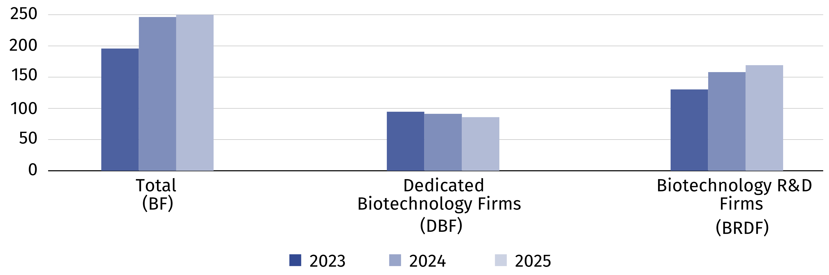

Biotechnology intramural expenditures of firms
In 2025, intramural expenditures of firms incurred on biotechnology amounted to PLN 3 153.7 million (4.1% less than in the previous year), of which internal funds of firms constituted 93.2%.
Chart 2. Biotechnology intramural expenditures of firms
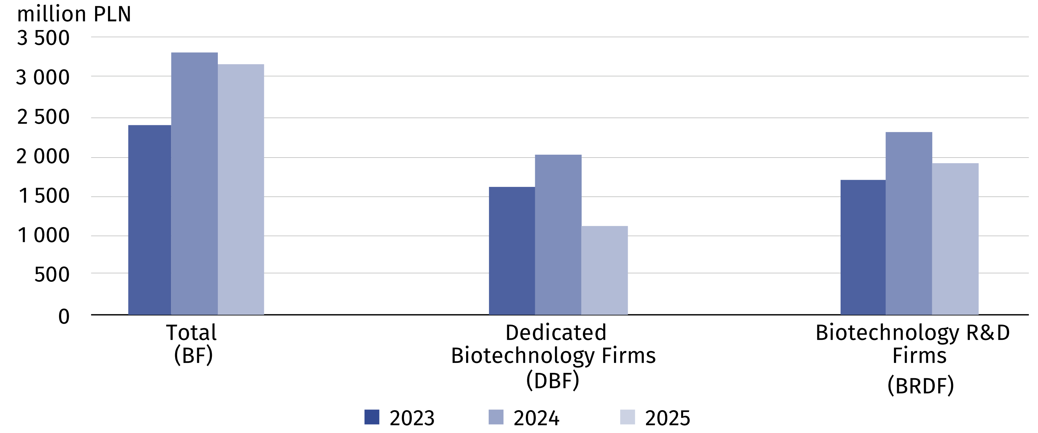

Biotechnology personnel in firms
Women constituted 62.5%
of persons employed
in biotechnology R&D firms
4 931 persons were engaged in biotechnology activity in firms, i.e. 23.0% less than the year before. Biotechnology research and experimental development in firms was carried out by 2 313 persons (6.8% less compared to the previous year), of which 1 445 women (5.2% less).
Chart 3. Biotechnology personnel in firms
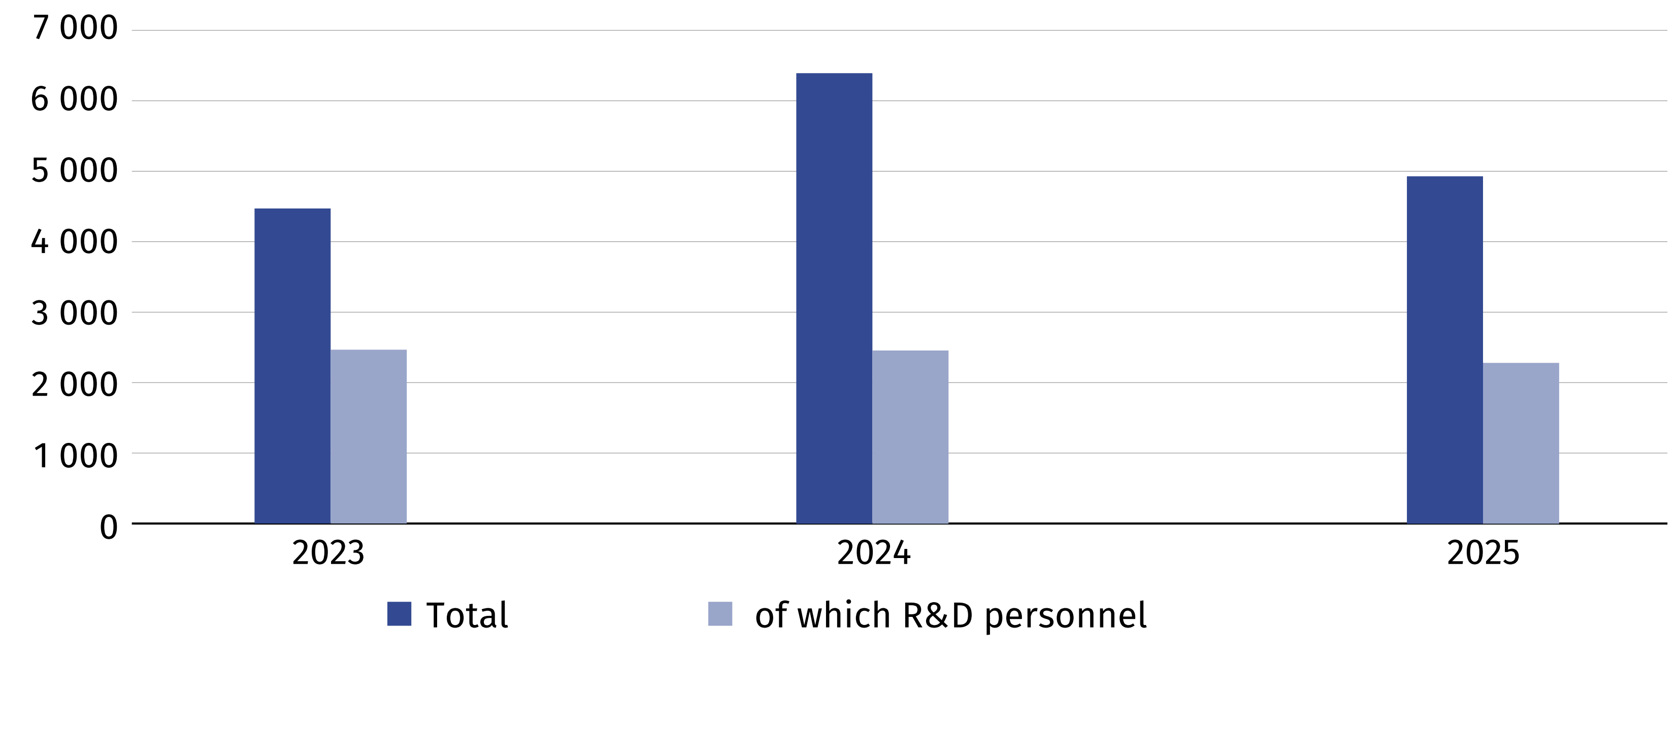

Biotechnology research and experimental development
In 2025, biotechnology research and experimental development was conducted by 284 entities (of which 169 firms), i.e. 3.3% more than the year before.
PLN 1 998.3 million was allocated to biotechnology R&D (8.4% more in comparison with 2024), of which intramural expenditures of the business enterprise sector and the higher education sector entities constituted the majority (54.5% and 42.5% of this amount, respectively).
Table 1. Biotechnology intramural R&D expenditures by sectors of performance
Sectors of performance | 2023 | 2024 | 2025
Sectors of performance | in thousand PLN
Total | 1 719 941.3 | 1 842 828.9 | 1 998 323.1
Business enterprise sector | 924 358.1 | 1 097 054.5 | 1 088 983.2
of which enterprises | 852 405.1 | 979 632.7 | 976 655.0
Government and private non-profit sector | 44 447.8 | 51 098.6 | 59 024.5
Higher education sector | 751 135.4 | 694 675.8 | 850 315.4

8 444 persons were engaged in biotechnology R&D in 2025 in entities from all sectors of performance. The number of persons employed was at a level similar to the previous year. Researchers constituted almost three-fourths of personnel involved in biotechnology R&D.
Nanotechnology research and experimental development was carried out by 139 entities from all sectors of performance, that is 7.3% less in comparison with the previous year. Nanotechnology intramural R&D expenditures amounted to PLN 408.4 million and were by 10.9% higher than in the previous year. 80 firms conducted nanotechnology activities, i.e. 8 fewer than in the previous year. Intramural expenditures on nanotechnology incurred by firms amounted to PLN 387.4 million and were lower by 10.6% than the year before.
10.9%
An increase in nanotechnology intramural R&D expenditures year-on-year

Nanotechnology in firms
In 2025, conducting nanotechnology activities (i.e. using nanotechnology for the production of intermediate and final goods and/or conducting nanotechnology research and experimental development) was reported by 80 firms, that is 8 fewer in comparison with the previous year.
Chart 4. Firms conducting nanotechnology activities
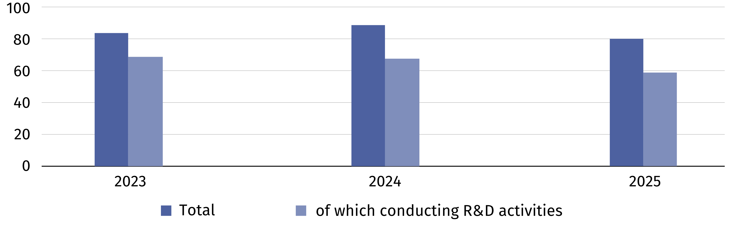

Nanotechnology activities in firms include production in which nanotechnology is used to produce intermediate and final goods. Nanotechnology can also be used indirectly – when a firm acts as a user or an integrator. It is also used in research and development, i.e. in scientific research and experimental development.
Nanomaterials constituted the dominant area of nanotechnology application for 76.3% of surveyed firms
In the nanotechnology survey, firms indicated the areas of nanotechnology application in their activities, as well as determined the dominant area. In 2025, as in the previous years, nanomaterials constituted the dominant area of nanotechnology application for the majority of firms – the number of such entities was similar to the previous year.
Table 2. Firms by the dominant area of nanotechnology application
Application areas | 2023 | 2024 | 2025
Total | 83 | 88 | 80
Nanomaterials | 61 | 62 | 61
Nanooptics | – | – | 1
Nanophotonics | 3 | 4 | 2
Nanobiotechnology | 5 | 3 | 4
Nanomedicine | 3 | 3 | –
Nanomechanics | – | 1 | –
Filtration and membranes | 1 | 5 | 3
Nanoinstruments and nanodevices | – | – | 1
Catalysis | 1 | 1 | –
Other | 9 | 9 | 8

Nanotechnology intramural expenditures of firms
Nanotechnology intramural expenditures are expenditures incurred for this purpose by firms in the reporting year, regardless of the source of the funds spent.
PLN 387.4 million was allocated to nanotechnology activities in 2025, of which 93.8% constituted internal funds of firms. Compared to the previous year, expenditures on nanotechnology decreased by 10.6%.
Chart 5. Nanotechnology intramural expenditures of firms
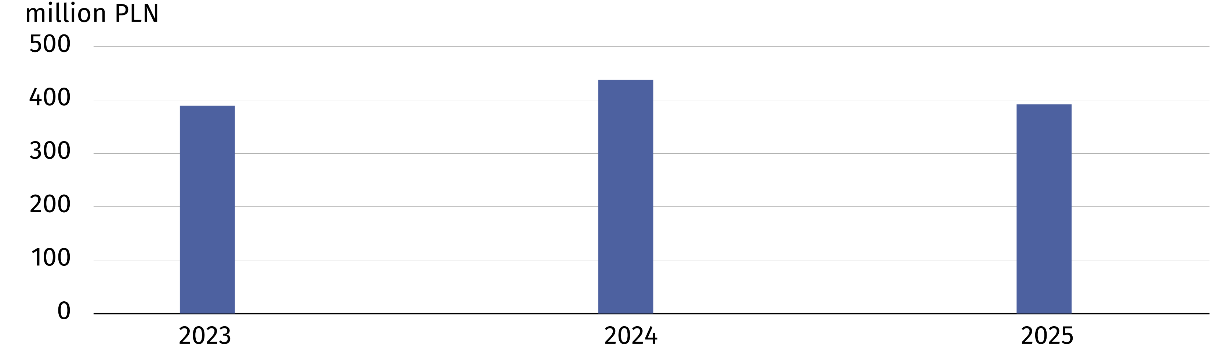

Nanotechnology personnel in firms
Women constituted 36.5% of all persons employed in nanotechnology R&D firms
1 204 persons were engaged in nanotechnology activities in firms, i.e. 4.3% less than in the previous year. Nanotechnology research and experimental development in firms was carried out by 474 persons (11.4% less compared to the previous year), of which 173 women (26.7% less).
Chart 6. Nanotechnology personnel in firms
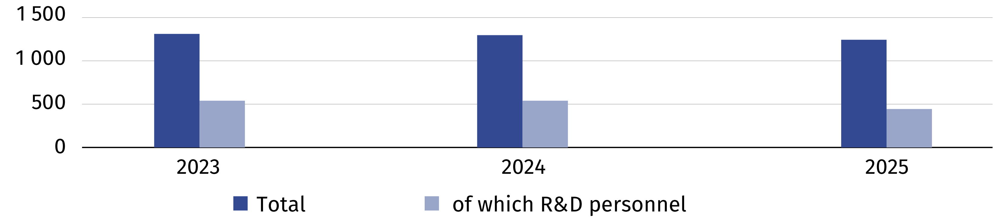

Nanotechnology research and experimental development
In 2025, nanotechnology research and experimental development was carried out by 139
entities (of which 59 firms), i.e. 7.3% less in comparison with the previous year. Nanotechnology intramural R&D expenditures amounted to PLN 408.4 million, i.e. 10.9% more than the year before.
The higher education sector had the highest share in nanotechnology intramural R&D expenditures
The basic classification of research and experimental development is the division of entities into sectors of performance. The higher education sector had the highest share in nanotechnology intramural R&D expenditures (61.8%).
Table 3. Nanotechnology intramural R&D expenditures by sectors of performance
Sectors of performance | 2023 | 2024 | 2025
Sectors of performance | in thousand PLN
Total | 380 293.6 | 368 296.8 | 408 387.1
Business enterprise sector | 155 736.3 | . | .
of which enterprises | 89 211.0 | 84 918.6 | 69 842.1
Government and private non-profit sector | 14 358.4 | . | .
Higher education sector | 210 198.9 | 211 447.3 | 252 332.7

2 550 persons, of which 1 101 women, were involved in nanotechnology research and experimental development in 2025 in all sectors of performance. Compared to 2024, the number
of nanotechnology R&D personnel decreased by 3.9%, of which women – by 4.3%.

When quoting this publication, please provide its title and indicate Statistics Poland as the author. When publishing your own calculations based on data from this publication, please include the following statement: Author’s work based on data from Statistics Poland’s publication entitled ‘Biotechnology and nanotechnology in Poland in 2025'.

Prepared by:  Statistical Office in Szczecin  Director Magdalena Wegner  Phone: +48 91 459 77 00 | Issued by:  Press Office  Mobile: (+48) 695 255 032  Phone: (+48 22) 608 38 04, (+48 22) 449 41 45,  (+48 22) 608 30 09  e-mail: obslugaprasowa@stat.gov.pl

stat.gov.pl/en/

@StatPoland

@GlownyUrzadStatystyczny

@gus_stat

@GłównyUrządStatystycznyGUS

@Główny Urząd Statystyczny
Related information
Biotechnology and nanotechnology in Poland in 2024
Science and technology in 2024
Methodological report. Biotechnology and nanotechnology
Data available in databases
Local Data Bank (BDL) – Science and Technology. Information society – Biotechnology
Knowledge Databases (DBW) – Science and technology
Terms used in official statistics
Biotechnology
Areas of biotechnology applications
Enterprise conducting biotechnology activities
Nanotechnology

In accordance with the guidelines for collecting and reporting data on research and experimental development presented in the Frascati Manual 2015 (OECD), entities operating in the biotechnology industry are classified according to sectors of performance: the business enterprise sector (including enterprises), the government sector (including the private non-profit sector) and the higher education sector.
Biotechnology firms (BF) – firms engaged in biotechnology using at least one biotechnology technique to produce goods or services and/or to perform biotechnology R&D. Dedicated biotechnology firm (DBF) – firms whose main activity involves application of at least one biotechnology technique. BRDF – firms conducting biotechnology R&D and incurring intramural expenditures on R&D.
Expenditures incurred during the reporting year on biotechnology R&D conducted within the reporting unit, regardless of the source of the funds spent.

